Reception Maths Long Term Overview

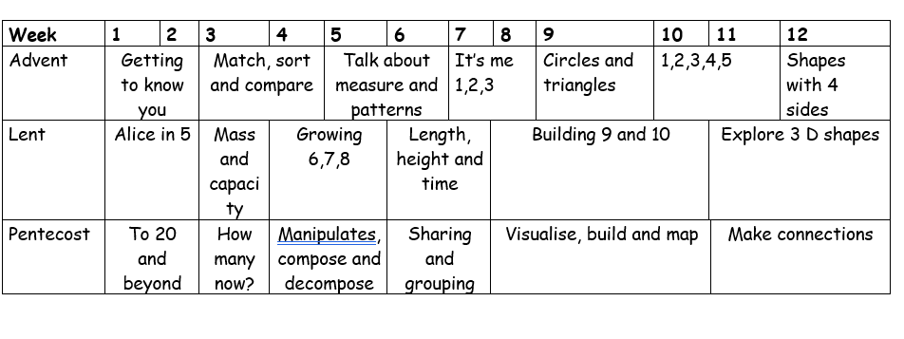
Week | 1 | 2 | 3 | 4 | 5 | 6 | 7 | 8 | 9 | 10 | 11 | 12
Advent | Number  Place value within 10 |  |  |  |  | Geometry  Shape | Number  Addition and subtraction
Lent | Number  Place value within 20 |  |  | Number  Addition and subtraction within 20 |  |  | Number  Place value within 50 |  | Measurement  Length and height |  | Measurement  Mass and volume
Pentecost | Number  Multiplication and division |  |  | Number  Fractions |  | Geometry  Position and direction | Number  Place value within 100 |  | Measurement  money | Measurement  Time
Year 1 Maths Long Term Overview

Year 2/3 Maths Long Term Overview
Week | 1 | 2 | 3 | 4 |  | 5 | 6 | 7 | 8 | 9 | 10 | 11 | 12
Advent | Number  Place Value |  |  |  |  | Number  Addition and subtractions |  |  |  |  |  | Number  Multiplication and division
Lent | Number  Multiplication and division |  |  |  | Measurement  money |  |  | Measurement  Length and perimeter |  |  | Number  Fractions
Pentecost | Number  Fractions |  | Measurement  Mass and capacity |  |  |  | Measurement  Time |  |  | Geometry  Shape |  | Geometry  Position and direction | Statistics

Week | 1 | 2 | 3 | 4 | 5 | 6 | 7 | 8 | 9 | 10 | 11 | 12
Advent | Number  Place Value |  |  |  | Number  Addition and subtraction |  |  |  | Number  Multiplication and division A |  |  | Measurement  Area
Lent | Number  Multiplication and division B |  |  | Measurement  Length and perimeter |  | Number  Fractions A |  |  | Measurement  Mass and capacity |  | Number  Fractions B
Pentecost | Measurement  Time |  | Number  Decimals |  |  | Measurement  Money |  | Geometry  Shape |  | Geometry  Position and direction | Statistics
Year 3/4 Maths Long Term Overview

Year 4/5 Maths Long Term Overview

Week | 1 | 2 | 3 | 4 |  | 5 | 6 | 7 | 8 | 9 | 10 | 11 | 12
Advent | Number  Place Value |  |  |  |  | Number  Addition and subtraction |  |  | Number  Multiplication and division |  |  | Geometry  Position and direction
Lent | Number  Fractions A |  |  |  | Number  Multiplication and division |  |  |  | Number  Decimals A and percentages |  |  | Statistics | Measurement  volume
Pentecost | Measurement  Length, perimeter and area |  |  | Number  Fractions B |  |  | Number  Decimals B |  |  | Geometry  shape |  | Number  Negative numbers | Measurement  Converting units /time

Year 6 Maths Long Term Overview

Week | 1 | 2 | 3 | 4 | 5 | 6 | 7 | 8 | 9 | 10 | 11 | 12
Advent | Number  Place Value |  | Number  Addition, subtraction, multiplication and division |  |  |  |  | Number  Fractions A |  | Number  Fractions B |  | Measurement  Converting units
Lent | Number  Ratio |  | Number  Algebra |  | Number  Decimals |  | Number  Fraction, decimal and percentages |  | Measurement  Area, perimeter and volume |  | Statistics
Pentecost | Geometry  Shape |  |  | Geometry  Position and dirtections |  | Thmes projects, consolidation dn problem solving

