
Climate Action Plan
Our Lady of Good Counsel
1 year plan Summer 2025 – Summer 2026
Carbon baseline: 115.81 Calculation: 5/6/25

Jo.pettifer@letsgozero.org

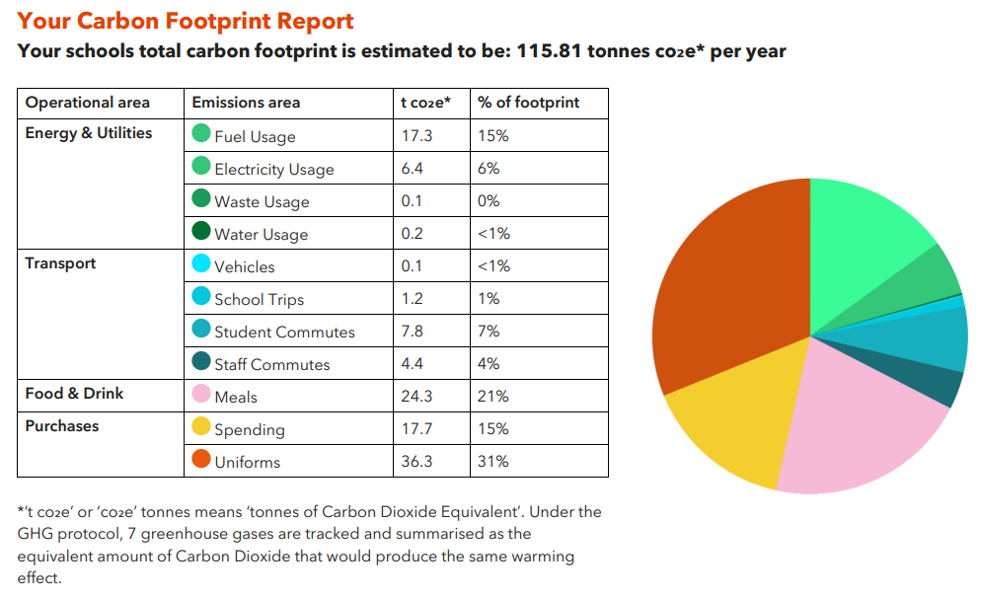
Overall per pupil, your school’s emissions are below average in all areas, keep up the great work . Emissions from food and uniform are at average so these would be good priorities to address in your plan.
GET STARTED
ACTION | TIMEFRAME | STAKEHOLDERS | Useful CSI Links | TRACKER
Sign up to the Let’s Go Zero campaign  By joining this campaign, your school confirms that it is taking action now to reduce its own carbon impact, and that it demands the UK Government help all schools reach this goal by the end of the decade. | Start: Summer 2025  Review: | Pauline Chawner | Laudato Si:  “If someone has not learned to stop and admire something beautiful, we should not be surprised if he or she treats everything as an object to be used and abused without scruple. If we want to bring about deep change, we need to realize that certain mindsets really do influence our behaviour. Our efforts at education will be inadequate and ineffectual unless we strive to promote a new way of thinking about human beings, life, society and our relationship with nature.” | Completed
  Calculate your school’s carbon footprint using Count Your Carbon  This free digital tool allows you to calculate the carbon footprint for your educational setting.  Join and sign up to this before end of Summer 2025 | Start:Pentecost 2025  Review: Pentecost 2026 | Pauline Chawner |  | Completed
Sign up to the Sustainability Support for Education  Sustainability Support for Education  A DfE-funded project that enables education settings to start or progress on their sustainability journey. This includes all types of settings from Early Years to Higher Education, offering suggested actions paired with quality-assured resources. You can filter these to show suggestions relevant to your setting based on your teaching age, priorities, how far you’ve progressed already, estate, and more. | Start: Pentecost :2026  Review: Pentecost 2027 | Pauline Chawner |  | Planning

1. Decarbonisation and Energy Efficiency
Calculating and taking actions to reduce carbon emissions and becoming more energy efficient
ENERGY (Behaviour Change and Retrofit)
ACTION | TIMEFRAME | STAKEHOLDERS | Useful CSI Links | TRACKER
Introduce a school policy around lighting use  Having a lighting policy is a quick win, and a great way to get students on board. Get the eco-club to design 'switch-off' signs or stickers to display by all lighting switch panels around the school. This may also include getting staff to consider whether they need all lights on in a room at a time where zoned lighting is possible, and how much light these provide.  Instruct all staff to follow policy and turn lights off when not in the classroom.  School counsel to organise posters to put around school | Start: Lent 2 2026  Review: Lent 2 :2027 | All staff/ School counsellors | School councel have put posters in every classroom reminding children and staff to switch off the lights when not in the classroom.  They have also mentioned that IWB are being left on at the end of the day and laptops are being charged when they don’t need to be.  Staff have been informed that IWB’s need to be turned off at the end of the day. | Completed
Take part in a switch off campaign  Take part in a Switch-Off campaign, e.g. Switch-Off Fortnight. Aim for 10% reduction of energy use (the typical amount saved by participating schools).  Sign up to the switch off campaign and get all staff and children involved led by the school counsellors | Start: Lent 2026  Review: Lent 2027 | All staff |  | Planning

PURCHASING and UNIFORM
ACTION | TIMEFRAME | STAKEHOLDERS | Useful CSI Links | TRACKER
 | Start: Advent 2025  Review: | PTA | Laudato Si:  “We all know that it is not possible to sustain the present  level of consumption in developed countries and wealthier sectors of  society, where the habit of wasting and discarding has reached unprecedented levels. The exploitation of the planet has already  exceeded acceptable limits and we still have not solved the problem of poverty.” | Completed and ongoing.  This has been set up since September 2025 and is being used by lots of parents  It is situated in a palce where parents can easily access this without any stigma
  Set up a rail of clothes for unfirm exchange with no charge in the entrance to the school, used at parents evening etc

FOOD
ACTION | TIMEFRAME | STAKEHOLDERS | Useful CSI Links | TRACKER
To identify and be able to off plant-based menu options.  Adding an additional planet-friendly day increases your vegan and vegetarian meal uptake. | Start: Advent 2025  Review: | Paul Tibble | Catholic Life and Mission (CLM3.5)  Leaders and governors are inspirational witnesses to the Gospel and to Catholic Social Teaching in their direction of the school at every level: this is shown through our decisions  surrounding the nourishment of our pupils, staff and community. They embody the Church’s  preferential option for the poor by ensuring that resources are consciously and effectively targeted at those in greatest need through our work on minimising food waste. In every one of their decisions, such as supporting meat reduction on our school menus, they demonstrate an exemplary  commitment to care for our Common Home, to the pursuit of the common good and to service of those in greatest need. | Planning
Increase meat-free offer on multiple days in a week.  Increase your vegan and vegetarian offers, whether this includes more hot meal options or addressing your sandwich or jacket potato offerings to begin to shift away from meat fillings. | Start: Advent 2025  Review: | Paul Tibble |  | Planning

TRANSPORT
ACTION | TIMEFRAME | STAKEHOLDERS | Useful CSI Links | TRACKER
Promote walking/ cycling to school weeks throughout the year  SLT to plan this over the year and share with parents, rewards given to those who complete this. Communicate to the wider school community the benefits of active travel. | Start: Pentecost 2026  Review: Pentecost 2027 | SLT | Catholic Life and Mission (CLM1.3)  Through actions such as our sustainable travel campaigns, pupils gladly embrace their personal responsibility to care for our Common Home, pursue the common good and through their global actions on transport, serve those in need. | Planning
Provide cycle proficiency on a yearly basis through Bike ability | Start:  Review: | Y5 class teacher |  | Completed and ongoing.  This is a yearly event for the chidlren in Year 5. They complete a week's trinign course with an outside provider

WASTE
ACTION | TIMEFRAME | STAKEHOLDERS | Useful CSI Links | TRACKER
Ensure recycling bins are in all key areas e.g. classrooms, corridors, playgrounds, cafeteria and staffroom.  Ensure that there are bins in all relevant areas of the school to make choosing to recycle easy. Consider colour differences to highlight general vs recycling clearly. | Start: Pentecost 2025  Review:  Pentecost 2026 | Site manager | Catholic Life and Mission (CLM1.3.) Through our mission to act as stewards of our common home, our pupils have a clear understanding that the school community is committed to following the teaching and example of Jesus as expressed in the Gospels, the social teaching of the Church and the school’s own particular charism.  As a result of taking part in our waste reduction actions, such as donating their pre-loved uniform to our uniform swap shops, pupils flourish as they seek opportunities to grow in virtue. Through leading campaigns, such as recycling the canteens, they gladly embrace their personal responsibility to care for our Common Home, pursue the common good and serve those in need. | Completed  Three differnt types of bins are in every classroom and children are taught how to recycle. Bins are also in tha hall for lunchtime and the staffroom.  Food waste bin is also used to collect wasted food items
Reduce the amount of printing  Ensure that all printing purposeful and that any paper is used as scrap paper throughout the year. | Start: Advent 2025  Review: | All staff |  | Completed  Staff are only printing what they need and trying to reduce this at every opportunity. Any unused paper is placed in the scrap paper and wet play drawer to be used again

2. Climate adaptation and resilience
Taking actions to reduce the risk of flooding and overheating and to future-proof scarce resources for potential shortages
ADAPTATION AND RESILIENCE
ACTION | TIMEFRAME | STAKEHOLDERS | Useful CSI Links | TRACKER
Write a heatwave policy that addresses areas such as school dress code, passive ventilation measures, PE lessons and slip slap slop campaigns  Write a heat wave policy to address issues such as uniform, PE, suncream and outdoor learning. Consider adopting the joint union heatwave protocol including short term, medium term and long term measures. | Start: Advent 2025  Review: | H/S governor to review this policy | Catholic Life and Mission (CLM1.4)  Pupils take a leading role in responding to the demands of Catholic Social Teaching and are pro-active in finding ways of responding, locally, nationally and globally to issues surrounding water conservation. They can clearly articulate the theology underpinning their actions to care for our common home, locally through turning off taps and collecting rainwater for our gardens through to global action for all God's children, such as supporting our adaptation and resilience measures. | Completed  Trust have completed and school have adapted a heatwave policy in school.

WATER
ACTION | TIMEFRAME | STAKEHOLDERS | Useful CSI Links | TRACKER
Raise awareness around water consumption and efficiency through workshops and displays, posters and assemblies. | Start:Advent 2025  Review:  Advent 2026 | School counsel |  | Planning
Start:
Review:

3. Biodiversity and Green Infrastructure
Creating habitats and adopting practices that will enhance species diversity on the school estate and beyond
NATURE
ACTION | TIMEFRAME | STAKEHOLDERS | Useful CSI Links | TRACKER
Enrol with National Education Nature Park  - Set up mini habitats and enhance the garden spaces around school. | Start: Lent 2026  Review: | School Counsel | Catholic Life and Mission (CLM1.4) Through our care for the natural world, our pupils take a leading role in responding to the  demands of Catholic Social Teaching and are pro-active in finding ways of responding, locally, nationally and globally. They can clearly articulate the theology underpinning their actions such as protecting God's world and caring for its inhabitants. They carry out this mission through wildflower seeding, tree planting and tending our gardens. | Planning

4. Climate Education, Green Skills and Green Careers
Ensuring the education you provide gives knowledge-rich and comprehensive teaching about climate change, and that your teaching staff feel supported to offer this

CULTURE, CURRICULM and GREEN SKILLS AND CAREERS
ACTION | TIMEFRAME | STAKEHOLDERS | Useful CSI Links | TRACKER
Set up a sustainable working group including the children  Already have a school counsel group of children | Start: Advent 2025  Review: | Pauline Chawner | Laudato Si:  “There is a nobility in the duty to care for creation through  little daily actions, and it is wonderful how education can bring about real changes in lifestyle. Education in environmental responsibility can encourage ways of acting which directly and significantly affect the world around us, such as cooking only what can reasonably be consumed and showing care for other living beings.  “ | Completed  School council has been set up with two representatives from each year group from year 1 to year 6.  One meeting has taken place in the advent term and other meeting and events are to be planned thoughout the yea.
Connect with Climate Ambassadors in your region and invite them to do a school assembly on a topic of interest to your school. | Start: Lent 2026  Review: | Pauline Chawner |  | Planning
  Access the Climate Ambassadors scheme




www.letsgozero.org

Ashden is registered in England and Wales as a company limited by guarantee.
Registered number: 05062574/ Charity number: 1104153
The Peak, 3rd Floor 5 Wilton Road, London, SW1V 1AP

