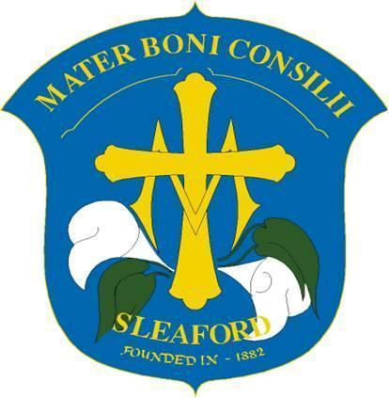
Year: Reception
Lent 1 Term
Curriculum Newsletter
English | Talk for Writing Fiction – The Gruffalo  This term the children will further their ‘Talk for Writing’ skills. They will practise using story-teller voices, as they learn to recite the recount of our hunt for The Gruffalo and his friends. The children will be speaking in the first person and the past tense and using some interesting prepositions; “I stepped over the log to see the snake.”  Spelling: This term, the children will continue to learn their set 1 sounds which will now incorporate the digraphs, ch, sh, th, qu, ng, and nk. We refer to these digraphs as ‘special friends’ which are two letters which together make one sound. They will continue to ‘Fred Talk’ to orally segment sounds and blend them together. The children will use their segmenting skills to write CVC words and begin to write simple captions.  Grammar: As part of their Talk for Writing lessons, the children will be learning about adjectives, prepositions and sequencing words.
Maths | Number  We will continue to explore number in a hands-on manner by engaging the children with practical activities, games, stories, songs and through play. We will continue to consolidate numbers 1-5 and then begin to consider numbers 6, 7 and 8. The children are working towards having a deep understanding of these numbers including the composition of each number. We will also continue to explore the concept of 1 more and 1 less. The children will also begin to investigate mass and capacity.
RE | Galilee to Jerusalem  This term in RE the children will be learning to:  - Know that the wise men visited Jesus  - Know that the wise men gave Jesus gifts  - Know that Jesus welcomes everyone  - Know that Jesus takes care of everyone  - Know that Jesus wants us to take care of other people  - Know that Jesus teaches us that we should share what we have with others  - Plan a ‘Celebration of the Word’ to respond to this topic  As with all of our learning RE lessons will be carried out with a range of circle times, listening to stories, creating arts and crafts, music and singing, as well as praying and learning how to set up our worship space and prayer table.
Topic – Under The Canopy | Our Topic this term is ‘Under The Canopy’ and our role play area will become a woodland habitat where we will also bring to life our English text ‘The Gruffalo.’ We will learn about the animals we may find in a British woodlands, where they live and the sounds they make. We will then begin to discover what a rainforest is, and how it compares and contrast to a woodland. Our role play area will change into a rainforest and incorporate rainforest animals small world play. We hope to finish the term with a trip to Lincolnshire Wildlife Park to observe some rainforest animals up close!
Art & DT | The craft area of the classroom continues to be a popular choice for all children. Here they can find many resources to create pictures and models using different materials and textures. They continue to revisit and develop previously built skills and ideas, enhancing and refining presentation. Increasingly careful thought is being given to selecting their own resources to join and assemble materials. Enjoying crafts together is a wonderfully social activity, encouraging conversation and building vocabulary as they share resources or work together cooperatively as part of a group. We will build upon the previous terms exploration of mixing primary colours to make secondary colours and using white to change the lightness. They will then use their colour pallete to produce parrot paintings, giving careful consideration to the different coloured feathers.
Music | The children will enjoy moving their bodies to different music and recognisable songs. They will explore ‘beat’ by clapping their hands and stopping their feet in time with different tempos.
PE | The children will develop their basic gymnastic skills through the topic of ‘animals and their habitats.’ We will explore creating shapes, balances, and jumps and begin to develop rocking and rolling. They will continue to show an awareness of space and how to use it safely and perform basic skills on both floor and apparatus. They will copy, create, remember and repeat short sequences . They begin to understand using levels and directions when travelling and balancing.
RSHE | RSHE continues to be woven into every aspect of our classroom. This term our RSHE unit is called ‘Created to Love Others!’  The children will listen to stories and songs and engage in practical activities to explore the difference between a good choice and a wrong choice. They will learn and understand words that describe a good friend. The children will learn that:  • We are part of God’s family  • Jesus cared for others and wanted them to live good lives like him  • We should love other people in the same way God loves us  The children will then consider steps to resolve conflicts with other children, e.g. finding a compromise. The children will learn that:  • When they have been unkind to others and say sorry.  • When we are unkind, we hurt God and should say sorry.  • When people are being unkind to them and others they know how to respond.  • We should forgive like Jesus forgives.
Curriculum enrichment | As an enhancement for our topic ‘Under The Canopy’ and our English Text ‘The Gruffalo’ the children will go on a Gruffalo Hunt and visit Lincolnshire Wildlife Park.

