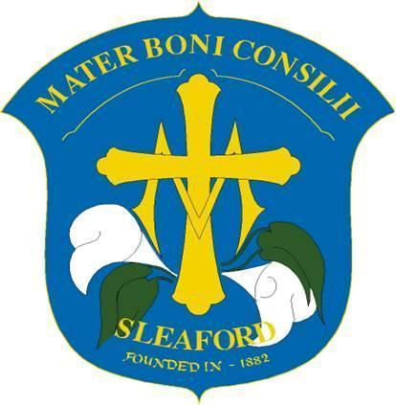
Year: Reception
Advent term
Curriculum Newsletter
English | Talk for Writing Fiction – Room on the Broom  This term the children will develop the ‘Talk for Writing’ actions further. They will practise using story-teller voices, as we learn to recite the story of Room on the Broom.  Spelling: This term, the children will continue to learn their set 1 sounds. They will be using ‘Fred Talk’ to orally segment sounds and blend them together; “m-a-t mat!” The children will use their segmenting skills to begin to make simple words using their magnetic boards and sound these out. They are setting the foundations to read and write simple three letter words.  Grammar: As part of their Talk for Writing lessons, the children will be learning about adjectives and sequencing words.
Maths | Number  We will continue to explore number in a hands-on manner by engaging the children with practical activities, games, stories, songs and through play. We will continue to consolidate numbers 1-3 and then begin to consider numbers 4 and 5. The children are working towards having a deep understanding of these numbers including the composition of each number – for example 5 can be made up by a 2 and a 3 or a 4 and a 1. The children will also be exploring the concept of 1 more and 1 less.
RE | In RE lessons we will be learning all about the Christmas story, breaking it down and learning in detail about each part of the story. We will be thinking about how each of the people felt when, for example, Angel Gabriel appeared to them, they travelled for a long time on the donkey, or they saw the baby Jesus laying in a manger. The children will create crafts and sing songs to reflect what they have learned and they will take part in the Key Stage 1 nativity at the end of the term. We will talk about what happens in Advent and how we feel during this period of waiting, creating advent wreaths and opening our advent calendar.  Throughout the term the children will also have an opportunity to help Mrs Petty to plan a whole-class ‘Celebration of the Word’ where we gather together to pray, listen to a bible story, respond in an appropriate way and then give the children a mission related to the story that we have just read.
Topic – Seasonal Celebrations | This term will begin with the children learning about the change in seasons. We will explore the natural world, for example going on a leaf hunt and observing the different colours of leaves in Autumn. The children will learn about a range of different celebrations and important events that occur this time of year. They will learn about Diwali by making their own Diya lamps, joining in with dances, creating beautiful rangolis and sampling some different Indian foods. The children will share personal experiences of bonfire night, watch different fire-works on our big screen and explore mixed media to make their own firework scenes. They will begin to learn about Remembrance Day and paint poppy stones which they will place in our sacred garden – where they will also sprinkle poppy seeds. The term will end with beginning to learn The Christmas story and performing songs in our annual Nativity.
Art & DT | Art and DT is strongly woven into many areas of our curriculum, for example topic and RSHE lessons which helps bring to life and embed learnings. Children will practise using scissors and holding pens, pencils, crayons, chalks and paintbrushes. The children will explore a wide range of materials – for example, using tissue paper on self-adhesive film to create sun-catcher Christmas decorations. The children will begin to refine their painting skills, for example beginning to learn to mix a colour pallete using the primary colours. An example of this is mixing red and yellow in different quantities to create different shades of orange to paint the leaves on an Autumn tree. The children will learn how to clean their brushes properly before mixing a different shade in order to keep their pallete clean. An extensive variety of arts and crafts materials are available for the children to explore during continuous provision.
Music | The children will enjoy moving their bodies to different music and recognisable songs. They will explore ‘beat’ by clapping their hands and stopping their feet in time with different tempos. The children will learn different Christmas songs to perform in the nativity.
PE | The children will practise how to move safely around each other and change direction and pace whilst showing an awareness of others. They will be recalling their knowledge about ‘People who help us’ from the previous term and emulate them – for example use their bodies to pretend to be firemen holding on to a powerful hose or pretending to climb a ladder. The children will practise their throwing, rolling and bouncing ball skills in a variety of games designed to work co-operatively with others. The children will continue to be encouraged to practise their gross motor skills during play, for example negotiating obstacles safely when using the climbing apparatus and building their strength and co-ordination when using the balance bikes.
RSHE | This term our RSHE unit is called ‘All the Feelings!’ The children will be introduced to the story ‘The Colour Monster’ which we will use to discuss how they are feeling, what feelings can look like in their bodies and what contributes to their feelings. The children will discover some simple strategies they can use when feeling sad, nervous or angry. The children will begin to use Colour Monster pictures to ‘check in’ with how they are feeling during various times of the day. They will also work on empathy and how to help others experiencing difficult feelings.
Curriculum enrichment | During our topic lessons we are learning about ‘Seasonal Celebrations’. The children will perform songs in our annual Nativity and experience a whole school visit from the pantomime.

