Year2
Lent term 1
Curriculum Newsletter
English | Traditional Tales, listening to and writing new traditional tales. Identifying the features of instructions and writing a set of instructions.  SPAG: Different types of sentences, sentence structure, nouns, adjectives, verbs.  Spellings: Securing Advent term spellings, Common Exception words, words that end in ing, contractions and apostrophes.  Handwriting- correct letter formation and cursive joins.
Maths | 3d shapes, money, multiplication and division. 2x,5x tables
RE | Branch 3: Galilee to Jerusalem: Knowing more about John the Baptist. Recognising some parables. Know that God forgives all people and that we are all tempted to bas choices at times. Begin to recognise the miracles of Jesus are signs that he is the Son of God.
Science | Use of everyday materials- Identifying different materials, objects made from materials and the properties of materials. Including investigations into absorbency and waterproofing
Computing | Programming including debugging
Geography | Comparing a small part of UK and a small part of non-European location – London and Nairobi
Design technology | Mechanisms- Are bigger wheels always better?  Understanding how wheels and axles work. Exploring the size of wheels and positioning of axle. Building and testing a simple vehicle.
Art | 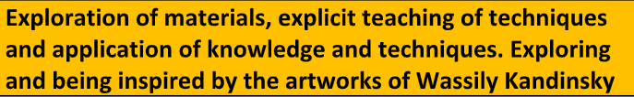
Music | Exploring feelings through music. How does music make our world feel better?
PE | Dance-Secret Garden. Exploring and moving like animals in a secret garden- Connecting dance moves.
RSHE | Protected characteristics, Super Susie gets angry, the circle of life,
Curriculum enrichment | Winter walk- Observing changes in our environment. Trip to the library

