1. | Sacraments of Initiation: | Baptism, Confirmation, Eucharist
2. | Sacraments of Healing: | Reconciliation (Penance), Anointing of the sick
3. | Sacraments in service to Holy Communion: | Marriage, Holy Orders
4. | Sacraments definition: | There are seven Sacraments, and they are meeting points with God that bring people into a closer relationship with God.
5. | Purpose of Sacraments: | To help people grow more like Jesus, and through him become children of God.
6. | Administering the Sacraments | The Bishop administers Confirmation and Holy Orders because he is a successor of the apostles.
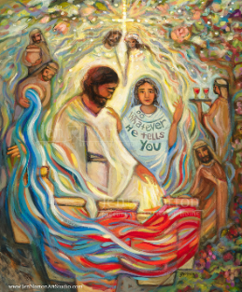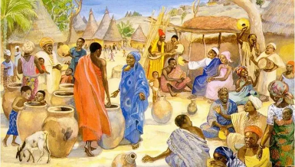
Jen Norton Jesus Mafa (Cameroon)
1. | The Wedding at Cana  (Jn 2:1-12) | Jesus turns water into wine. He can transform created elements – links with the Eucharist.
2. | Healing of the Official’s Son (Jn 4:46-54) | Jesus heals with a word, his words have power, he is the Word of God. Links with the prologue Jn 1:1-2.
3. | Healing the man at Bethesda  (Jn 5:1-15) | Jesus heals on the Sabbath; he is Lord of the Sabbath. However, the man does not recognise that Jesus has healed him and speaks to the authorities. Links with spiritual blindness and seeing Jesus as the Messiah.
4. | Feeding of the Five Thousand (Jn 6:5-14) | Jesus feeds the people as the Israelites were fed by manna in the desert. Links with the Eucharist.
5. | Jesus walks on water  (Jn 6:16-24) | Jesus is the new Moses; as Moses led the people across the Red Sea, Jesus leads the way to the Kingdom of God.
6. | Healing of the man born blind (Jn 9:1-7) | Links with healing the man at Bethesda. In this miracle, the man recognises Jesus, and he sees physically and spiritually experiencing conversion and healing.
7. | The raising of Lazarus  (Jn 11:1-45) | Jesus is the way to eternal life. Martha, his sister, experiences conversion, recognising Jesus as ‘the Christ, the Son of God’, and then Jesus raises Lazarus from the dead. This miracle that prompts the authorities to act against Jesus and the events of Holy Week follow.
The Seven Signs of St John’s Gospel (Hear)
The Sacraments
Core Vocabulary
1. | Cana | The place where the bible story The Wedding at Cana is set. This is in lower Galilee, North Israel.
2. | Bethesda | The Pool of Bethesda is referred to in John's Gospel in the New Testament, in an account of Jesus healing a man at a pool of water.
3. | Lazarus | He was brought back to life from the dead by Jesus. This demonstrates God’s glory and the power of the resurrection.
‘I am’ Statements

1. | ‘I am the Resurrection and the life’  (Jn 11:25) | 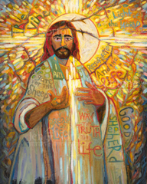 Jen Norton
2. | ‘I am the Bread of Life’  (Jn 6:35) | 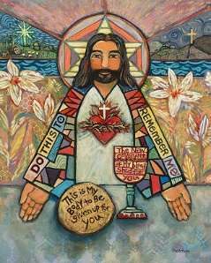 Jen Norton

