Religion | Impact on Lives
Christianity   | Decision-making: Their understanding of right and wrong, based on biblical principles, guides their choices.  Relationships: They strive to love and treat others with respect and compassion, reflecting God's love.  Work and Service: Christians may see their work as a way to serve God and contribute to society.  Facing Challenges: A Christian worldview can provide comfort, hope, and strength in the face of suffering and adversity.
Hinduism   | Emphasis on Dharma: Hindus strive to live in accordance with their dharma, fulfilling their duties and responsibilities in life.  Seeking Liberation (Moksha): The ultimate goal for many Hindus is to break free from the cycle of samsara and achieve moksha.  Respect for All Life: Due to the belief in reincarnation, Hindus generally view all living creatures as part of the same cosmic family, fostering respect and compassion.
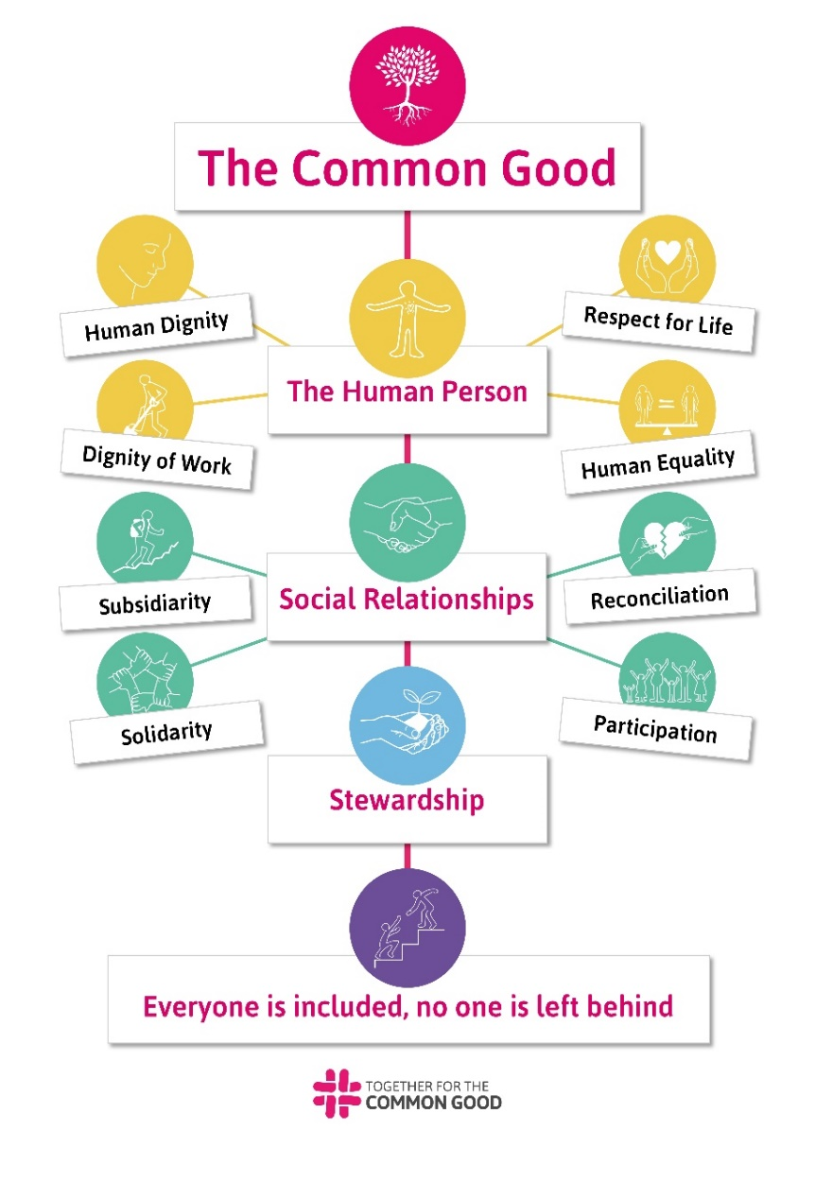
Core Vocabulary
Catholic Social Teaching
Worldviews of Religions
1. | Dialogue | Dialogue is a conversation between two or more people
2. | Catholic Social Teaching | A compass that helps people live their faith by doing good and building a fair world
3. | Worldview | The lense through which you see the world
4. | Hinduism | A very old religion from India, and it teaches people about how to live a good life. It's like a big collection of different beliefs and practices, not just one set of rules.
5. | Dharma | The spiritual law for human beings
6. | Vedas | A collection of ancient scriptures considered to be the most sacred texts, containing spiritual knowledge and wisdom.
7. | Karma | The concept of cause and effect, where actions, both good and bad, influence future consequences, potentially in this life or future lives through reincarnation.
8. | Sikhism | A religion that originated in the Punjab region of India. It emphasizes belief in one God, equality, and selfless service.

