1. | Sieger Koder ‘The Washing of feet’ | 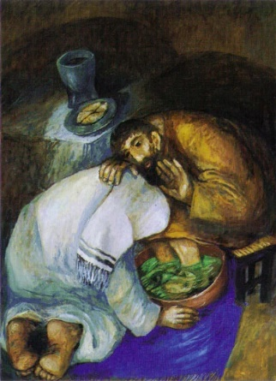
2. | Sieger Koder ‘The Last Supper’ | 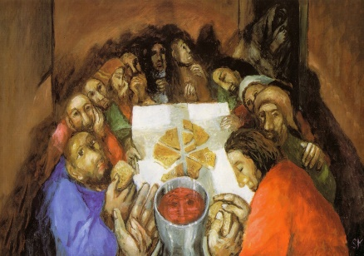
1. | The First Station | Jesus is condemned to death.
2. | The Second Station | Jesus accepts the cross.
3. | The Third Station | Jesus falls the first time.
4. | The Fourth Station | Jesus meets his mother.
5. | The Fifth Station | Simon of Cyrene helps Jesus carry the cross.
6. | The Sixth Station | Veronica wipes the face of Jesus.
7. | The Seventh Station | Jesus falls the second time.
8. | The Eighth Station | Jesus meets the women of Jerusalem.
9. | The Ninth Station | Jesus falls the third time.
10. | The Tenth Station | Jesus is stripped of his garments.
11. | The Eleventh Station | Jesus is nailed to the cross.
12. | The Twelfth Station | Jesus dies on the cross.
13. | The Thirteenth Station | Jesus is taken down from the cross.
14. | The Fourteenth Station | Jesus is buried in the tomb.
1. | John 12:1-11 | Mary anoints Jesus’ feet at Bethany. This reveals a deeper meaning about Jesus as the Messiah. Mary was preparing Jesus for his death and burial.
2. | John 13:1-17 | Jesus washes his disciples’ feet at The Last Supper. This links to what happens at Mass on Holy Thursday.
3. | John 18:1-11 | The arrest of Jesus.
4. | John 18:28-40,  John 19:4-6 | Jesus is put on trial before Pontius Pilate.
5. | John 19:17-22 | The Crucifixion of Jesus.  Christians remember this on Good Friday.
6. | John 19:25-27 | Jesus’ mother Mary was standing near the cross during the crucifixion. Mary is the mother of all Christians.
7. | John 19:28-37 | The death of Jesus.  Jesus showed his love by dying on the cross.  On the cross he took on the guilt and pain of the whole world to bring the world back home to God’s perfect love.
The Stations of the Cross
Artistic representations of Holy Week
The events of Holy Week
The Way of the Cross in Lourdes, France
