1. | Discipleship | Being a follower of Christ and following His teaching.
2. | Mary | Mary is an example of Discipleship through her commitment to Jesus.
1. | Holy Spirit  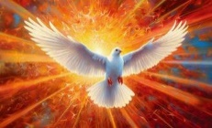 | The Holy Spirit is God,  as is the Father  and as is Jesus the Son.  The Holy Spirit is the third person of the Trinity. God the Father, God the Son, God the Holy Spirit.
2. | The gifts of the Holy Spirit | These include:  Wisdom, understanding, counsel, fortitude (courage), knowledge, piety and fear of the Lord.
3. | The fruits of the Holy Spirit | These include:  Love, joy, peace, patience, kindness, goodness, truthfulness, gentleness and self-control.
1. | Sacrament | An outward sign of an inward grace through which Christians share in God’s love through the Holy Spirit. They are meeting points with God.
2. | Sacrament of Initiation | Confirmation is one of the three sacraments of initiation of the Church. The other two are Baptism and Eucharist (First Holy Communion)
3. | Confirmation | This sacrament recalls the Holy Spirit descending on the disciples at Pentecost. It is when a Christian becomes a full member of the Church.
4. | What happens during Confirmation? | In the Sacrament people are strengthened in faith through the power of the Holy Spirit, the gifts of the Spirit are increased.
5. | The Bishop | The Bishop usually administers confirmation. The Bishop extends his hands over the confirmands as a successor of the apostles. He says “Be sealed with the gift of the Holy Spirit.”
6. | Spiritual change | During confirmation, the person is invited to live a life inspired by God’s grace and the Holy Spirit
7. | Oil of Chrism | This is the oil of anointing. The anointing with chrism marks a Christian’s total belonging to Christ.
The gifts and fruits of the Holy Spirit

Discipleship
Sacrament of Confirmation

The glorious mysteries of the Rosary
1. | The Rosary | A prayerful reflection on the life of Christ.
2. | The glorious mysteries of the Rosary | - The Resurrection  - The Ascension into Heaven  - The descent of The Holy Spirit  - The Assumption of Mary  - The Crowning of Mary
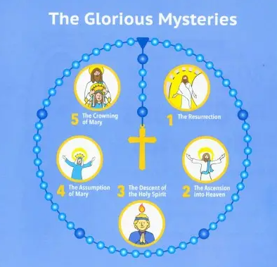

Blessed Carlo Acutis
“I never fail to keep the most gracious appointment of the day – recitation of the Holy Rosary.”
