1. | Happy are the poor in spirit: | Theirs is the kingdom of heaven.
2. | Happy are the gentle: | They shall have the earth for their heritage.
3. | Happy those who morn: | They shall be comforted.
4. | Happy those who hunger and thirst for what is right: | They shall be satisfied.
5. | Happy the merciful: | They shall have mercy shown them.
6. | Happy the pure in heart: | They shall see God.
7. | Happy the peacemakers: | They shall be called sons of God.
8. | Happy are those who are persecuted in the cause of right: | Theirs is the kingdom of heaven.
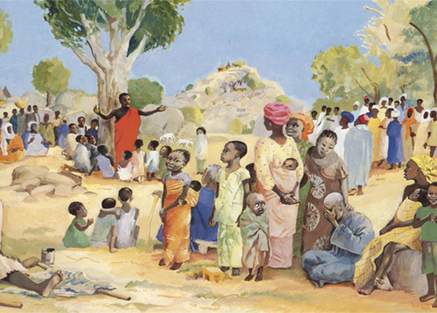
1. | God gave the people of Israel the Ten Commandments.
2. | The Ten Commandments were given as rules for the people to live together well.
3. | Rule 1 | I am the Lord your God. You shall have no gods except me.
4. | Rule 2 | You shall not take the name of your Lord in vain.
5. | Rule 3 | Remember the sabbath day and keep it holy.
6. | Rule 4 | Honour your father and your mother.
7. | Rule 5 | You shall not kill.
8. | Rule 6 | You shall not commit adultery.
9. | Rule 7 | You shall not steal.
10. | Rule 8 | You shall not bear false witness against your neighbour.
11. | Rule 9 | You shall not covet your neighbour’s wife.
12. | Rule 10 | You shall not covet your neighbour’s goods.
13. | Jesus summarises all the Ten Commandments in one greatest commandment:  “You must love the Lord your God with all your heart, with all your soul, with all your strength, and with all your mind, and your neighbour as yourself.” (Luke 10:27)
The Beatitudes (Matthew 5:1-12)
The Transfiguration
The Ten Commandments
1. | Peter, James and John  (three disciples) | Jesus reveals his divine glory to three of his disciples at The Transfiguration.
2. | Moses and Elijah | Moses and Elijah appeared to the disciples with Jesus at The Transfiguration.
3. | A voice spoke from a bright cloud: | “This is my Son, the Beloved; with Him I am well pleased; listen to him!”
Theological Virtues

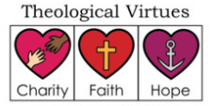
1. | Charity (Love) | Christians love God above all things and our neighbour as ourselves for the love of God.
2. | Faith | Christians believe in God and all He has said and revealed to us.
3. | Hope | This helps Christians look forward to heaven and the fulfilment of God’s promises.

