1. | The parable of the Prodigal Son.  This highlights Christian beliefs about God’s mercy and forgiveness. | 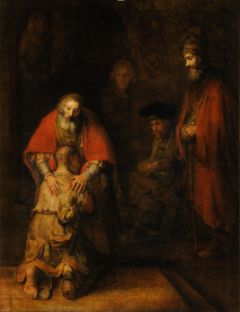
2. | The Judgement of Nations parable.  This highlights the Christian belief that helping others is part of loving God. | 
1. | The First Station | Jesus is condemned to death.
2. | The Second Station | Jesus accepts the cross.
3. | The Third Station | Jesus falls the first time.
4. | The Fourth Station | Jesus meets his mother.
5. | The Fifth Station | Simon of Cyrene helps Jesus carry the cross.
6. | The Sixth Station | Veronica wipes the face of Jesus.
7. | The Seventh Station | Jesus falls the second time.
8. | The Eighth Station | Jesus meets the women of Jerusalem.
9. | The Ninth Station | Jesus falls the third time.
10. | The Tenth Station | Jesus is stripped of his garments.
11. | The Eleventh Station | Jesus is nailed to the cross.
12. | The Twelfth Station | Jesus dies on the cross.
13. | The Thirteenth Station | Jesus is taken down from the cross.
14. | The Fourteenth Station | Jesus is buried in the tomb.
1. | Feed the hungry | Provide food for those who are hungry or in need.
2. | Give drink to the thirsty | Provide water or other drinks to those who are thirsty or lack access to clean water.
3. | Cloth the naked | Provide clothing or other essentials to those who are in need.
4. | Shelter the homeless | Provide shelter or housing for those who are homeless or lack a safe place to stay.
5. | Visit the sick | Visiting and providing care and companionship to those who are ill or in hospital.
6. | Visit those in prison | Visiting and offering support to those who are in prison.
7. | Bury those who have died | Providing proper burial or funeral services for the deceased and supporting their loved ones.
8.
The events of Holy Week

Parables – stories told by Jesus
Corporal Works of Mercy
Saint Peter in Lourdes, France
