1. | Call of Abraham  Genesis 12: 1-5 | 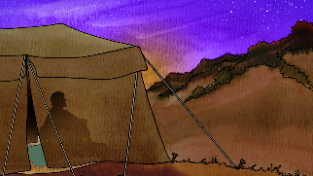
2. | God’s Covenant with Abraham  Genesis 15: 1-6 | 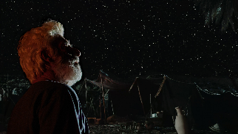
3. | Abraham and Sarah  Genesis 18: 1-15 | 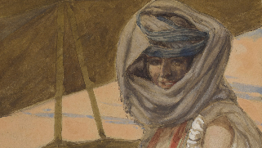
4. | Abraham and Isaac  Genesis 22: 1-18 | 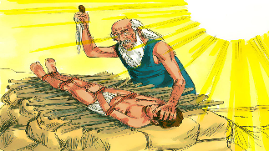
Scripture prior knowledge
5. | The Ten Commandments  Exodus 20:2-17 | 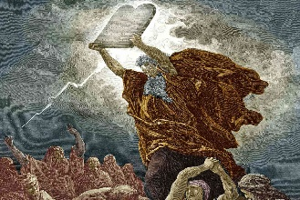
6. | Abraham is recognised as the father of faith as he made the first covenant between God and man.
1. | Abraham | A man of great faith who had a special relationship between God and the Jewish people.
2. | Historical context | Events in History that influenced what was written and who it was written for.
3. | Covenant | A contract and a promise made between a person and God.
4. | Genesis | The first book in the Bible that contains the creation story and the story of Abraham.
5. | Sarah | The wife of Abraham.
6. | Encounter | Recognising God’s presence in our own lives and moments when we have a personal encounter with God.
7. | Virtue | A virtue is a good habit that helps us to act according to God's love for us
8. | Blessings | An act of good will whereby the person implores God's aid for the person.
9. | Sacrifice | An act of giving up something that we treasure.  Making an offering or slaughtering an animal or person as an offering to God.
Big question

How can you be a good neighbour in your life
using the virtues of love, hope and faith?

Abraham: Father of Faith
Scripture
Key religious vocabulary
1. | 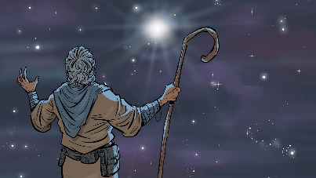 | Abraham is one of the most important figures in religious history because Jews, Christians, and Muslims trace their belief in one God back to him.
2. | 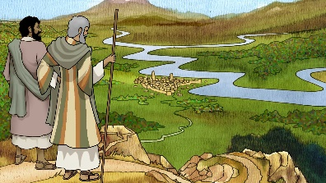 | God’s covenant with Abraham is the foundation of the faith of the people of the Old and New Testaments: Judaism and Christianity.
3. |  | The virtues of faith, hope and love help us to be a good neighbour. These virtues can transform our lives.
4. | 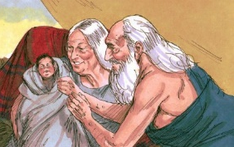 | God blessed Abraham during his life. His blessings included:  - A new land in which he and his family could live.  - A promise from God that he will watch over Abraham and his family.  - His first-born child Isaac.

