1. | Joseph | Joseph was Mary’s husband and Jesus’ earthly father. He was a kind and faithful man who listened to God. When the angel came to him in a dream and told him that Mary would have a special baby from God, Joseph trusted God and took care of Mary and Jesus.
2. | Mary | Mary was a young woman chosen by God to be the mother of Jesus. She was kind, humble, and had a strong faith.
3. | Prophet Isaiah | Isaiah was a prophet, or a messenger of God, who lived a long time before Jesus. God chose Isaiah to give people important messages about His love and His plans.
Christians go to a Mass on a Sunday because it is a Holy Day and they want to worship in God.
There are four parts to a celebration of the word;
Gather, listen, give thanks and SEND (go forth)
People gather in a Church. Everyone is welcome.
We begin with the sign of the cross.
We listen. During Mass, we listen to God’s word. The reading ends with, ‘The Word of the Lord.’ We respond with, ‘Thanks be to God.’
A psalm is usually sung.
We then stand to listen to the Gospel reading. The Priest or Deacon ends the reading with, ‘The Gospel of the Lord.’ The people respond with, ‘Praise to you Lord Jesus Christ.’
In the Eucharist Prayer, the priest does what Jesus did at the last supper. Catholics remember Jesus’ sacrifice during the Eucharist.
The people are sent out at the end to try to live out the messages they have heard and be more like Jesus.
1. | Sunday | The Holy day of rest for Christians.
2. | Mass | The most important ceremony in the Catholic church where the Eucharist is celebrated.
3. | Liturgy of the word | The words of holy scripture
4. | Eucharist | Holy Communion – The body and blood of Christ
5. | Psalms | a sacred song or poem in the Bible that is meant to be sung, but can also be read as a prayer.
6. | Hymns | a religious song of praise to God
7. | Holy Spirit | personal being who is God
8. | Nativity | The birth of Jesus
9. | The Annunciation | When the angel Gabriel came to visit Mary to give her a very special message from God.
10. | Prophet | A prophet is someone chosen by God to share His messages with people.
11. | Advent | Advent is the time of year when we prepare for Christmas and the celebration of Jesus' birth.
12. | Messaiah | The Messiah is a special person chosen by God to save and help people. In Christianity, we believe that Jesus is the Messiah.
Key Vocabulary
Order of Mass
Key people and scripture

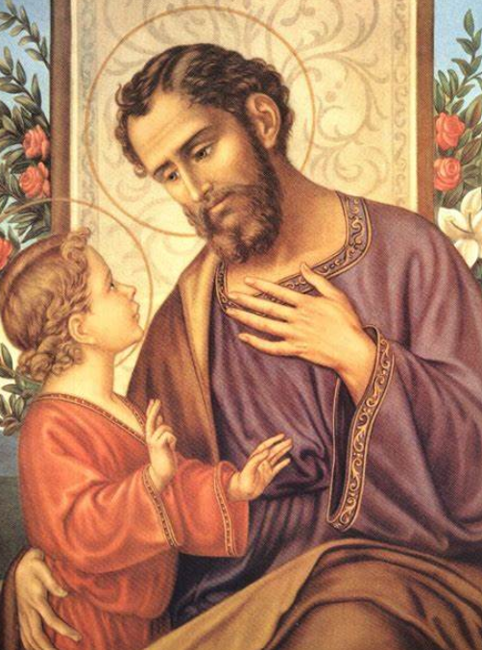
Saint Joseph was just a man, a tireless worker, the upright guardian of those entrusted to his care. May he always guard, protect and enlighten families.
- St Pope John Paul II

