LENT Term 2
BRANCH -Desert to Garden
Year 2

Age 7 Learning outcomes:
• Retell, in any form, a narrative that corresponds to the scripture source used, beginning to recognise the different literary forms in scripture.
• Correctly use religious words and phrases to recognise features of religious life and practice.
• Recognise links and simple connections between sources, beliefs, worship and life.
• Play with possibilities, asking ‘what if?’ questions, saying what they wonder about and suggesting answers, imagining how they and others are feeling..
•Consider how their own lives and the future of the communities to which they belong could be transformed by what they have learned.
• Act to bring about transformation in their own lives and in the communities to which they belong, as a consequence of their learning.
Discern
By age 7, pupils will begin to develop critical and creative skills in religious education, by expressing personal views and responses to what they have studied and exploring their ideas and reasons for their opinions. Teachers will introduce pupils to picture language, imagery in art, and symbolism, making simple links between objects, words, or images and deeper meanings. They will encounter reflective opportunities to experience wonder. They will reflect on their personal experiences in light of learning about other cultures, communities, and traditions. They may express their creative or critical reflections through different mediums, such as writing, poetry, art, music, or dance.
Respond
By age 7, pupils will be invited to share personal responses to what they have studied through personal reflection, sharing thoughts and ideas, listening to the views and opinions of others, and reflecting on what they have heard. They will consider what forgiveness and reconciliation mean in their own lives, the lives of their families and community, and the wider world. Pupils will spend reflective time to experience awe and wonder about what they have studied. Pupils will be invited to respond through individual or collective prayer, singing, or music. Pupils will think about how what they have studied has implications for their own lives and the lives of others locally and globally.

UNDERSTAND
U2.4.1 Recognise what Jesus said on the cross about forgiveness and make simple connections with the belief that God always forgives us.
U2.4.2 recognise that Lent is a time for reconciliation and forgiveness.
U2.4.3 Correctly use religious words and phrases when describing in an age-appropriate way the Sacrament of Reconciliation, making simple connections between the sacrament and a belief in God’s forgiveness.
U2.4.4 Correctly use religious words and phrases to talk about the symbols of light and water in the Easter Vigil Mass.

 | 1 | 2 | 3 | 4 | 5  (Shorter lesson) | 6
Knowledge Lens | BELIEVE  That Lent is a time of preparing our hearts and minds for Easter through reconciliation and forgiveness. | HEAR  Jesus enters Jerusalem (Lk 19:28-38*) • The last supper (Lk 22:7-23*, 28-34) | HEAR  The Crucifixion and death of Jesus (Lk 23:33-46*) | BELIEVE/CELEBRATE  . • That Lent is a time of preparing our hearts and minds for Easter through reconciliation and forgiveness.  Some prayers and actions that are ways in which Catholics turn back to God, | Celebrate  Some prayers and actions that are ways in which Catholics turn back to God, in the Sacrament of Reconciliation, for example, a simple Examen or an act of sorrow and in the Penitential rite, for example, the Kyrie Eleison (Lord have Mercy). | Celebrate/BELIEVE  That Jesus gave us the Sacrament of Reconciliation to heal and restore our friendship with God and through this ourselves  Some prayers and actions that are ways in which Catholics turn back to God, in the Sacrament of Reconciliation, for example, a simple Examen or an act of sorrow and in the Penitential rite, for example, the Kyrie Eleison (Lord have Mercy).
Learning Focus | To know that Lent is a time for reflection and is important in the church's year. | To recall the scripture stories of Palm Sunday and the Last Supper. | To retell the story of the crucifixion. | To know that prayers and actions that are ways in which Catholics turn back to God, | To know that as for forgiveness during the mass in the penitential rite and what Kyrie Elision means. | Know that we can ask forgiveness from God in the sacrament of reconciliation.
Recall and Retrieval | From 2025- recall scripture stories from last unit- all based on dignity and solidarity)  Name these stories from Scripture. Are they from the Old Testament of New Testament?  Summarise. What are these Scripture stories about? | Name the three practices Christians try to do during Lent.  Explain why Christians do these things during Lent.  Do you agree or disagree? “Giving up things is the most important.”  (Recall Almsgiving, Prayer and fasting. Time of forgiveness) | Recall the story of Palm Sunday and of the Last Supper.  Compare and contrast: How were the people feeling about Jesus? | What did Jesus say on the cross?  (Have 5 speech bubbles and children select the ones that Jesus said on the cross. Include one of the things said by the robber and a red herring).  Explain what Jesus meant by this. | How many parts are there in an examen prayer?  Why is it important to reflect on what we’ve done each day. | When do we ask for forgiveness in the Mass?  Explain what the words Kyrie Eleison mean?
Key Skills/disciplinary knowledge | U2.4.2 Recognise that Lent is a time for reconciliation and forgiveness. | D2.4.1. Looking at works of art to recall the story of Holy Week studied in the previous year | D2.4.1. Looking at works of art to recall the story of Holy Week studied in the previous year  U2.4.1 Recognise what Jesus said on the cross about forgiveness and make simple connections with the belief that God always forgives us.  U2.4.2 Recognise that Lent is a time for reconciliation and forgiveness | U2.4.2 Recognise that Lent is a time for reconciliation and forgiveness  U2.4.1 Recognise what Jesus said on the cross about forgiveness and make simple connections with the belief that God always forgives us.  R2.4.2. Think about how making bad choices can harm themselves and others and why saying sorry matters. | D2.4.3. Listening to different sung versions of the Kyrie Eleison and talking about what the words mean.  D2.4.2. Considering some examples of reconciliation and peacebuilding in art, e.g., reconciliation outside Coventry Cathedral. | U2.4.3 Correctly use religious words and phrases when describing in an age-appropriate way the Sacrament of Reconciliation, making simple connections between the sacrament and a belief in God’s forgiveness
Sequence of knowledge throughout the lesson | - Know that we are now (dependent on the point of teaching) in the season on Lent in the Church's liturgical year.  - Know that the colour purple is used in Lent as a symbol of penitence.  - Know that Lent is a time of penitence (feeling and showing that we are sorry for our sins) and reconciliation (receiving God’s forgiveness).  - Know that Lent is a time for reflection and prayer, almsgiving and fasting. | 1.Know in summary form, the scripture story of Palm Sunday.  2.Know the story of the Last Supper.  3. Talk about how different artists represent these stories. | - Know that Jesus’ crucifixion happened after Palm Sunday and the Last Supper ( Maundy Thursday) on a Friday – we call it Good Friday.  - Know the story of the Crucifixion  - Know what Jesus said on the cross.  - Know that they were forgiven | 1. Know that Lent is a time for forgiveness – like Jesus did on the cross.  2. Know that God will always forgive us.  3. Know that a simple examen can help us grow closer to God  Know how to conduct a simple Examine  4. know that forgiveness is part of our school Mission. | - Know that we ask for forgiveness in the mass. CYU 122)  - Know the meaning of the Kyrie Eleison, “Lord have Mercy” in Greek.  - Know what the words mean.  - Know how to sing a simple version.  - Know that it is one way of asking for God’s forgiveness | - Know that we can ask for God’s forgiveness in many ways.  - Know that a sacrament is a meeting point with God.  - Know that we ask for forgiveness of sins in the sacrament.  - Know that we say a special prayer – The Act of contrition/ Sorrow
Suggested Main teaching activity | Gather: Begin listening to and hearing Kyrie Eleison (children to become familiar with this by lesson 5).  - Slide 8: Introduce that the focus of Branch 4 is the season of Lent. Explain that Lent is a liturgical season and a time of preparation before Easter. What colour do you think we will use on our prayer area/the priest’s vestments at church? (Purple)  - Use the video resource to explain what Lent is, how long it lasts and the three practices that Catholics try to engage with during Lent. What is Lent? Prayer, Fasting, and Almsgiving explained  - Discuss aspects of Lent with the children.  - Children are to demonstrate their understanding of Lent. This could be demonstrated as poster, double page spread or using the worksheet provided. Ensure that children have secure knowledge that Lent is a set time in the Church’s year where we focus on penitence (feeling and showing that we’re sorry for our sins) and reconciliation (receiving God’s healing and forgiveness for our sins). | Gather: Prayer, light candle and play gentle music.  - Show the children the Liturgical Wheel. Recall what was learnt in the previous lesson about the season of Lent. Explain that the final week in Lent is called Holy Week. It begins on Palm Sunday and takes us through to Good Friday, when Jesus dies on the cross, to his resurrection on Easter Sunday.  - Share the Gospel Reading of Palm Sunday (Luke 19: 28-38).  - Picture Detectives: Share the image of Palm Sunday by Hanna Cheriyan Varghese. Invite the children to explore the painting using question prompts:  - What is happening in this painting?  - Who is in the picture?  - Why are the people waving palm leaves and laying them on the floor?  - What else can you see in this painting? Are there any hidden symbols?  - What did the people say?  - Children work in pairs to create written responses to the questions.  - Share the Gospel Reading of the Last Supper (Luke 22: 14-23).  - Picture detectives: Share the image of the Last Supper by Sieger Koder. Invite the children to explore the painting using the following question prompts:  - Who do you know is in the picture?  - Why are they all gathered?  - Where are they gathered?  - What symbols can you see?  - What else can you see in this painting? Are there any hidden symbols?  - What did the people say?  - Freeze Frame: Explain that we are now going to make a human piece of art. Split the class into two groups. Ask each group to discuss, plan and present a freeze frame for either Palm Sunday or The Last Supper. Ask What if you were there? How would you feel?  - Photograph for evidence.  - Challenge: Opportunity for children to summarise the story they have freeze-framed. | Gather: Begin listening to and hearing Kyrie Eleison (children to become familiar with this by lesson 5).  - Use Salvador Dali’s painting of Christ of St John of the Cross as a ‘wonder moment’ to begin the lesson.  - Wonder about Jesus’ hands and feet. What do you notice? (There’s no blood like in other paintings. This shows he is powerful and has already won victory over death.)  - Wonder about the cross. Where is it? (The cross is above the world. Below Jesus is the earth, with water and boats. Perhaps the artist s reminding us how Jesus looks over the whole world and is there for everyone.)  - Wonder about the light and dark. Where can you see light? What might it represent? (Jesus look like he is glowing. Perhaps the artist is showing Jesus’ love, goodness and holiness with this light.) Where can you see darkness? What might it represent? (Sin)  - Wonder about the perspective. Whose perspective is this from? (From above. Perhaps it it’s like God’s perspective with his Son being sent to Earth to bring the people close to Him. What’s above (God) remains unseen.)  - Can you spot any other hidden symbols? (E.g. a triangle for the trinity. The men and boat as the disciples.)  - Share the Gospel Reading of the Crucifixion (Luke 23: 33-46). Invite the children to assist you in role-playing.  - Highlight the words that Jesus said. Why does Jesus tell one of the robbers that today he will be with him in paradise? (Link to forgiveness, repentance and the parable of the Lost Sheep). Discuss how Jesus forgave the people who crucified him.  - Provide the children with an image of Jesus on the cross, with the robbers either side, include speech bubbles. Children are to recall and write the three key things that were said in the story (Below). They may also add words to show what the authorities or the other criminal said.  - Below the picture. Children are to make a link between what Jesus said and repentance, forgiveness and reconciliation. “When Jesus was on the cross, he said... This shows/means...”  “Father, forgive them; for they do not know what they are doing”  “Jesus, remember me when you come into^{[g]} your kingdom.”  “Truly I tell you, today you will be with me in Paradise.” | Gather: Begin listening to and hearing Kyrie Eleison (children to become familiar with this by lesson 5).  - Share the story of St Ignatius by using the summary on the PowerPoint or ‘Audacious Ignatius’ by Paul Mitchell. "Audacious Ignatius" Stop Motion Video with LEGO® Bricks - YouTube  - Explain that St Ignatius came up with his own special prayer called the ‘Examen’.  - Explain the five parts of the ‘Examen’ prayer using the hand.  - Children are to write their own prayer using the structure of the ‘Examen’.  - Children are to write sentences to make links between the ‘Examen’ prayer, the school mission/values and why saying sorry matters.  “The Examen prayer helps us to...”  “It is important to say sorry because..”  “Using this helps us to live out our school mission because..”  “Using this helps us to live out our Gospel values because...”  - Meditation: Children gather and bring their prayers with them. Use the video about the Examen prayer for children: The Examen for Children on Vimeo Pass around an LED candle, globe at the appropriate point. | Gather: Begin listening to and hearing Kyrie Eleison (children to become familiar by this point).  - Explain the different parts of the Mass e.g. Liturgy of the Word, Liturgy of the Eucharist etc.  - Explain we say sorry during the Mass in the Penitential Rite. We ask for God’s forgiveness and Mercy.  - It’s important to ask God’s forgiveness at the beginning of Mass to ready our hearts to hear his Word and receive Jesus in Holy Communion.  - Share the Penitential Rite used in Mass on Sundays with the children.  - Explain that we always say these words: “Lord have mercy, Christ have Mercy, Lord have Mercy.”  - Explain that this can also be said in Greek – Kyrie Eleison. It is common during Holy Week and at Easter to sing the prayer in Greek.  - Learn to sing a version of the Kyrie Elison and know the meaning of the song. Perform as a class and record for evidence. | Gather: ‘Sometimes Lord’ by Dan Callow and Emily Clark (One Life Music).  - Explain that there is a very special Sacrament, sign of God’s love, that helps Catholics, to examine or look at their consciences and ask God’s forgiveness. It is called the Sacrament of Reconciliation.  - Explain, in simple terms, what happens in the Sacrament: First, you think of the sins you’re sorry for - the things you have done wrong on purpose! Then, you ask God to forgive you and tell the priest. The priest keeps it a secret and won’t tell anyone. Next, you tell God you are sorry and promise to try your best not to sin again. Then, the priest then tells you that your sins are forgiven in Jesus’ name and asks you to make up for them by saying a prayer (act of sorrow/contrition) and by being kind. This is called a penance. (Symbols include thought bubbles to show reflection and speech bubbles to show that something is said).  - On the board, share symbols and headings of the different parts of the Sacrament. Provide each pair with a set of mixed up emojis that represent the parts of the Sacrament and ask them to sequence. Discuss answers.  - Children use the sequenced emojis and a word bank to describe, in simple terms, what happens in the Sacrament of Reconciliation. (Alternatively, teachers may wish to sequence illustrations of the different parts of the Sacrament.)  - Go Forth: Children to write something they are sorry for the shape of a person made from acetate. Children say a simple sorry prayer and wash away their sins.
Adaptive teaching | Give a selection of images relating to Lent and other times of the Church's year – pupils are to choose which is applicable. | Pupils to use a simplified version of the scripture and use small world play to recall the stories.  Sequence images of the stories of Palm Sunday and the Last Supper. | Simply draw Jesus crucified on the cross with a speech bubble for the words Forgive then, they know not what they do. | Use a scribe to write down ideas or children record ideas using pictures. |  | Match the emojis to the part of the Sacrament of Reconciliation and talk about this with an adult.
Challenge | Why is lent 40 days and 40 nights? What story does it relate to in the Bible? (Link to Jesus’ temptation in the desert) | Challenge questions for Picture Detectives: What else can you see in this painting? Are there any hidden symbols?  What did the people say?  Summarise the key elements of the story they have freeze-framed. | Reflect on the feelings of others throughout the story. How do you think the followers of Jesus felt when he was crucified and died?  Can you include the parable of the Lost Sheep in your link? | Link the Examen prayer to our school mission statement values and virtues. |  | Include the words ‘Act of Contrition’ and ‘Penance’ within their descriptions and explain what these mean.
Key vocabulary and definition | Lent: a season of the Church's year that lasts 40 days and 40 nights, excluding Sundays. It is a time of penance and reconciliation.  Penitence: Feeling truly sorry in your heart for the wrong things you have done, saying sorry and asking God for forgiveness.  Reconciliation: Making peace with God by saying sorry for our sins, receiving his forgiveness and growing closer to him. Reconciliation is a sacrament.  Forgiveness: Forgiveness is when God lets go of our mistakes when we are truly sorry because he loves us. Forgiveness is a fresh start and a chance to be a better person.  Liturgical Season: A defined amount of time in the Church’s year/calendar. | Lent: a season of the Church's year that lasts 40 days and 40 nights, excluding Sundays. It is a time of penance and reconciliation.  The Last Supper: the last time Jesus ate with His friends.  Palm Sunday: when we remember Jesus entering Jerusalem on a donkey. | Sin: Doing something wrong on purpose, which breaks our relationship with God, with others and with Creation.  Crucifixion: A way of executing (killing) someone by tying or nailing them to a cross.  Condemned: To sentence someone to a particular punishment, especially death.  Forgive: Forgiveness is when God lets go of our mistakes when we are truly sorry because he loves us. Forgiveness is a fresh start and a chance to be a better person.  Paradise: Another word for ‘heaven’, a place where good people go after death.  Repentant: Expressing or feeling truly sorry for the wrong things you have done and wanting forgiveness. | Sins  Forgiveness  Examen  St Ignatius | Forgiveness  Greek -  Mercy  Penitential Rite | Sacrament  Reconciliation  Forgiveness  Sins  Act of Contrition
Resources | PowerPoint  Lenten Q&A worksheet.  Exit Quiz (printed or Kahoot)  Adaptive teaching resources | PowerPoint  Paintings (1 per pair)  Question prompt sheets  Word Bank  Storyboard sequencing for adapted curriculum. | PowerPoint  Dali’s image of Jesus on the Cross  Images of the story  Suggested images to illustrate work. | PowerPoint  Picture of St Ignatuis cut into the circle – sheet provided one per pupil  Pencils and pens  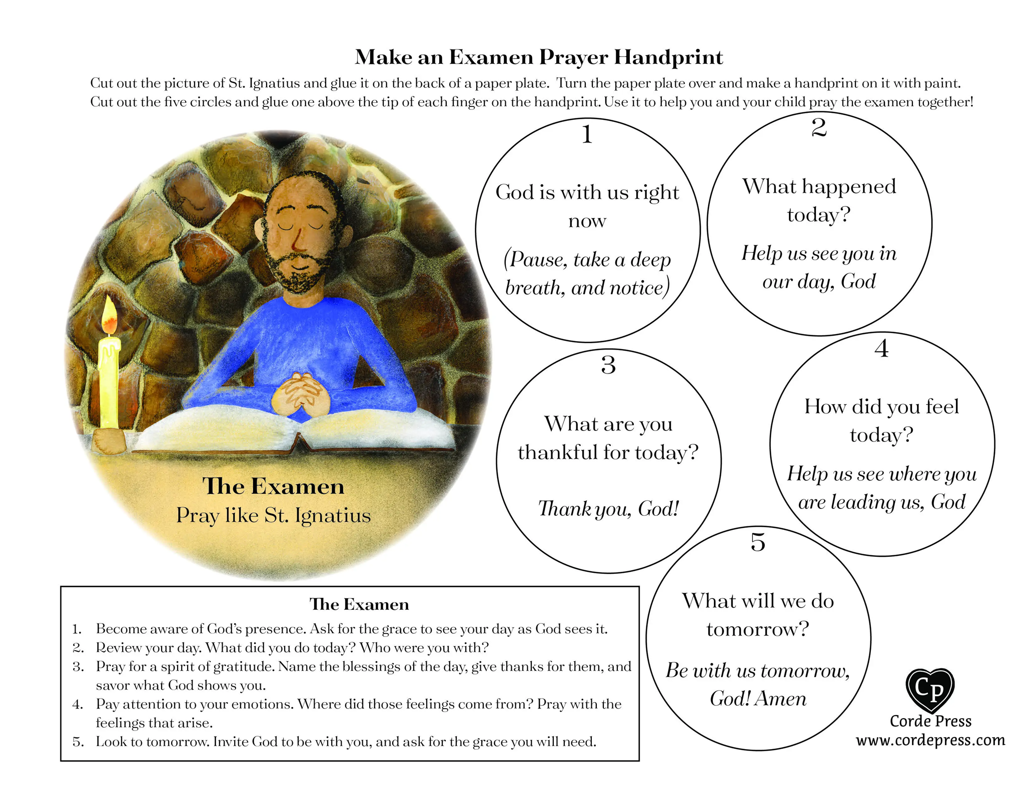 | https://www.youtube.com/watch?v=v6CRsw2gdcc  https://www.youtube.com/watch?v=b8WdyJHLUgg Call and response  OR DIOCESE new setting
Diversity Links | Those using the Alexandrian Rite, i.e., the Coptic Orthodox, Coptic Catholic, Ethiopian Orthodox, Ethiopian Catholic, Eritrean Orthodox, and Eritrean Catholic Churches, observe eight continuous weeks of fasting constituting three distinct consecutive fasting periods: a Pre-Lenten fast in preparation for Great Lent. | 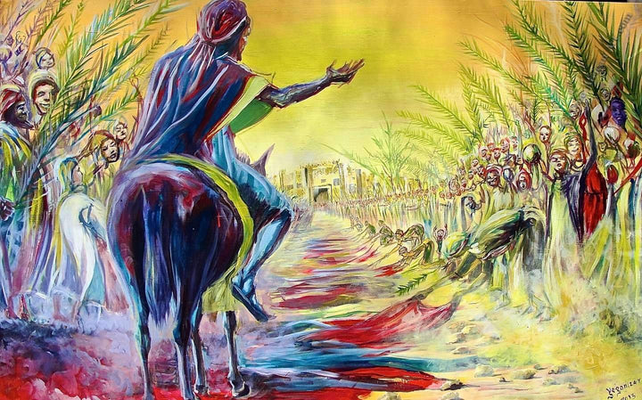Works of art by African Artists  Palm Sunday – by Evans Yegon |  |  | Know that the Kyrie Elison can be sung all the way around the world in one language – Greek  You could listen to it in from different cultural traditions.
Checking for understanding (summative assessment) | Exit Ticket: True or False?  Children are to be provided with statements about Lent and decide which ones are true or false. Discuss the answers for each response.  This could be completed as written questions or as a KAHOOT/Plickers/PowerPoint quiz.  - Lent lasts for 30 days, excluding Sundays. (F)  - The liturgical colour used in Lent is green. (F)  - Lent is a time of penitence, forgiveness and reconciliation. (T)  - Penitence means feeling sorry for our sins. (T)  - Catholics try not to pray so much during Lent. (F)  - Almsgiving means giving to those in need. (T)  - To observe ‘fasting’ in Lent, you can’t eat anything at all. (F – Giving up something you like)  - During Lent, we are thinking about the Sacrifice Jesus made for us to forgive our sins. (T) | Exit Ticket: Which painting do you prefer and why?  Show the images of the stories, including the painting of Palm Sunday by Evans Yegon. Children state a preference about which painting is their favourite and why. | Gather around a prayer focus area to quiet music. Children share the link they’ve made between the story of Jesus on the Cross and God’s forgiveness. |  | Exit Ticket: Explain what the words of the Kyrie Eleison mean. | Exit Ticket: Match the vocabulary to its definition.  Children are to match key words from the lesson with their definition to demonstrate their understanding: Examination of Conscience/Examen, Sacrament, Reconciliation, Act of Contrition, Penance, Forgiveness

LENT Term 2
Knowledge Lens | Lesson 7 | Lesson 8  HEAR  The angel’s message (Lk 24:1-8*) • Peter at the tomb (Lk 24:9-12) | Lesson 9(longer lesson)  BELIEVE/CELEBRATE  • The Easter Vigil Mass is the high point of the year and is rich in symbols of light and darkness.  Some simple words, actions, and symbols of the Easter Vigil, focusing on light and water. | Lesson 10  LIVE  The importance of saying sorry to God and to others. • That prayer can help people say sorry for their sins. • That making bad choices damages relationships and damages them.
Learning Focus | Consider peacebuilding works of art and use these as inspiration | Know and retell the story of the resurrection | Use religious words and phrases to talk about the symbols of light and water in the Easter Vigil Mass | Collective Worship Lesson ( no PP)
Recall and Retrieval | Name 3 ways we ask for forgiveness from God?  What does forgiveness mean to you? | What is lent? Which definition is the best.  A time for forgiveness and reconciliation. | What is the story from Palm Sunday to Easter Sunday.
Key Skills/disciplinary knowledge | D2.4.2. Considering some examples of reconciliation and peacebuilding in art, e.g., reconciliation outside Coventry Cathedral. | Looking at works of art to recall the story of Holy Week studied in the previous year. | U2.4.4. Correctly use religious words and phrases to talk about the symbols of light and water in the Easter Vigil Mass  D2.4.4. Talking about links between the symbols of light and water at the Easter Vigil and what the symbols remind them of, for example, the story of Creation, the Sacrament of Baptism or Advent | R2.4.1. Thinking about what forgiveness means to them. (RVE)  R2.4.2. Thinking about how making bad choices can harm themselves and others and why saying sorry matters. (RVE)  R2.4.3. Reflecting on how Jesus teaches people to forgive.
Sequence of knowledge throughout the lesson | Know that we can represent forgiveness and reconciliation through art which is a universal language. | Know the events of Palm Sunday, Maundy Thursday and the crucifixion of Jesus through art works studied  Retell in any form the story of the women at the tomb – Luke 24 1-8 and Peter at the tomb. | Know that the Easter vigil is held on the Saturday before Easter Sunday  Know that the Mass is a high point of the church’s year.  Know that the vigil starts in the dark (like creation)  Know that as the priest says Jesus is risen the congregation light the candles to illuminate the church – Jesus's is the light (like god gave light in the creation story)  Know that holy water is blessed in the Easter vigil  Know that water keeps us clean and washes away our sins – just like at our baptism.
Suggested Main teaching activity | - Set up the classroom as an art gallery of forgiveness and display different artistic impressions of the theme around the room. (Some examples added to the PowerPoint. Click on each image in the gallery to learn more about it.)  - Children circulate and look at each of the images. How does each one show forgiveness? Which one do they think best represents the theme of forgiveness? Why?  - Children are to use the artwork as inspiration for their own artwork/sculpture about reconciliation and peacebuilding. (This could be a painting, air dry clay sculpture, friendship/reconciliation bracelet with a sculpted charm made from FIMO/Polymer Clay). | SL -  - Jesus’ Life on Twitter to recap our journey over the last half term from ‘Desert to Garden’.  - Read the Scripture linked to the Resurrection of Jesus (The Angel’s Message Luke 24: 1-8; Peter at the Tomb Luke 24: 9-12).  - Discuss the Scripture with the children: How do you think the women felt before they went to the tomb? What did the angel have to tell them? What do you think the women said when they saw the disciples? What is Easter about?  - ‘Eyewitness’ Drama Activity: Split the class into groups for the different roles within the story e.g. angel, soldiers, women, Peter, disciples. Also choose a couple of children to be newsreaders/reporters. Give children time to discuss what each of them will say they have seen, heard or experienced based on the story of the Resurrection.  - Retell the story by interviewing the different groups of people. “Now, over at Golgotha, something amazing seems to have happened...”  “I’m here with a group of women who followed Jesus. Tell me, why were you here?”  “Now, these strapping centurions were guarding the tomb of Jesus to make sure it was not disturbed. Well, boys, did you notice anything unusual?” Etc  - Teachers may choose to ask children to write their retell of the story. The children’s role play could also be recorded/photographed for evidence. | The light reminds me of....  The water reminds me of....
Adaptive teaching |  | Small world play with the tomb and figures from the story.  Printable Resurrection Set (Religious Easter Craft For Kids!)
Challenge | Children create a ‘gallery plaque’ to be hung under a picture of their artwork/sculpture in their books to explain what it represents and what it is trying to communicate to people.  “In this piece…” | Make a link between the story of the Resurrection of Jesus and belief in forgiveness.
Key vocabulary and definition |  | tomb  Resurrection
Resources | 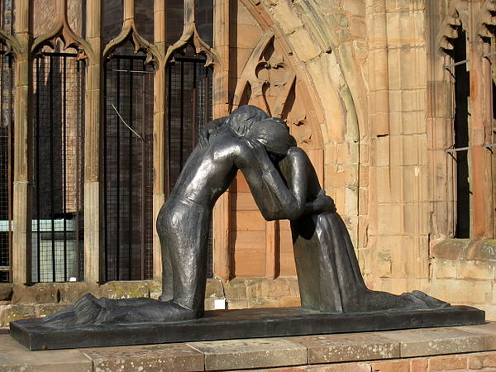 |  | https://request.org.uk/resource/festivals/holy-week-and-easter/easter-vigil/
Diversity Links | 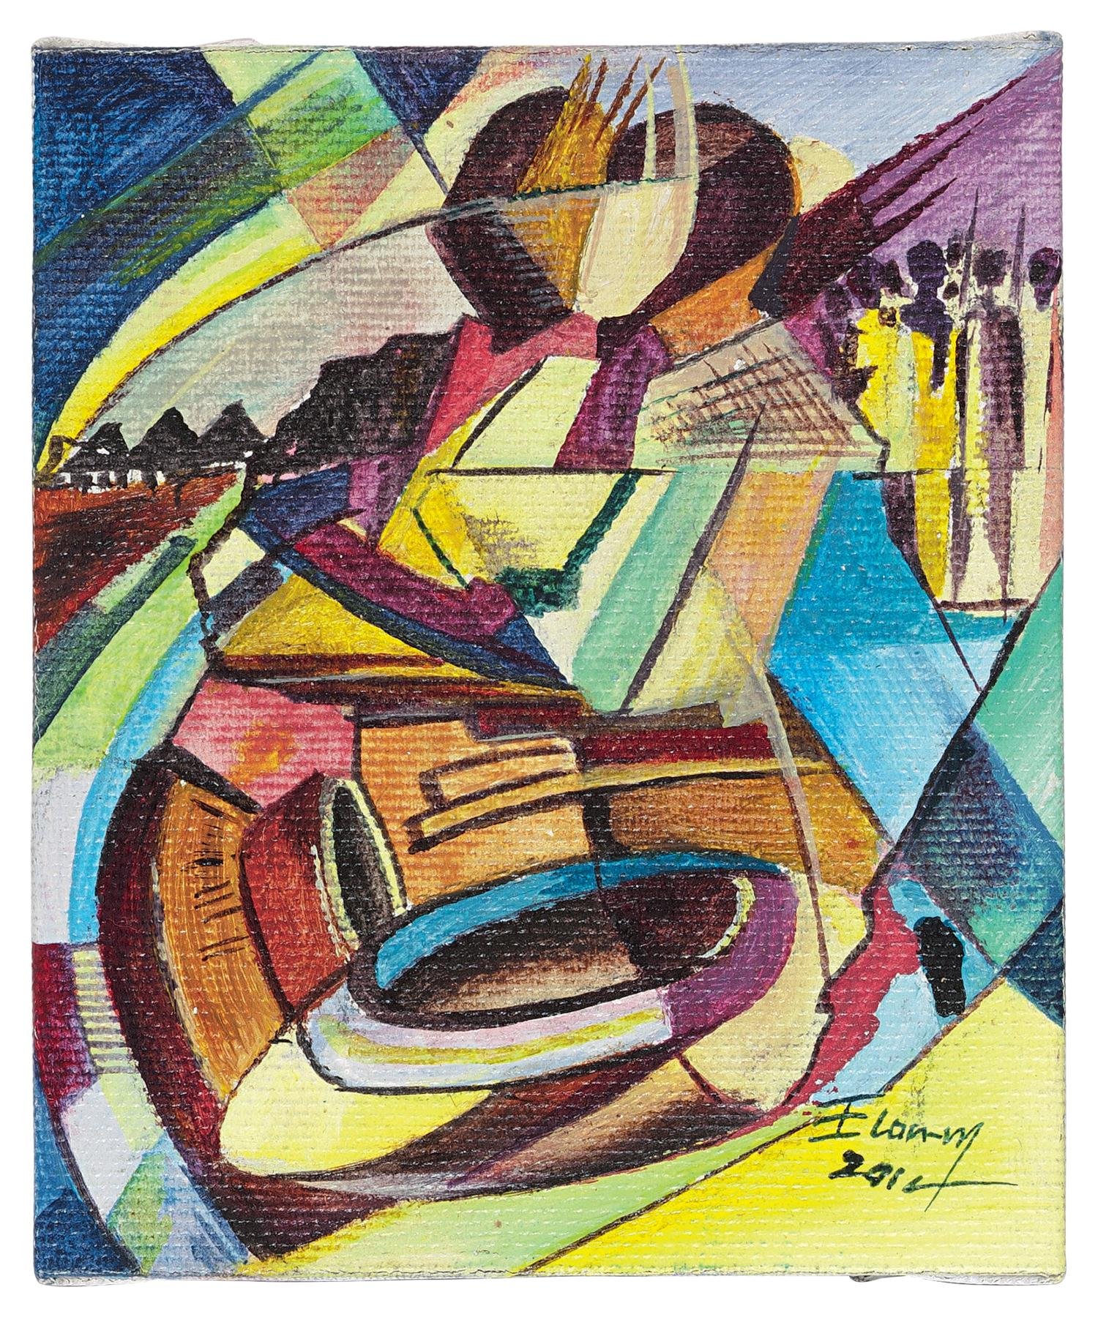
Checking for understanding (summative assessment) | Exit Ticket: Children create a ‘gallery plaque’ to be hung under a picture of their artwork in their books to explain what it represents and what it is trying to speak/communicate to people.  “In this piece…”

