Galilee to Jerusalem – Year 1


What I know and understand
U1.3.1 | Identify some of the people that encounter Jesus and recognise that he is special. | Pupil | Teacher
U1.3.2 | Retell, in any form, one of the stories they have heard, recognising these are religious accounts from the Gospel of Luke.
U1.3.3 | Make simple connections between Jesus’ announcement of his mission (Lk 4:16-19) and how Christians are called to tell people about God’s love today.
U1.3.4 | Ask and answer questions about the story of Zacchaeus and how he changed after meeting Jesus.
  How do you think it would feel to meet Jesus? Would meeting Jesus change you? Why? | Discern– Talk and think creatively about.
  How can you bring ‘light’ to your family and community? | Respond– Further thought and reflection, wonder moments.
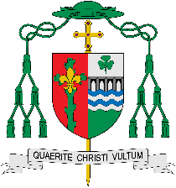  Make links to Encounter and Prayer or Pilgrims of Hope | Links to Diocesan themes – Encounter and Prayer or Pilgrims of Hope.
What do you wonder about?
I wonder…

