698Advent Term 2
Prophecy and Promise – Year 1
Age 6 Learning outcomes:
4. Encounter the story of the life of Jesus in an age-appropriate way and recognise what it reveals about Jesus (e.g., for Christians, the Christmas story reveals God’s love by sending Jesus his Son).
5. Be introduced to the Bible as a special book and encounter the stories and accounts of how people came to know God and the Good News of Jesus in the gospels.
6. Recall and retell, in any form, some of the scriptural stories and accounts studied.
7. Know that Mary is important for Christians because she said ‘Yes’ to God.
8. Recognise that angels bring God’s message and are a sign of the presence of God.
11. Make simple connections between words in Scripture and prayers Christians say today (e.g., the Hail Mary).

Understand
U1.2.1 Recognise that, for Christians, the Christmas story reveals God’s love by sending Jesus his Son.
U1.2.2 Be introduced to the Bible as a special book and encounter the stories and accounts of how people came to know God and the Good News of Jesus in the gospels
U1.2.3 Sequence the accounts from the Annunciation through to the visit of the shepherds
U1.2.4 Know that in the Annunciation God called Mary and she said ‘Yes’ to his call and why this makes Mary important for Christians.
U1.2.5 Match the first words of the Hail Mary with the words of the Angel Gabriel.
U1.2.6 Recognise that angels bring God’s message and are a sign that Jesus is the Son of God

Discern
D1.2.1 Talking about why the shepherds saw angels when Jesus was born.
D1.2.2 Thinking about why the words of the angels are in the ‘Hail Mary’ and the beginning of the ‘Gloria’.
D1.2.3 Exploring artistic representations of the nativity story from around the world. (RVE)

By age 6, pupils will be exposed to opportunities to think creatively and critically about what they have studied through art and music, drawing on the global Christian tradition. They will talk about what they have learned, exploring their learning through asking questions, wondering, and imagining. They may express their creative or critical reflections through different mediums, such as writing, poetry, art, music, or dance.

Respond
R1.2.1 Hearing and beginning to join in with the words of the Hail Mary.
R1.2.2 Singing or saying the first words of the Gloria
R1.2.3. Talking about how Christians in their local community celebrate the birth of Jesus. (RVE)

By age 6, pupils will be invited to share personal responses to what they have studied through personal reflection, sharing thoughts and ideas and listening to the views and opinions of others. They will spend reflective time to experience awe and wonder about what they have studied. Pupils will be invited to respond through individual or collective prayer, singing, or music. Pupils will think about how what they have studied has implications for their own lives and the lives of others locally and globally.

Big Question: | How does the Christmas story teach us about God’s love?
 | Session 1  Hear  Luke 1:2336 – 38 focus on 26-32,38 | Session 2  Believe  Hear Luke 1:23 36 – 38 focus on 26-32,38 | Session 3  Hear/ believe  Luke 1:39 - 45 | Session 4  Believe/ Celebrate | Session 5  Hear/ Believe
Learning Focus | Know why the stories in the bible are so special.  Understand | Know that in the annunciation God called Mary and she said ‘yes’ and this is why Mary is important to Christians. | Know the story of the Visitation and that it came after the Annunciation. | Know that the first words of the Hail Mary were said by the Angel Gabriel at the Annunciation.  Understand/ Discern | Know the story of Jesus’s birth.  Understand
Recall and Retrieval | What is the bible? (EYFS) | What do you know about the birth of Jesus? Pupils learnt about the annunciation in EYFS in basic form. | What was the annunciation? Why does it make Mary so special to us? | What have we learnt about before the birth of Jesus so far?  Who was Mary?  Who is Elizabeth?  What did they Angel Gabriel say? | What have we learnt about before the birth of Jesus so far?  Can you remember what happens next?
Sequence of knowledge throughout the lesson | Pupils will Know:  That the Bible is a special book that we encounter stories about how people get to know God.  U1.2.1 Recognise that, for Christians, the Christmas story reveals God’s love by sending Jesus his Son | Pupils will know:  The Story of the Annunciation  That God called Mary and she said Yes  That Mary is very special to Christians.  That Mary is diversely represented (celebrate)  8. Recognise that angels bring God’s message and are a sign of the presence of God. | Pupils will know  Story of the visitation  That the visitation happened after the annunciation.  That in the story, Elizabeths baby recognised that Mary’s baby was very special. | Pupils will know:  The Hail Mary, we pray with Mary when we need comfort  That the words of Gabriel can be matched up with the Hail Mary.  That the words of the angels are in the hail Mary  ( Elizabeth’s words are also in the Hail Mary- can they spot them? | Pupils will know  That Mary and Joseph travelled to Bethlehem for the census  That Mary was on a donkey  That they found it hard to find a place to sleep.  That an innkeeper suggested a stable  That Jesus was born and laid in a manger.  That this story is remembered and celebrated every year as Jesus is God’s only son.
Key Skills/disciplinary knowledge | U1.2.1 Recognise that, for Christians, the Christmas story reveals God’s love by sending Jesus his Son.  U1.2.2 Be introduced to the Bible as a special book and encounter the stories and accounts of how people came to know God and the Good News of Jesus in the gospels | U1.2.4 Know that in the Annunciation God called Mary and she said ‘Yes’ to his call and why this makes Mary important for Christians.  U1.2.3 Sequence the accounts from the Annunciation through to the visit of the shepherds  U1.2.6 Recognise that angels bring God’s message and are a sign of the presence of God. | U1.2.3 Sequence the accounts from the Annunciation through to the visit of the shepherds | U 1.2.5 Match the first words of the Hail Mary with the words of the Angel Gabriel.  D1.2.2 Thinking about why the words of the angels are in the ‘Hail Mary’ (and the Gloria). | U1.2.3 Sequence the accounts from the Annunciation through to the visit of the shepherds  U1.2.1 Recognise that, for Christians, the Christmas story reveals God’s love by sending Jesus his Son.
Main teaching activity  If the school has another short-term planning format, this does not need to be included. | Prayer should be the Hail Mary for the first few lessons mixed in with Gloria.  - What is the present? Discuss what it means (probably covered in History Y1). Get children to think about the past and what happened  - Children in circle: In middle - Show a range of Bibles and talk about the Bible – from prayer focus in class.  Enthrone Bible in the middle.  - Enthrone the Bible – discuss why it has been enthroned. This is a special book where we hear stories of how people came to know God and Good News of Jesus.  - Discuss – what stories do we know from the Bible? Play the ‘Ping Pong’ game. Highlight some of these at the end about how we come to know God.  - Show images of the Gospel writers: discuss who they are and why they are important. We learn about Jesus’ birth... Christmas.  - Talk about how this reveals God’s love for us by sending his son Jesus. Listen and reflect on ‘Love Shone down’ - learn song.  - Start a timeline on the classroom working wall.  Matching activity: Bible stories and their titles.  Image to put on the timeline for display | OLOL Schools could link this to the CMATs motto – Have the Courage to say yes to God? Use logo etc?  - Images on the table/on the screen. What does it show? What do you wonder? Children to write down questions they have. Discuss any links between the pictures? What is in all the images?  - Listen to the Annunciation story from the Bible– mini Lectio Divina/Christian Meditation. (Luke 1:26-32, 38)  - Children to then have the Scripture in front of them.  Find answers – who visited Mary?  - What did the angel say? What did God want Mary to do?  - What did Mary say? YES. Discuss how difficult it must have been to have said yes. Talk about this being very brave and courageous of her. She is very special... why? She chose to say YES to be the Mother of the Son of God.  - Mary – the Mother of Jesus and the Mother of all of us.  - Act out: freeze frame the Angel Gabriel visiting Mary and the response of Our Lady (take pictures).  Write a prayer to Mary...  Thank you Mary, you are special to me because...  Create own angel decoration: hand print or paper plate  Add the Annunciation to the Timeline | Image to put on the timeline display  No written outcome for this – needed to sequence the story but doesn’t come under understand...?  - Revisit the Annunciation from the previous lesson on the timeline and why Mary is so important and so special to Christians. Ask children what they think happened next?  - Share some of the prayers from the children to Our Lady.  - Explain the importance of knowing about these stories from the Bible.  - Show images of the visitation and discuss what they think is happening. What is similar in all the pictures? What do you think is being said?  - Read the story of the Visitation to the children from the Bible text: Luke 1:39-45  - Answer key questions to support children’s understanding of this story.  Use stick puppets or act out the visitation in groups.  Children complete speech bubbles of what Mary said to Elizabeth.  End the lesson with a discussion about how we prepare for Jesus to come. Mary would have now had to prepare for Jesus – how do we! Christmas Advent Calendar, Advent Wreath in school and church counting the weeks, Christmas tree, Christmas decorations.  Add the Visitation image to the Timeline. | Sign hail Mary – Class match up  Talk about WHY the words are there....  - What does trust mean? Play a trust game – blind fold and stepping over things/putting hand into bag. Explain we are trusting... Mary putting trust in God  - Listen to/join in with the sign language of the Hail Mary and watch the ‘Hail Mary’ by Mike Stanley.  - At tables, children have the Hail Mary prayer in BIG and jumbled. Listen again to the Hail Mary, children to work in groups to put into the correct order.  - Share the Scripture of the Annunciation again. What do you notice? Can children identify the Angel Gabriel’s words in the Hail Mary.  - Share the words of Angel Gabriel on the table, children to match this with the Hail Mary.  - Discuss why the words have been put in there – sharing how important Mary is, she is full of grace and God is with her, He has chosen her for this special job.  Learn the Hail Mary with Sign language as a class.  Draw picture of Our Lady and write the key words from the first lines around the picture.  Create a video of the children sharing the Hail Mary, this could be shared in assembly with the school. | - Discuss what the special book for Christians is called again. Remember that through the Bible we encounter stories about how people came to know God, and all about Jesus in the Gospels.  - Discuss again the four Gospels.  - Display the word ‘Christmas’. Ask children to discuss what they think this means.  - If possible, use a nativity scene (or pictures) and display each part one at a time – the word ‘Bethlehem’, the stable, the star, the animals, Mary, Joseph, manger. Jesus.  - Using Christian Meditation or Lectio style, read the Scripture to the children (Luke 2:4-8) - focus on which words and phrases stand out to the children.  - Use Godly Play Script to act out the Nativity.  - Share the song ‘Casting Crown’ (see resources) and spend some time quietly listening.  - Children to discuss how they may have felt, what they might have said, what they may have thought (use an an extension). Teacher make note.  - Model a story map style to retell the story of the Nativity.  Children to complete a storyboard (differentiated) of the Nativity.
Adaptive teaching | Group activity of the matching game. | Verbal response and writing. |  | Working in groups with more able. | Stick down the pictures in the correct order.
Challenge | Write a sentence to say how we get to know God in the story. | Why was it important for Mary to say yes? |  | Extend further with finding the words from the Visitation in the Hail Mary. | Blank story board to draw pictures and add sentences.
Key vocabulary and definition | Jesus  Bible  Annunciation  Angels  Visitation  Hail Mary  Gloria | Annunciation  Angel Gabriel  Baby  God | Visitation  Special | Hail Mary  Angel Gabriel  Hail...  Trust | Nativity  Jesus  Mary  Joseph  Inn  Bethlehem
Resources | Love Shone Down – song  Love Shone Down by Boyce & Stanley // LYRIC VIDEO - YouTube | The angel Gabriel from Heaven came  The Angel Gabriel from Heaven Came (youtube.com) | Hail Mary:  Hail Mary || Signing Video (youtube.com) | Hail Mary:  Hail Mary || Signing Video (youtube.com) | Casting Crowns - Make Room (Official Music Video) ft. Matt Maher (youtube.com)
Diversity Links |  | Diverse Representations of Mary. Use of images from around the world showing the Annunciation. | Use of art work with diverse representation to show the visitation
Checking for understanding (summative assessment) | DO the pupils know that the bible is a special book that tells us about God’s love?  Do the pupils know that the Christmas story tells us of God’s love | Can the children retell the story of the annunciation? | Can the children know the story of the visitation? | Can the pupils recognise that the words angel Gabriel said are the first lines in the Hail Mary? | Can the pupils retell the story of Jesus’ birth?

Advent Term 2
Prophecy and Promise
Year 2
 | Session 6  Live | Session 7  Hear/Believe/Celebrate | Session 8  Believe | Session 9  Knowledge Capture | Session 10  Celebrate
Learning Focus | know that the nativity can be represented in many ways.  Discern/ Respond | know why the angels came to see the shepherds  Understand/Discern | know that the angels message to the shepherds is used in the Gloria.  Understand/ Respond | Know the sequence of stories from the annunciation to the visit from the shepherds  Understand | Respond
Recall and Retrieval | What can you remember from the story of Jesus’ birth? | What can you remember of the story so far – ordering the pictures from a selection. | Who visited the shepherds in the field? What did they say? | Retrieve the learning so far using the images. | How have we been preparing for Jesus’ birth? What have we been doing on school?
Sequence of knowledge throughout the lesson | - Know the story of the night of Jesus’ birth  - Know that different cultures and different artist represent this differently.  - Know that the scriptures tell us that Jesus was born in a stable but we don’t exactly know what this looked liked as it was so long ago. | - Know that in Lukes Gospel, Shepherds visited Jesus.  - Know that the angels bring God’s messages and are a sign of the presence of God.  - Know the words that the Angels said to the Shepherds. | - Know the story of the angels visiting the shepherds with greater confidence.  - Know that the words of the angels are still important to us today.  - Know that the angels' words create the first few lines of the Gloria, and we say these in Mass.  - ( know that in Latin we say Gloria in Gloria in Excelsis Deo “Gloria in Excelsis Deo” is a Latin phrase that translates to “Glory to God in the highest”. It is a Christian hymn also known as the Greater Doxology, the Angelic Hymn, or the Hymn of the Angels. The phrase is often abbreviated to “Gloria in Excelsis” or simply “Gloria” | - Pupils will show knowledge of the story order and events from the annunciation to the Shepherds,  - Some children will just be able to order the pictures. Most children will be able to paraphrase the story. Some children will remember the words that were said by the Angels and that Mary said yes. | Know how we have prepared for Christmas as a school.  Know how Christian people prepare locally for Christmas  Reflect on the story of the birth of Jesus.  Reflect on the big question.
Key Skills/disciplinary knowledge | D1.2.3 Exploring artistic representations of the nativity story from around the world. (RVE) | U1.2.6 Recognise that angels bring God’s message and are a sign that Jesus is the Son of God  D1.2.1 Talking about why the shepherds saw angels when Jesus was born.  D1.2.2 Thinking about why the words of the angels are in the ‘Hail Mary | D1.2.2 Thinking about why the words of the angels are in the ‘Hail Mary’ and the beginning of the ‘Gloria’.  R1.2.2 Singing or saying the first words of the Gloria | U1.2.3 Sequence the accounts from the Annunciation through to the visit of the shepherds | R1.2.3. Talking about how Christians in their local community celebrate the birth of Jesus. (RVE)
Main teaching activity  If the school has another short-term planning format, this does not need to be included. | - Begin by reiterating and sharing the story from Luke’s Gospel again. Ask children to discuss who we heard about and what happened.  - Explain again about the Bible being a special book where we heard and encounter the stories about how people encountered God and about Jesus.  - Look at the first artwork (Jen Norton) – who can you see? What can you see? How does it make you feel? What is happening? How do you think they feel? Why? What do you think might be being said? (Use backing music to help with the atmosphere)  - Look at the other pieces of art (could be done in carousel) – use key questions to focus discussion. Discuss how the artwork shows different representations.  Note down the key figures in the pictures (note to save confusion, if other artworks are selected to go with an art unit ensure that the kings are not in the pictures as concentrating on Luke’s Gospel).  Pupils to create their own artwork depicting the nativity scene using a media of the teacher's choice.  Teacher could decide to create a larger class artwork created by the children in various styles and use this as display in the hall? | - Begin by thanking God for Jesus –reflect on why God sent him. Place this on the prayer focus/around the manger.  - Children in groups, have in envelopes... special mission – use the images: ask children to see if they can put these into order  FreeBibleimages :: Shepherds hear of the birth of Jesus :: Angels announce the birth of Jesus to shepherds (Luke 2:8-20)  - Who can you see in these images? Name them...  - Another envelope at the front – gold if possible – does it look special?!  - Open the envelope and share (the words of the angels). Discuss what they think it might be and who said them? Why? Reflect on the angels saying these words and WHY the shepherds saw them.  - Share the Scripture reading together (Luke 2:8-20).  - Messengers – explain that the angels are messengers of God and they are a sign that Jesus is the Son of God.  - Look again at the words that the Angels spoke (from your Gold envelope). Where do we hear this?  Create their own messages as the Angels to the Shepherds: highlight – I am a messenger of God, I come to bring you good news that Jesus, the Son of God is born.  Add the Visit to the Shepherds to the class timeline. | - Set the classroom up like a party (include balloons)  - Begin with sharing Good News – how does it make you feel? Happy – children to share times when they have felt happy? How might we show it? Discuss.  - Share together: either - The Clapping Gloria - Christmas version (youtube.com)  - Clapping Gloria - Mike Anderson - original version (youtube.com)  - Ask children to listen carefully to the words, where have we heard this?  - Repeat the words that were said in the Scripture. What were the Angels doing? They were celebrating! They were glorifying God’s name... they were praising him.  - Share the Gloria from Mass and explain that we share in the Angel’s praise during the Mass too. Discuss the meaning (see Lesson sequence about Latin/Greek orthodox)  - Learn some of the song together. Recap the words of the Gloria and begin to learn them.  - Reiterate how happy the Angels were that Jesus was born and shows that Jesus is the Son of God.  - Reflect again on times when we have been happy. Share that we are happy that Jesus was born into our world.  - Share thankyou prayers verbally.  Children to have balloon shapes – Can they write the first lines of the Angels Message? On the back, write a thank you for God for sending Jesus into our world (like the Angels with their message) | Use images from lessons to annotate , verbally tell/ order the whole story in Lukes Gospel  His could be completed on a comic strip with extra boxes underneath for added detail?  - Return to exploring the Bible. Children to offer thanks – Jesus loves me, for the Bible tells me so’.  - Look at the timeline in the classroom and ask children to talk through what happens in the Bible story according to Luke.  - As a class, retell the story –Annunciation, Visitation, Birth of Jesus, Visit of the Shepherds (with angels).  - At each part – talk through how people must have felt at this time and how it built up our excitement for Jesus coming into the world. Express how important Mary is for saying yes, without her saying yes we would not have had Jesus!  - Discuss the Hail Mary and Gloria – where do we find these prayers in our story – highlight.  Children to have images from the story – children to create a story map of what happened – sequencing the story.  LA – Sequence and use labels.  Most – Sequence the images, write a sentence for each of the parts of the story.  AA – Ensure they have added in words from Hail Mary, Gloria. | Celebration of the word – Respond booklets – will these be the activity here?  - Show images/website of your parish community and the celebrations in the lead up and over Christmas.  - Discuss and share what your school does over Christmas period.  - Discuss how we prepare for the coming of Jesus in our homes again: Advent Calendar, Christmas Tree, Nativity scene (with no Jesus in), Advent wreath.  - Explain that we do this so that we are getting ready excitedly for the coming of Jesus into our world.  - Discuss the Big Question from the start of the unit: children have an opportunity to write their responses/draw pictures to their big questions after the discussion. Think about Jesus as the Son of God, God sent his Son to show how much He loves us. Jesus came into this world so as to teach us how to live a good life, to teach us about God, to save us so we can go to Heaven... God did this for us.  - Work as a class to create the celebration of the word (Elaine Arundell document useful for this)
Scaffolding | Support in discussions at the tables. | Fill in the missing words for the speech. | Use the words to put together in order. | Sequence the pictures and match the labels. | Verbal responses for the big question.
Challenge | Have ‘I wonder’ sheets on the table for children to ask their own wondering questions. | Extension of: Which words do we find in the Hail Mary? Why do you think they are there? | Why do you think we say the Gloria in Mass?  Children to write their own prayers of praise and glory on the back of their balloon. | Simple sentences to explain each part, including the Hail Mary and Gloria. | Key words that need to be included:  Mary, Hail Mary, Gloria
Key vocabulary and definition | Nativity  Jesus  Mary  Joseph  Inn  Bethlehem | Shepherds  Angels  Messengers  Son of God  Saviour | Angels  Messengers  Son of God  Saviour  Gloria | Bible  Annunciation  Visitation  Hail Mary  Gloria  Nativity  Jesus  Love  Shepherds  Angels
Resources | 1. https://www.jennortonartstudio.com/away-in-a-manger-with-father-and-son/jn797_josephsmoment/  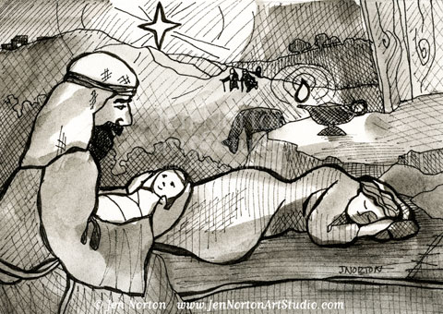  2. https://thethousandmiler.com/visit-one-of-the-worlds-largest-nativity-collections/ African  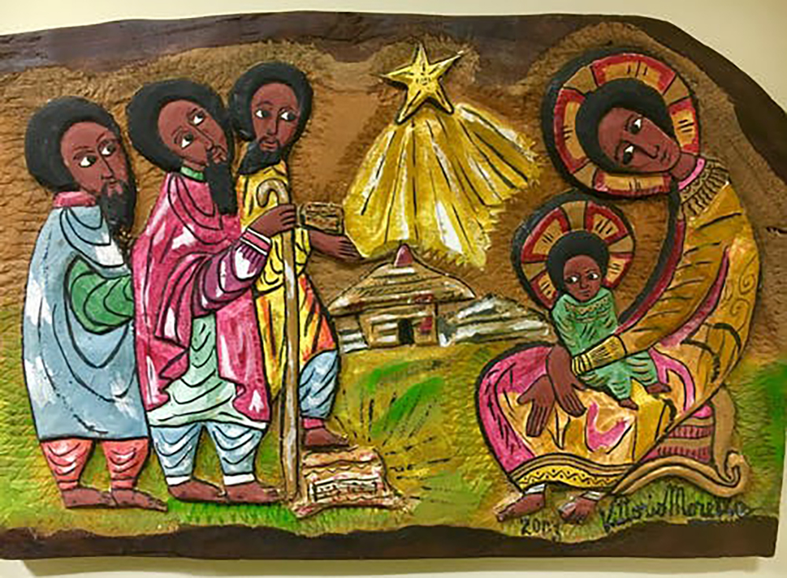  3.  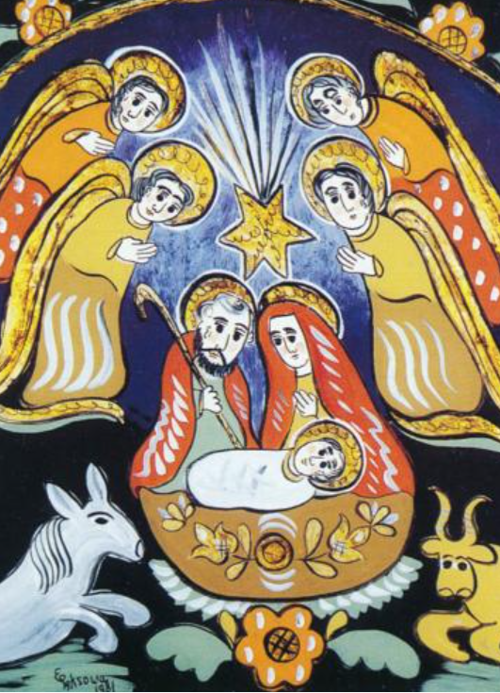  https://culture.pl/en/article/8-christmassy-paintings-from-poland  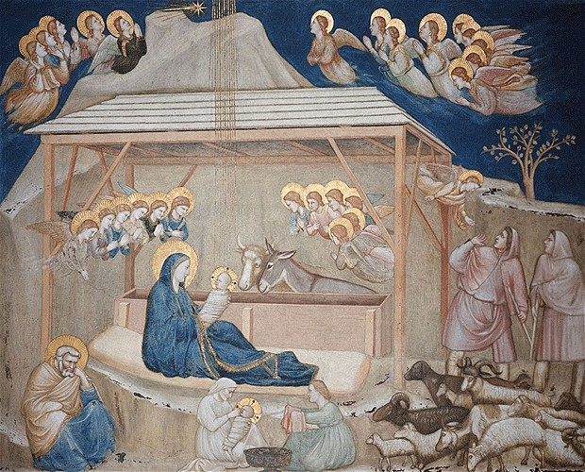Giotto di Bondone, Nativity Scene in the Lower Church of San Francesco d’Assisi (1304 und 1306)  http://the-creative-business.com/24-famous-paintings-nativity/ | https://www.bbc.co.uk/bitesize/guides/zvxtgwx/revision/5  https://www.freebibleimages.org/illustrations/christmas-shepherds/ Images of the scripture  While Shepherds watch their flocks by night.  While Shepherds Watched their flocks by night | Christmas Carol | Emmaus Music (youtube.com) | The Clapping Gloria - Christmas version (youtube.com)  Clapping Gloria - Mike Anderson - original version (youtube.com)
Diversity Links | Diverse representations of the nativity scene - English, African, Polish and Italian artworks. | Images used from different cultural backgrounds. | Glorias from around the world
Checking for understanding (summative assessment) | Do the pupils understand that the nativity scene can be represented differently. | Do children recognise that the Angels are messengers sent by God? Can children express that the Angels were sent to show Jesus is the Son of God? | Can children recognise that the Gloria is formed from the Angels’ message to the Shepherds? Do children know that the Gloria is said in Mass? | Do the pupils know the sequence of the story from the Anunciation to the Shepherds visit? | Can children recognise that God sends his love by sending Jesus his only Son?  Do children know that Jesus is God’s gift to our world?

