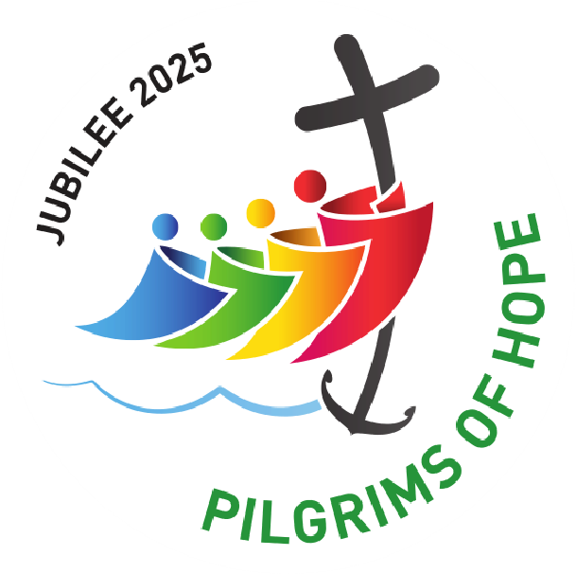
Jubilee 2025
I N T H E D I O C E S E O F N O T T I N G H A M

5th November 2023

Although the Jubilee is being celebrated in 2025, the Holy Father Pope Francis has asked for two years of preparation before the Jubilee Year itself. The first of these is coming to a close: 2023 has been a year dedicated to revisiting afresh the fruits of the Second Vatican Council, and the four great constitutions in particular. Alongside resources provided by the Bishops’ Conference of England and Wales, Nottingham Deanery has taken a lead in organising speakers to present talks about Dei Verbum, Sacrosanctum Concilium, Gaudium et Spes, and Lumen Gentium. These are all available on the diocesan website.

The coming three years will form a tripos of celebrations around the Jubilee, tying-in with the diocesan Spiritual Themes as well as the celebrations across the Universal Church. Bishop Patrick asked the entire Diocese of Nottingham to consider the three Themes back in November 2018, and since then they have been well established in a pattern of Encounter in the Advent Term; Discipleship in the Lent Term; and Missionary Discipleship in the Pentecost Term.

From Advent 2023 the focus will be changed slightly to align with the Jubilee, so that there is a whole year of Encounter in 2024, to tie-in with the Year of Preparation focusing on Prayer in its many forms. The Jubilee Year 2025 will be a whole year of Discipleship, looking at some of the themes of the Year including care for creation, food poverty, modern slavery, cancelling debt, forgiveness, and rest & worship. The following year will look at Missionary Discipleship, as a thanksgiving for the Jubilee, and a response-in-action to the blessing and graces received during the Jubilee: we will be encouraged afresh to be those Missionary Disciples which is God’s gift to us at our baptism.

Since the ‘Years’ don’t quite align with the calendar years, the three Spiritual Themes will begin and end to coincide with the Jubilee, so that:
- Year of Preparation & Prayer – Encounter – First Sunday of Advent (3rd December 2023) – Christmas Eve morning (24th December 2024);
- Year of Jubilee 2025 – Discipleship – Christmas Eve evening (24th December 2024) – Epiphany (6th January 2026);
- Year of Thanksgiving – Missionary Discipleship – Post-Epiphany (7th January 2026) – end of ordinary time (28th November 2026).
Alongside the resources already available for each of the Spiritual Themes, the diocese will be providing other resources as each Year unfolds.

Father Simon Gillespie
Diocesan Jubilee Co-Ordinator 07760 372105 / simon.gillespie@dioceseofnottingham.uk

