Year 6
Advent term 1
Curriculum Newsletter
English | Narrative writing based around the text Holes  Biography about Winston Churchill
Maths | Place value  Four operations  Fractions  Converting Units
RE | Creation and Covenant  Other Faiths - Judaism
Science | Electricity  Animals, including humans
Computing | Communication & Collaboration  Creating Media - Web Pages
History | Beyond 1066  Local history study - how did conflict change our locality in World War 2
Design technology | Drawing Block A
Art | Drawing Painting and Collage
Music | Ostinato
French | Habitats
PE | Tag rugby  Gymnastics
RSHE | Care for our common home  Calming the storm  Gifts and talents  Girls’ Bodies  Boys’ Bodies  Spots and sleep  Body image  Peculiar feelings  Emotional changes  Seeing Stuff online  Making Babies Part 1

Meet the Teacher Notes

Our weekly lesson timetable is as follows:
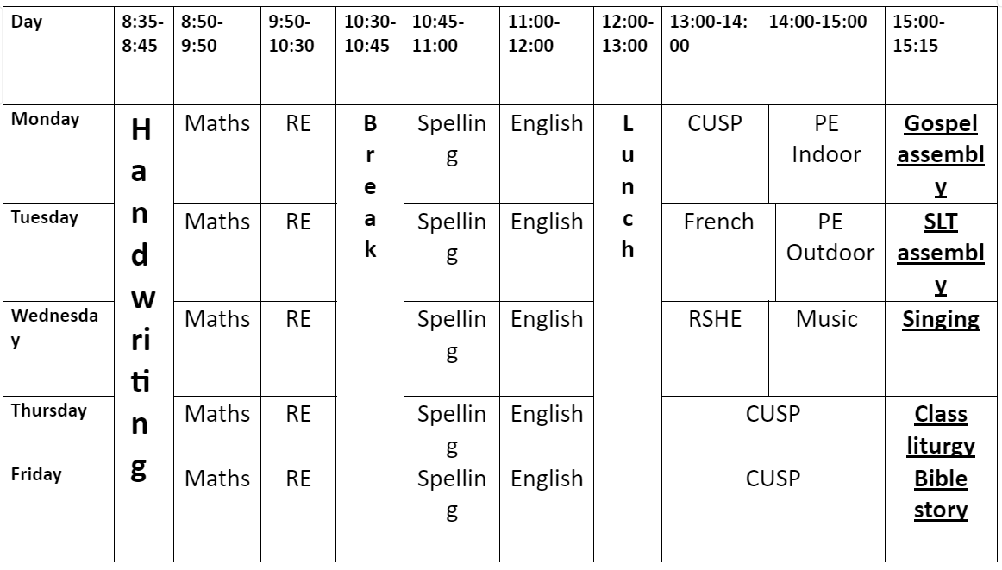
- Our behaviour policy is the same with demonstrating tick behaviours and correcting cross behaviours throughout the day to grow into responsible citizens.
- Children will still be working towards their learners code to achieve bronze, silver or gold level.
Personal organisers have lots of useful information:
- Attendance values
- Rainbow grammar support for children
- Matsh support
- It is the responsibility of children to read x3 weekly and to get parents to sign confirmation.

PE Expectations
- Days are Monday & Tuesday
- Children are to bring kit to change into.

Homework
- Reading 3x a week with parent/guardian signature.
- Math – fluency practice.
- English – comprehension and grammar preparation
- TTRS 20 mins per week (5 mins a day)

SATs are 11th May 2026 – Monday – Thursday.
Swimming will be Term 6
PGL School Trip
- PGL Caythorpe - June 16th -18th 2025
- Letters to follow soon

