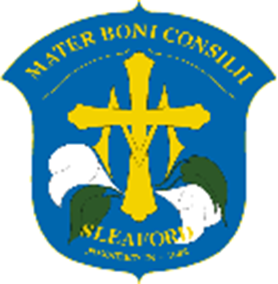

**Our Lady of Good Counsel Catholic Primary School**

**“Loving, Living, Learning in the Light of Christ.”**

**French Education Intent**

**Intent**

Our intent is for the French curriculum is that children will develop an enthusiasm for learning a new language and the skills it has to offer irrespective of their background and starting points. That they will understand the culture in France, learning about well-known festivals and celebrations. That they will understand the world around them, stimulating their curiosity about other languages. To support the learning of French we will use the ‘Language Angels’ curriculum.

**Implementation**

Throughout Key Stage 2, at Our Lady’s school, we follow and adapt the curriculum of ‘Language Angels’. This is supported by the requirements of the National Curriculum and is approved by the Department for Education.

Children receive 1 hour of their curriculum time spent learning French each week. It is recommended Key Stage 2 pupils should receive at least 30 minutes of Foreign Language teaching per week. As they move further up Key Stage 2, they build on key words adopted and begin applying these into full sentences.

Early language teaching – used to introduce the French language. Topics from early language teaching are taught across LKS2.

Intermediate teaching – used to begin developing the French language. Topics from intermediate teaching are taught across UKS2.

Progressive teaching – used to prepare pupils with the skills to go further in their educational life. Topics from progressive teaching are taught in Year 6.

**Impact**

The French curriculum at Our Lady’s school presents an ambition for high achievement, providing children with the skills to pursue a foreign language further during their time in education irrespective of their background and starting points. Both a combination of formative and summative assessments are used to measure the impact and progress of French in our school.

Children at Our Lady of Good Counsel Primary School will:

* Develop their oracy skills, being provided with opportunities to speak a different language.
* Progress their listening skills, as they listen and reflect on the pronunciation of newly learnt vocabulary.
* Show awareness for cultural differences and similarities.
* Spark a curiosity for learning a new language.
* Have evidence of new vocabulary learnt through a range of speaking, reading, listening and writing tasks, all tailored to individual needs.
* Gain the skill of a new language through a range of teaching topics, all finding something that excites and motivates them.