Science Year 6 Medium Term Planning – Lent 1: Light
National Curriculum
recognise that light appears to travel in straight lines
• use the idea that light travels in straight lines to explain that objects are seen because they give out or reflect light into the eye
• explain that we see things because light travels from light sources to our eyes or from light sources to objects and then to our eyes
• use the idea that light travels in straight lines to explain why shadows have the same shape as the objects that cast them
Prior vocabulary knowledge
reflect absence, presence transparent, translucent, opaque visible
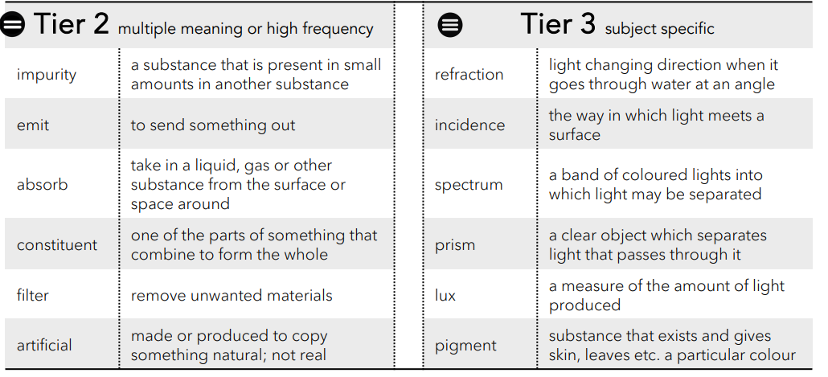
 | Lesson 1 | Lesson 2 | Lesson 3 | Lesson 4 | Lesson 5 | Lesson 6
Learning intention | How does light travel? | ENRICHMENT  What colour is light made of? | Reflection - how does light help us to see objects? | Which surfaces make the best reflectors? | ENRICHMENT  Why do we see objects as a particular colour? | What happens to the appearance of objects when placed in water?
Working Scientifically |  |  |  | Investigation: Darkened classroom |  | observe, record,
Recall and retrieval | 1-5 | 6-9 | 10-13 | 14-16 | 17-19 | 20-21
Sequence of knowledge throughout the lesson | light ONLY travels in straight lines example: sunlight through clouds.  To know that shadows are formed in the absence of light.  To know shadows have the same shape as the object that cast them and shadows are formed when an object blocks the path of light. Working scientifically: This is incorrect “A shadow is a reflection.”  To use scientific knowledge about light to explain why this is incorrect and Prove it. | To know what white light is made from and an acronym to remember the colours.  To investigate:  To know dispersion is white light being split into its constituent parts through investigations.  To know that in 1671 Sir Isaac Newton described visible spectrum of light.  To know how to use a Newton colour wheel to observe what happens to the colours as they spin? |  To explain if this happens with just primary colours.  TO investigate, observe and explain what happens if a spinner just has two colours. | To know that light travels in straight lines.  To know that a mirror is a smooth surface.  To know that the angle that light hits the mirror (angle of incidence) is the same as it leaves the mirror (angle of reflection). Working scientifically TEST IT  To know what happens when an object is placed where it can be seen in a mirror. To know how to measure the angle of incidence and reflection using a protractor.  To know how to record observations.  To know how to record observations of what happens if you move and the object stays in the same place. | To know an investigation has controlled elements which do not change: light meter, torch, set distance.  To know what an independent variable is  • use a mirror as a standard measurement •record the units of Lux on the light meter or describe the brightness on the card.  To know how to select a range of materials to test reflectivity.  To know how to set up and record the dependent variable: measure the change in reflection.  To know how to record results.  To know how to record the influence of shiny or dull / smooth or rough materials.  To know how to record observations. | To know a pigment is the colour of a material.  To know that a material that has a blue (or other colours) pigment absorbs all other colours in the visible spectrum.  To know that blue light is the only colour reflected.  To know that is how we see the colour blue.  Working scientifically  I know how to use colour filters  I know how to use my knowledge about colours to explain why filters only allow certain colours.  To explain what happens when mix coloured filters are used. | Working scientifically To observe and accurately draw a pencil standing in a glass.  To observe changes to the appearance of the pencil when water is added to the glasschanges and to accurately record observations through drawings.  To know what refraction is and that it occurs because (liquid) is denser than air (gas) and light slows down when it enters water and changes direction (but does not bend)  To know that light carries on in a new straight line in water (liquid) refracted ray and air (gas) incidence ray.
Scaffolding | Scaffolded steps. | stem sentence to explain what is observed when spinning a Newton colour wheel. | Stem sentences to be completed. | Word mat for descriptions. | simple colour filter investigation. | To label the changes using scientific vocabulary.
Challenge | To explain why it is incorrect and explain correctly how shadows are formed. | To explain what we see and why when spinning the Newton colour wheel. | To explain what happens if the object is moved and the investigator stays in the same place. | To explain uses for most reflective materials. | To explain what happens when 2 colour filters are used. | To label refracted and incidence rays.
Vocabulary  Tier 2 | Impurity  Emmit  Absorb  Constituent  Filter  Artificial | Impurity  Emmit  Absorb  Constituent  Filter  Artificial | Impurity  Emmit  Absorb  Constituent  Filter  Artificial | Impurity  Emmit  Absorb  Constituent  Filter  Artificial | Impurity  Emmit  Absorb  Constituent  Filter  Artificial | Impurity  Emmit  Absorb  Constituent  Filter  Artificial
Vocabulary  Tier 3 | Refraction  Incidence  Spectrum  Prism  Lux  Pigment | Refraction  Incidence  Spectrum  Prism  Lux  Pigment | Refraction  Incidence  Spectrum  Prism  Lux  Pigment | Refraction  Incidence  Spectrum  Prism  Lux  Pigment | Refraction  Incidence  Spectrum  Prism  Lux  Pigment | Refraction  Incidence  Spectrum  Prism  Lux  Pigment

