Science Year 5 Medium Term Planning – Lent 1: Forces and gravity
National Curriculum
explain that unsupported objects fall towards the Earth because of the force of gravity acting between the Earth and the falling object
• identify the effects of air resistance, water resistance and friction, that act between moving surfaces
• recognise that some mechanisms including levers, pulleys and gears allow a smaller force to have a greater effect
Prior vocabulary knowledge
force magnetism, attract, repel friction, resistance
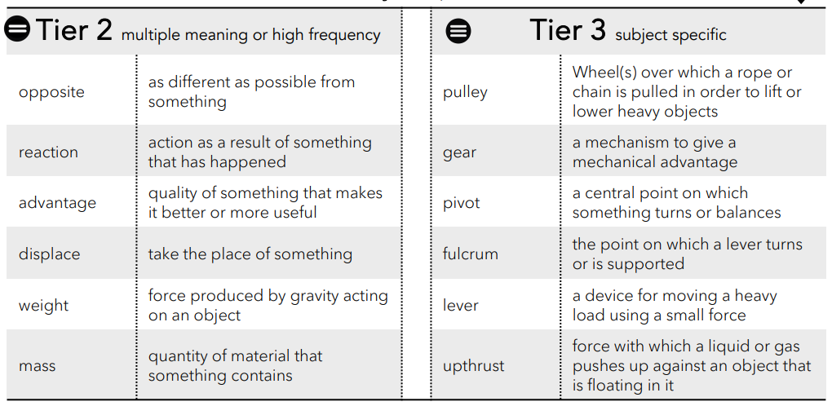
 | Lesson 1 | Lesson 2 | Lesson 3 | Lesson 4 | Lesson 5 | Lesson 6
Learning intention | When is friction helpful and when is it not?  (Year3) | What’s the effect of air resistance? | What’s the effect of water resistance? | ENRICHMENT  Who was Galileo Galilei? | How do levers help us? | How do pulleys and gears help us?  Sir Isaac Newton questions ( Retrieval KS1 History)
Working Scientifically | Investigate, observe, record, explain.
Recall and retrieval | 1-2 | 3-5 | 6-7 | 8-11 | 12-14 | 15-20
Sequence of knowledge throughout the lesson | To know what friction is and examples of when it is helpful and unhelpful.  Working scientifically: TEST FRICTION:using chopsticks, move cubes of jelly from one board to another Now cover the jelly cubes in cooking oil and repeat the test. How has the oil changed the effect of friction? | To know that air resistance is a type of friction that opposes the movement of an object through the air.  To know factors that affect air resistance  surface area  speed  WORKING SCIENTIFICALLY To investigate air resistance:  To know what air resistance feels like.  To describe what you notice, what you feel?  To know how the increase of speed affects air resistance.  To know what happens if the surface area is reduced.  To know how to control variables and record results. | To know that water resistance occurs when an object moves (pushes) through water.  To know that upthrust is a force that acts upwards on objects in liquid or gas.  To know that the shape of the object changes the amount of water it displaces more liquid or gas displaced | more upthrust  Working scientifically To know how to plan and test the hypothesis: The same piece of Plasticine can sink and float.  Define Controlled variable  Choose Independent variable  Measure Dependent variable  To know how to use knowledge of forces to increase the upthrust of water to make the Plasticine float. | To know that Galileo Galilei 1564 – 1642 was an Italian astronomer and physicist.  To know he tested all his ideas by experiment to prove or disprove his theories and studied the science of motion.  To know he discovered the weight of an object doesn’t affect how fast it falls and how he proved that by dropped 2 different sized balls from the Leaning Tower of Pisa to prove that the size and mass of an object didn’t affect the speed it fell improved.  To know he studied the surface of the Moon 1610 Galileo discovered 4 large moons of Jupiter - Io, Europa, Ganymede, and Callisto. His observations supported the work of Copernicus who said the Earth orbited the Sun and that as this contrasted with Catholic beliefs and Galileo was sentenced to house arrest for the rest of his life! | To know that all levers have a load, an arm, pivot, fulcrum.  To know that levers are force multipliers.  To know that levers give us a mechanical advantage.  Working scientifically: IDENTIFY IT: fulcrum arm load on various everyday objects. | To know that a pulley is a mechanism that helps move heavy things.  To be able to identify and explain the purpose of a:  grooved wheel • axle • rope.
Scaffolding | Complete stem sentences to explain friction in relation to the investigation. | Preprepared table for results. | Label diagram of investigation to explain the forces used to get the plasticine to float. | Simple fact file about Galileo. | Simple object to label. | To label pulleys.
Challenge | Include reasons why and another example of friction affecting something ie ice on the road/ pavement. | To record results and explain why. | To predict and write and explanation of the forces involved when the plasticine floats and when it sinks. | Add additional facts from research about Galileo. | Explain how each part works. | To label and explain how each part of the pulley works.
Vocabulary Tier 2 | Opposite  Reaction  Advantage  Displace  Weight  Mass | Opposite  Reaction  Advantage  Displace  Weight  Mass | Opposite  Reaction  Advantage  Displace  Weight  Mass | Opposite  Reaction  Advantage  Displace  Weight  Mass | Opposite  Reaction  Advantage  Displace  Weight  Mass | Opposite  Reaction  Advantage  Displace  Weight  Mass
Vocaubalry Tier 3 | Pulley  Gear  Pivot  Fulcrum  Lever  Upthrust | Pulley  Gear  Pivot  Fulcrum  Lever  Upthrust | Pulley  Gear  Pivot  Fulcrum  Lever  Upthrust | Pulley  Gear  Pivot  Fulcrum  Lever  Upthrust | Pulley  Gear  Pivot  Fulcrum  Lever  Upthrust | Pulley  Gear  Pivot  Fulcrum  Lever  Upthrust

