Science Year 4 Medium Term Planning – Lent 1: Animals including humans teeth and function.
Animals including humans digestion.
National Curriculum
identify the different types of teeth in humans and their simple functions
• describe the simple functions of the basic parts of the digestive system in humans
• construct and interpret a variety of food chains, identifying producers, predators and prey
Prior vocabulary knowledge
Skull,skeleton,carbohydrates,vitamins,proteins,absorb

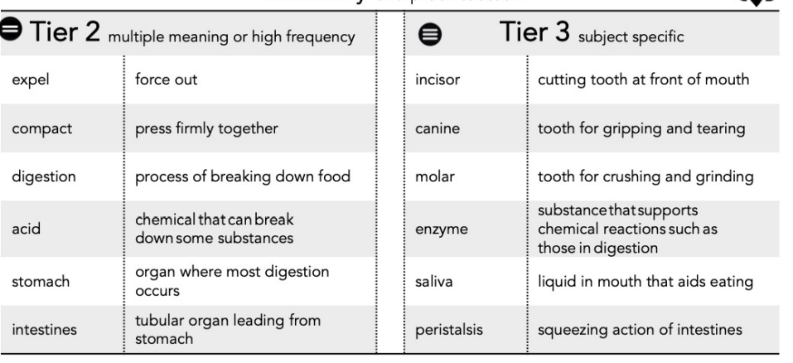
 | Lesson 1 | Lesson 2 | Lesson 3 | Lesson 4 | Lesson 5
Learning intention | What teeth do humans have? What do they do? | How do our teeth and mouth help with digestion? What’s the process? | ENRICHMENT  Can teeth tell us what animals eat? | PART 2:  What are the parts of the digestive system? What do they do? | How does digestion work? What’s the process?
Working Scientifically
Recall and retrieval | 1-4 | 5-8( or to 10 if not teaching the enrichment lesson) | 9-10 | 1-7 | 8-12
Sequence of knowledge throughout the lesson | To know that humans have different types of teeth, where they are in the mouth and their function.  To know the amount of teeth a child and adult have and why they are different. | To know the role of teeth ,tongue saliva in the digestion of food.  To explain the role of teeth, tongue and saliva in the digestion of food.  To know that small pieces of food are called bolus. | To know humans incisors canines molars.  To know the types of food are we designed to eat? To know that herbivores have incisors lots of molars - To know that carnivores incisors canines a few molars.  To identify whether an animal is a herbivore, carnivore or omnivore from its teeth. | To know the parts of the body and its role in the digestion of food.  To know where the oesophagus is and that it is a muscular tube contracts and relaxes, joins mouth to stomach.  To know where the stomach is and that it holds 1.5 litres, mixes food together, holds strong acids and enzymes left-hand side under your chest.  To know where the small intestine is and that it is about 7m long (longest) and absorbs liquidy food into the bloodstream around your belly button.  To know where the large intestine is and that it is about 1.5m long colon rectum and around the outside small intestine. | to know the process of digestion.  To know the mouth is the first stage, it breaks food up, saliva starts to digest food tongue, pushes food to entrance of oesophagus.  To know the oesophagus is a muscular tube which pushes food down to the stomach peristalsis. To know the peri-stal-sis is a wave-like contractions that moves food through oesophagus, small and large intestine.  To know the role of the stomach muscles is to churn food with strong acids and enzymes gastric juices turns food into a liquidy mixture.  To know that in the small intestine digestible food is absorbed into the bloodstream.  To know the role of the colon in the large intestines is to remove water from food.  To know that in the rectum food that cannot be digested is expelled as faeces.
Scaffolding | Visuals of each type of tooth.  Initial letter for labelling. | To label parts of the mouth.  Fill in missing words in stem sentences to explain the role of teeth, tongue and saliva in the digestion of food. | Use pictures of teeth to identify if the animal is a herbivore, omnivore, carnivore. | Initial letter and labelled diagram to support accurate identification of the part of the body needed for digestion. | Stem sentences to explain digestive system.
Challenge | Write an explanation about the function of each type of tooth. | To write an explanation of each part and its role in the digestion of food. | Use scientific knowledge of animals from Year 1 to predict whether an animal will be a herbivore, omnivore or carnivore before investigating their teeth. | To write an explanation of each of the roles of the parts of the digestive system. | Explanation of each stage of digestion.
Vocabulary  Tier 2 | Expel  Compact  Digestion  Acid  Stomach  Intestines | Expel  Compact  Digestion  Acid  Stomach  Intestines | Expel  Compact  Digestion  Acid  Stomach  Intestines | Expel  Compact  Digestion  Acid  Stomach  Intestines | Expel  Compact  Digestion  Acid  Stomach  Intestines
Vocabuary  Teir 3 | Incisor  Canine  Molar  Enzyme  Saliva  Peristalsis | Incisor  Canine  Molar  Enzyme  Saliva  Peristalsis | Incisor  Canine  Molar  Enzyme  Saliva  Peristalsis | Incisor  Canine  Molar  Enzyme  Saliva  Peristalsis | Incisor  Canine  Molar  Enzyme  Saliva  Peristalsis

