Science Year 3 Medium Term Planning – Lent 1: Forces and Magnets
National Curriculum
compare how things move on different surfaces • notice that some forces need contact between 2 objects, but magnetic forces can act at a distance
• observe how magnets attract or repel each other and attract some materials and not others
• compare and group together a variety of everyday materials on the basis of whether they are attracted to a magnet, and identify some magnetic materials
• describe magnets as having 2 poles
• predict whether 2 magnets will attract or repel each other, depending on which poles are facing
Prior vocabulary knowledge
materials properties physical metal
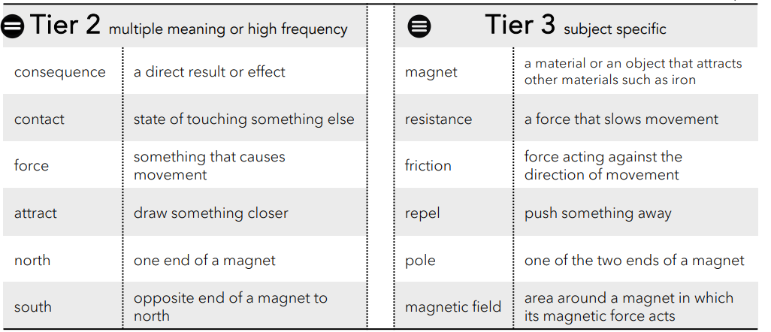
 | Lesson 1 | Lesson 2 | Lesson 3 | Lesson 4 | Lesson 5 | Lesson 6
Learning intention | What are contact forces? 1 - 2 | How do surfaces affect the motion of an object? | How does friction affect moving objects? | What is a non contact force?  How is this different to a contact force? | How do magnets attract and repel? | ENRICHMENT  Which materials are magnetic? Forces and magnetism summary
Working Scientifically | investigate and explain. | investigate and explain. | investigate, observe, record, explain. |  |  | Investigate, record, explain
Recall and retrieval | 1-2 | 3-4 | 5-7 | 8-9 | 10-13 or16 if no enrichment lesson | 14-16
Sequence of knowledge throughout the lesson | To know what contact force is and examples.  To demonstrate knowledge of force by answering questions:  Does wind, push or pull etc  Work scientifically to investigate and explain:  How are contact forces used in the classroom PE or with toys? | To know that resistance is a force that slows down an object that is moving.  To know that forces act in opposite directions.  Working Scientifically:  Which surfaces would be high resistance and which would be low resistance? Why is that?  To use knowledge from investigation to identify and explain the similarities and differences between the surfaces. | WORKING SCIENTIFICALLY To know what a forcemeter is, what it measures.  To know that friction is measured in Newtons (N) Newtons (N) = units.  To know how to use a forcemeter to measure friction.  To investigate friction using a forcemeter and record results:  How much force (N) is needed to lift a book?  How much force (N) is needed to drag a book across the table? What do you notice?  Is there a difference?  Try lifting and dragging an apple using a force meter. What do you notice? | To know that non contact force is a force that acts on an object without touching it.  To know that gravity is an unseen force that pulls things to the ground.  To know that magnetism is the invisible push or pull that works between some materials and that magnetism is an unseen force.  To use know of contact and non contact force to explain the difference. | Magnets have an invisible force field that repels or attracts certain materials.  To know that Ring, bar or horseshoe magnets have a north and south pole.  To investigate forces to explain:  How magnetic ring magnets stay suspended without touching each other on the centre pole? | To know that any material made of iron or steel is magnet.  To know that the magnetic field will only act on materials made of iron or steel.  To know through investigation that not all metals are magnetic aluminium and copper do not contain iron or steel.  To know through investigation that magnetic force can work through water.
Scaffolding | Practical vocabulary explanation before each force is investigated. | Stem sentences to explain similarities and differences. | Stem sentences to support explanation. | Fill in the gaps to give simple explanation of contact and non contact force. | Use vocabulary mat to write a simple explanation of why magnets can stay suspended. | To sort magnetic and non magnetic materials.
Challenge | Independent investigation. | More detailed explanations using scientific vocabulary. | Use scientific vocabulary to explain which why more/less force is required. | Include investigation results in the explanation of contact and non contact force. | To predict what might happen if the force of one of the magnets is stronger than the others. | To explain why some metals are magnetic and some aren’t using scientific vocabulary.
Vocabulary Tier 2 | Consequence  Contact  Force  Attract  North  South | Consequence  Contact  Force  Attract  North  South | Consequence  Contact  Force  Attract  North  South | Consequence  Contact  Force  Attract  North  South | Consequence  Contact  Force  Attract  North  South | Consequence  Contact  Force  Attract  North  South
Vocabulary Tier 3 | Magnet  Resistance  Friction  Repel  Pole  Magnetic field | Magnet  Resistance  Friction  Repel  Pole  Magnetic field | Magnet  Resistance  Friction  Repel  Pole  Magnetic field | Magnet  Resistance  Friction  Repel  Pole  Magnetic field | Magnet  Resistance  Friction  Repel  Pole  Magnetic field | Magnet  Resistance  Friction  Repel  Pole  Magnetic field

