2
Science Year 2 Medium Term Planning – Lent 1/2: Uses of everyday materials
National Curriculum
identify and compare the suitability of a variety of everyday materials, including wood, metal, plastic, glass, brick, rock, paper and cardboard for particular uses
• find out how the shapes of solid objects made from some materials can be changed by squashing, bending, twisting and stretching
Prior vocabulary knowledge
Materials,physical,properties,flexible,transparent,waterproof,opaque,absorb

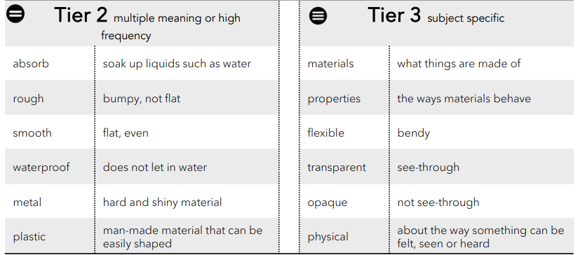
 | Lesson 1 | Lesson 2 | Lesson 3 | Lesson 4 | Lesson 5 | Lesson 6
Learning intention | What are materials used for? | What are materials used for? | What happens when we squash, bend, twist or stretch a material? | What’s the right material for the job?  LENT 2 | What’s the most absorbent material?  LENT 2 | What is waterproofing?  ENRICHMENT-  Taught and investigated during DT Topic.
Working Scientifically
Recall and retrieval | 1-2 | 3-5 | 6-7 | 8-9 | 10-14
Sequence of knowledge throughout the lesson | To know the names of materials, items made from that material and properties of the material:  wood  metal  ceramics  rock  paper  glass  fabrics  plastics |  | To know what means to squash, bend, twist and stretch.  To predict,plan and investigate whether materials change when they are bent, squashed, twisted or stretched. | To know the difference between the material that an object is made from and the object.  To know that an object can have different properties and be made from different materials.  To investigate spoons made from different materials and discuss the properties of the materials. | To collaboratively plan and design a scientific test to see which material is the best at absorbing water.  To know what absorb is.  To predict, practise and test how well these materials absorb water:  A4 paper  blue paper towel paper  towel cloth.  Investigate which paper will absorb the water the quickest.
Scaffolding | items made from the materials.  Additional items not investigated |  | Visual for : stretch, bend, squash, stretch prior to investigating and answering the deciding question. | Objects and words to match to identify the properties. | Think about what we use the paper for: What jobs do the papers do?
Challenge |  |  | Investigate additional items and answer deciding question. | Explain why an object is not hard/soft etc BUT it is the material that the object is made from that is hard, soft etc | Explain reason for prediction. Ie paper towel because I use it to absorb water from my hands.
Vocabulary Tier 2 | Absorb  Rough  Smooth  Waterproof  Metal  Plastic |  | Absorb  Rough  Smooth  Waterproof  Metal  Plastic | Absorb  Rough  Smooth  Waterproof  Metal  Plastic | Absorb  Rough  Smooth  Waterproof  Metal  Plastic | Absorb  Rough  Smooth  Waterproof  Metal  Plastic
Vocabulary Tier 3 | Materials  Properties  Flexible  Transparent  Opaque  physical |  | Materials  Properties  Flexible  Transparent  Opaque  physical | Materials  Properties  Flexible  Transparent  Opaque  physical | Materials  Properties  Flexible  Transparent  Opaque  physical | Materials  Properties  Flexible  Transparent  Opaque  physical

