Science Year 1 Medium Term Planning – Lent 1: Materials
National Curriculum
• distinguish between an object and the material from which it is made • identify and name a variety of everyday materials, including wood, plastic, glass, metal, water, and rock
• describe the simple physical properties of a variety of everyday materials
• compare and group together a variety of everyday materials on the basis of their simple physical properties
Prior vocabulary knowledge
hard, soft, stretch, bend
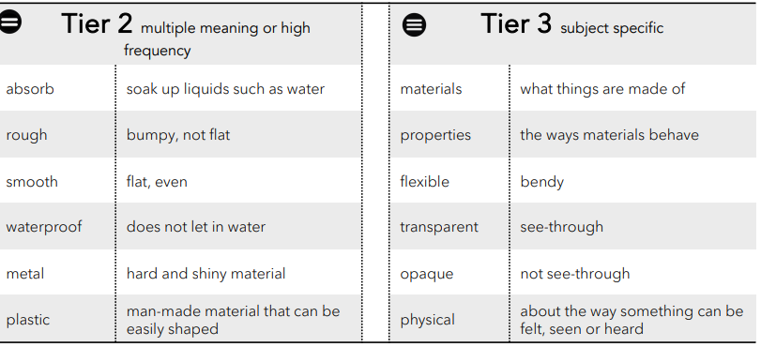
 | Lesson 1 | Lesson 2 | Lesson 3 | Lesson 4 | Lesson 5 | Lesson 6
Learning intention | What are materials? | What are things made of in school? | How can I describe materials? | Which materials are waterproof and which are not? | Which materials are transparent and which are opaque? | What’s the best material for the job? Why?
Working Scientifically | observe and record | observe and record | observe and record | investigate, observe, record. | observe, investigate, record | observe, investigate, record
Recall and retrieval | 1 | 2-3 | 4-6 | 7 | 8-9 | 1-12
Sequence of knowledge throughout the lesson | Sorting and using materials Wood, Wool, Soft things, Metal, Plastic, Waterproof, Glass | To invest objects in school made from:  metal, wood, glass, rock, fabric, plastic, paper and card. | To know that materials have different properties.  To investigate, sort objects and list different properties of materials. | To know what waterproof, absorb and resist mean in terms of waterproofing.  To investigate a selection of materials to test if they are waterproof. | To know what transparent and opaque means.  To sort materials into opaque and transparent.  To identify and list materials in the school that are transparent and opaque. | To investigate a range of objects:  table  chair  coat  towels  cuddly toy  things used for drawing/writing  cutlery  and decide what properties the materials MUST have to make them good for the job.
Scaffolding | Real objects to list | Reinforce the material prior to investigation. | To have a smaller group to discuss and pre teach vocabulary. | Pre teach the vocab. | Pre teach with objects. | Less materials to investigate for each object.
Challenge | Thing of their own objects | List many objects made from each material independently. | To encourage the use of alternative vocabulary to describe the material. ie hard, rigid, inflexible. | Use vocab when discussing and explaining what they observe. | Simple explanation of what transparent and opaque mean. | Explain why a material is suitable using properties.
Vocabulary Tier 2 | Absorb  Rough  Smooth  Waterproof  Metal  Plastic | Absorb  Rough  Smooth  Waterproof  Metal  Plastic | Absorb  Rough  Smooth  Waterproof  Metal  Plastic | Absorb  Rough  Smooth  Waterproof  Metal  Plastic | Absorb  Rough  Smooth  Waterproof  Metal  Plastic | Absorb  Rough  Smooth  Waterproof  Metal  Plastic
Vocabulary Tier 3 | Materials  Properties  Flexible  Transparent  Opaque  physical | Materials  Properties  Flexible  Transparent  Opaque  physical | Materials  Properties  Flexible  Transparent  Opaque  physical | Materials  Properties  Flexible  Transparent  Opaque  physical | Materials  Properties  Flexible  Transparent  Opaque  physical | Materials  Properties  Flexible  Transparent  Opaque  physical

