2
Science Year 6 Medium Term Planning – ADVENT 2: Animals including humans
National Curriculum
identify and name the main parts of the human circulatory system, and describe the functions of the heart, blood vessels and blood
• recognise the impact of diet, exercise, drugs and lifestyle on the way their bodies function
• describe the ways in which nutrients and water are transported within animals, including humans
Prior vocabulary knowledge
chronology, chronological multiply
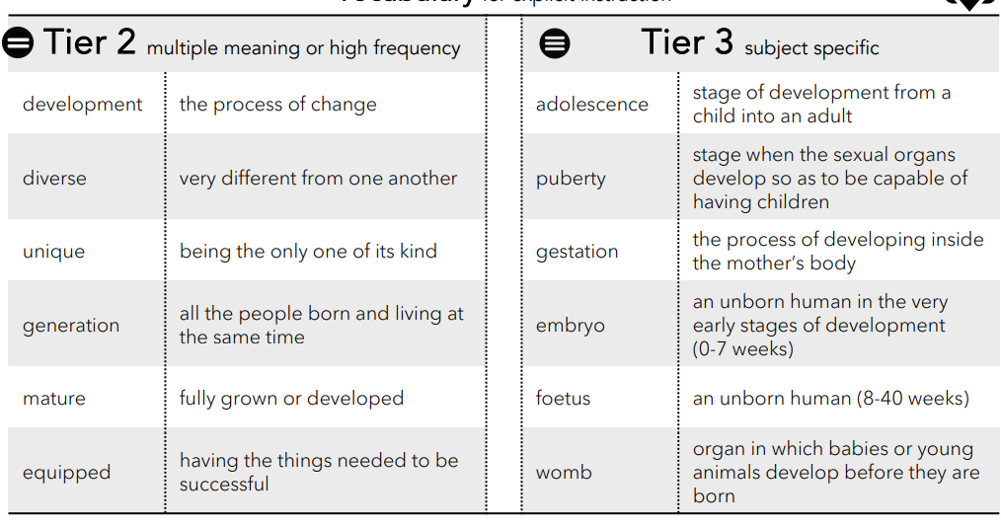
 | Lesson 1 | Lesson 2 | Lesson 3 | Lesson 4 and 5 | Lesson 6 | Lesson 7-8 |  | Lesson 9
Learning intention | What is blood made of and why do we need it? | Why do our bodies need nutrients and how are they transported? | What is our circulatory system? | What is our heart like inside? How does it work? | ENRICHMENT  Who influenced what we know about our circulatory system? | What can we do to keep healthy? |  | ENRICHMENT  Present and explain what we know about the circulatory system, nutrients and keeping healthy
Working Scientifically
Recall and retrieval | CQ: 1-6 | CQ: 7-8 | CQ:9-13 | CQ 14-17 | CQ 18 | CQ19-21 | CQ19-21 |  | CQ 1-21
Sequence of knowledge throughout the lesson | To know the components of blood cells.  To know that plasma is mainly water and a liquid that blood cells are suspended in and waste is carried.  To know the function of red blood cells.  To know the role of red blood cells in respiration.  To know the function of white blood cells and how and where they are made in the body.  To know the role of platelets To know fibrin bonds platelets together. | To know that cells in our bodies need to grow, feed and MULTIPLY.  To know that nutrients feed cells through the cell membrane.  To know the meaning and function of respiration.  To know food must be a liquid for cells.  To know blood is mostly water that carries red and white blood cells, platlets and nutrients.  To know that plasma carries other nutrients.  To know the important nutrients. | To know the origin of the word circulatory.  To know the parts of the circulatory system.  To know why some parts of the circulatory system are coloured blue and some are red.  To know the pathway blood takes around our bodies. | To label parts of the heart.  To know the function of the left and right sides of the heart, including the role of the chambers on the left and right side of the heart.  To know the meaning and role of oxygenated and deoxygenated blood in the circulatory system. | To know who Galen and William Harvey were, their jobs and their influence on knowledge and understanding of the circulatory system. | To know that being healthy means to help keep the body functioning and the impact of exercising and drinking water on our bodies.  To know healthy means eating the right foods to keep our bodies functioning effectively. Food groups which should eat more of and more often and food groups we should have as treats and less often.  To know the benefit we get from eating healthily. | INVESTIGATION:  Hypothesis:  Fruit drinks have less sugar than fizzy drinks.  Predict  Plan  Record and collect data  Analysis results in relation to prediction. |  | To relate knowledge learnt this topic about circulatory system, nutrients and keeping healthy.  How they work and how nutrients affect the health and performance of the body.  To make a presentation about the circulatory system.
Scaffolding |  | Label diagrams.  Initial letter for important nutrients. | To label the circulatory system. | Stem sentences to explain the role of the right and left sides of the heart. |  | Word mat for explanation of food we should eat more/ less of. | Scaffolded steps for investigation.  Simple conclusion about the results and whether the prediction was accurate. |  | Questions to guide knowledge of the  circulatory system, nutrients and keeping healthy
Challenge |  | Explain the role of nutrients and their importance in our bodies and blood cells. | To explain how the heart and lungs are key organs in the circulatory system. | To explain what would happen if the heart doesn’t function properly. |  | Describe and explain the impact on the body of having a diet high in fats and sugars. | Plan and carry out an investigation including reasons for variables. |  | Include scenarios about what happens if… when writing about the circulatory system, nutrients and keeping healthy to demonstrate understanding.
Vocab  Tier 2 | Development  Diverse  Unique  Generation  Mature  Equipped | Development  Diverse  Unique  Generation  Mature  Equipped | Development  Diverse  Unique  Generation  Mature  Equipped | Development  Diverse  Unique  Generation  Mature  Equipped | Development  Diverse  Unique  Generation  Mature  Equipped | Development  Diverse  Unique  Generation  Mature  Equipped | Development  Diverse  Unique  Generation  Mature  Equipped |  | Development  Diverse  Unique  Generation  Mature  Equipped
Vocab  Tiere 3 | Adolescence  Puberty  Gestation  Embryo  Foetus  Womb | Adolescence  Puberty  Gestation  Embryo  Foetus  Womb | Adolescence  Puberty  Gestation  Embryo  Foetus  Womb | Adolescence  Puberty  Gestation  Embryo  Foetus  Womb | Adolescence  Puberty  Gestation  Embryo  Foetus  Womb | Adolescence  Puberty  Gestation  Embryo  Foetus  Womb | Adolescence  Puberty  Gestation  Embryo  Foetus  Womb |  | Adolescence  Puberty  Gestation  Embryo  Foetus  Womb

