Science Year 6 Medium Term Planning – Advent 1:
National Curriculum

● associate the brightness of a lamp or the volume of a buzzer with the number and voltage of cells used in the circuit
● compare and give reasons for variations in how components function, including the brightness of bulbs, the loudness of buzzers and the on/off position of switches
● use recognised symbols when representing a simple circuit in a diagram
Prior vocabulary knowledge
circuit/circuitous current conduct/conductor insulate/insulator/insulation
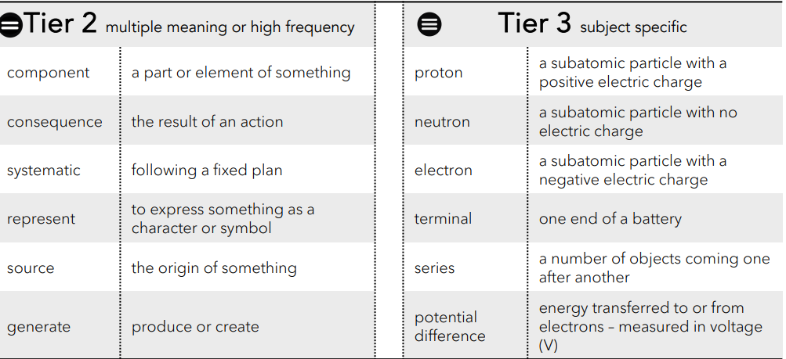
 | Lesson 1 | Lesson 2 | Lesson 3
Learning intention | What is electricity? How does it work?  Do it - How do we build and represent a series circuit? | What are the components in a series circuit?  Test it - How does the number of cells and voltage affect components in a circuit? | Diagnose it – what are the effects and consequences of changing circuit components and batteries?  ENRICHMENT
Working Scientifically |  | planning, recording and reporting
Recall and retrieval | CQ: 1-11 | CQ: 12-18 | CQ:19-21
Sequence of knowledge throughout the lesson | Key knowledge  To know electricity is a form of energy.  To know what an atom is and its make up.  To know the power source gives energy to electrons (potential difference)  and this can make them move around the circuit (current)  To know what conductors and insulators are and examples of both.  To know how energy is transferred in a circuit. | Key knowledge  To know what a series circuit is.  To know symbols used to draw diagrams of a circuit.  To demonstrate knowledge of circuits and symbols by drawing and labelling a circuit when investigating how the number of batteries and potential difference affect the components in a circuit. | Key knowledge  To know:  open circuits  closed circuits  single looped circuits.  To predict and investigate using electrical knowledge to answer a question.  To identify potential differences.  Know what a current is, in an electrical circuit.
Scaffolding | Matching labels to atom parts. | Match labels and parts. | Simple investigation question.
Challenge | Write a sentence to describe the functions of atom parts. | Describe what happens if the number of batteries is increased/decreased and use scientific vocabulary to explain this change. | Write a reason for prediction and include prediction in the conclusion.
Key Vocabulary  Tier 2 | Component  Consequence  Systematic  Represent  Source  Generate | Component  Consequence  Systematic  Represent  Source  Generate | Component  Consequence  Systematic  Represent  Source  Generate
Key Vocabulary  Tier 3 | Proton  Neutron  Electron  Terminal  Series  Potential difference | Proton  Neutron  Electron  Terminal  Series  Potential difference | Proton  Neutron  Electron  Terminal  Series  Potential difference

