2
Science Year 5 Medium Term Planning – ADVENT 2: Animals including humans
National Curriculum
• Pupils should draw a timeline to indicate stages in the growth and development of humans
• They should learn about the changes experienced in puberty
• Pupils could work scientifically by researching the gestation periods of other animals and comparing them with humans; by finding out and recording the length and mass of a baby as it grows
Prior vocabulary knowledge
chronology, chronological multiply
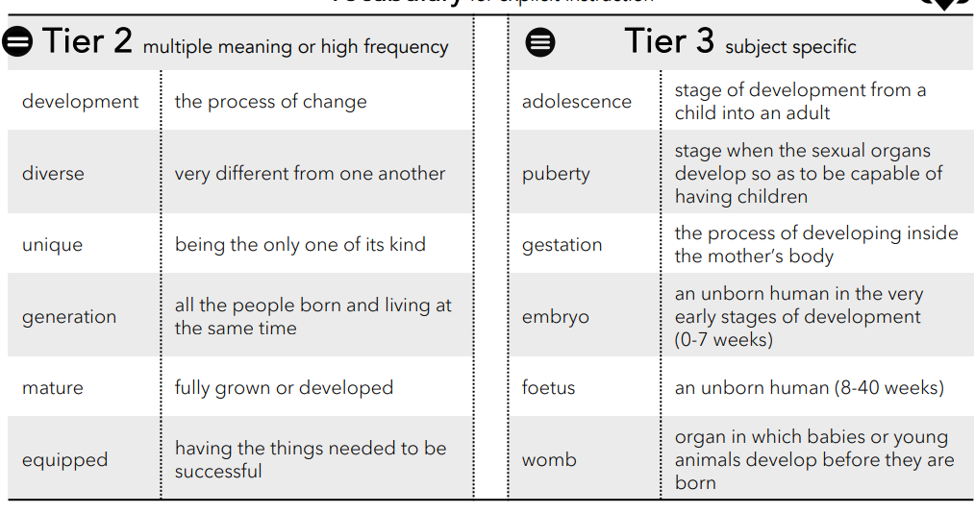
 | Lesson 1 | Lesson 2 | Lesson 3
Learning intention | What is the human timeline? | How do we change into adults? | How does human and animal gestation and lifespan compare?  ENRICHMENT
Working Scientifically
Recall and retrieval | CQ: 1-5 | CQ: 6-9 | CQ:10-14
Sequence of knowledge throughout the lesson | To know the names and ages for the stages of human life from conception to old age/death.  To know the scientific names for womb, foetus and embryo | To know the origins and meaning of the word adolescence.  To know what puberty is, when it occurs in a human’s life and how and when girls and boys change during puberty. | To know the gestation period of humans and different animals.  To know that life expectancy is the estimated time something is expected to live and the different life expectancy of various animals.
Scaffolding | Ordering stages and ages. | Ordering timeline of puberty for boys and girls. | Simple recording about 3 different animals, one of which must be a human.  To use the gestation of human and butterfly to answer if all animals have the same gestation pattern.
Challenge | Write an explanation of the development of an embryo to child using scientific vocabulary, | Write an explanation of changes.and why boys and girls need to go through these changes. | To use scientific knowledge to discuss if all gestation patterns are the same with reasons and examples.
Vocabulary  Tier 2 | Developmetn  Diverse  Unique  Generation  Mature  Equipped | Developmetn  Diverse  Unique  Generation  Mature  Equipped | Developmetn  Diverse  Unique  Generation  Mature  Equipped
Vocabulary  Tier 3 | Adolescence  Puberty  Gestation  Embryo  Foetus  Womb | Adolescence  Puberty  Gestation  Embryo  Foetus  Womb | Adolescence  Puberty  Gestation  Embryo  Foetus  Womb

