Science Year 5 Medium Term Planning – Advent 1:
National Curriculum
- compare and group together everyday materials on the basis of their properties, including their hardness, solubility, transparency, conductivity (electrical and thermal), and response to magnets
- know that some materials will dissolve in liquid to form a solution, and describe how to recover a substance from a solution
- use knowledge of solids, liquids and gases to decide how mixtures might be separated, including through filtering, sieving and evaporating give reasons, based on evidence from comparative and fair tests, for the particular uses of everyday materials, including metals, wood and plastic
- demonstrate that dissolving, mixing and changes of state are reversible changes
- explain that some changes result in the formation of new materials, and that this kind of change is not usually reversible, including changes associated with burning and the action of acid on bicarbonate of soda

Prior vocabulary knowledge
transparent, transparency, translucent thermal magnetism
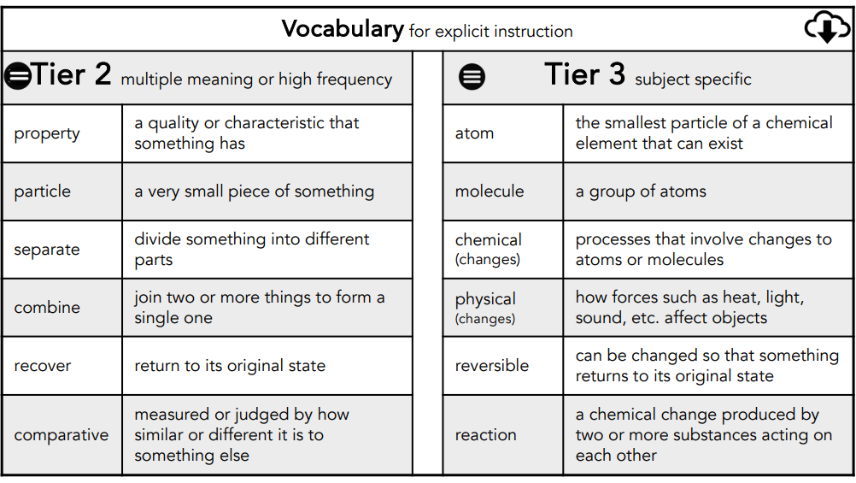
 | Lesson 1 | Lesson 2 | Lesson 3 | Lesson 4 | Lesson 5 | Lesson 6
Learning intention | What properties do materials have? How do we use them? | What is a solution and what is a mixture? | How can we separate materials from a mixture? | How can we separate materials from a solution?  Investigation:  Enrichment | What changes are reversible? | What changes are irreversible?  Enrichment
Working Scientifically |  | .Define it: | plan,record and report | Test it:
Recall and retrieval | CQ: 1-5 | CQ: 1-10 | CQ:11-16 | CQ 17-20 | CQ:17-20  States of matter (Y4) | CQ: 1-20  .
Sequence of knowledge throughout the lesson | Key knowledge  Sort materials and match the material to their purpose:  conductor  insulator  solubility  transparency  magnetism | Key knowledge  Investigating physical changes:  solid + solid  solid + liquid  liquid + liquid  To know what a solution, solute, solvent and carrier are.  Investigate changes to variables.  Demonstrate: knowledge through answering the question:  What happens if you put too much salt in the water? | Key knowledge  INVESTIGATE:  To know ways of separating larger solids using a variety of equipment:  sieve  filter paper  magnets | Key knowledge  Separating materials from a mixture.  Devising, carryout and record an investigation into separating materials using previous knowledge (L3)  Know which method of separating materials is most effective in different situations.  Know what soluble and insoluble means and examples of each. | Key knowledge  Know different physical changes:  dissolving  melting  freezing  evaporating  Investigate different materials, record results and identify if the changes are reversible or irreversible. | Key knowledge  To know what chemical change is and that it is irreversible.  Heat a range of materials:Predict, test and record.
Scaffolding | Supported for more simple material sorting. | Stem sentences. | Supported investigation using prompts. | More simple materials used in investigation. | Simple irreversible/reversible tests and guided investigations. | Stem sentences.
Challenge | Greater variety of materials to sort. | Independent explanation using scientific vocabulary. | Explain why different methods work for different materials. | Wider variety of resources to sort. | Write explanation of changes using scientific vocabulary. | Write explanation of changes using scientific vocabulary.
Key Vocabulary  Tier 2 | Prperty  Particle  Separate  Combine  Recover  Comparative | Prperty  Particle  Separate  Combine  Recover  Comparative | Prperty  Particle  Separate  Combine  Recover  Comparative | Prperty  Particle  Separate  Combine  Recover  Comparative | Prperty  Particle  Separate  Combine  Recover  Comparative | Prperty  Particle  Separate  Combine  Recover  Comparative
Key Vocabulary  Tier 3 | Atom  Molecule  Chemical changes  Physical changes  Reversible  Reaction | Atom  Molecule  Chemical changes  Physical changes  Reversible  Reaction | Atom  Molecule  Chemical changes  Physical changes  Reversible  Reaction | Atom  Molecule  Chemical changes  Physical changes  Reversible  Reaction | Atom  Molecule  Chemical changes  Physical changes  Reversible  Reaction | Atom  Molecule  Chemical changes  Physical changes  Reversible  Reaction

