2
Science Year 4 Medium Term Planning – ADVENT 2: States of Matter
National Curriculum
compare and group materials together, according to whether they are solids, liquids or gases
• observe that some materials change state when they are heated or cooled, and measure or research the temperature at which this happens in degrees Celsius (°C)
• identify the part played by evaporation and condensation in the water cycle and associate the rate of evaporation with temperature
Prior vocabulary knowledge
heat, cool, temperature, change, freeze compare, materials, properties
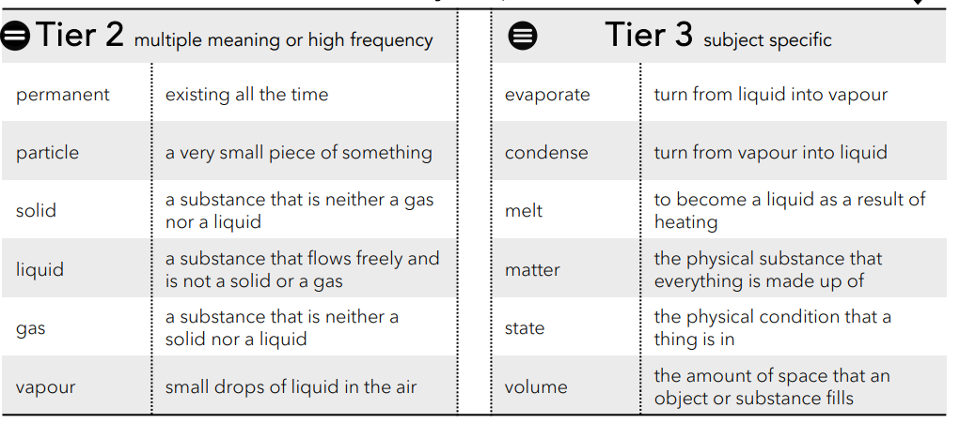
 | Lesson 1 | Lesson 2 | Lesson 3 | Lesson 4 | Lesson 5 | Lesson 6
Learning intention | What is matter? What does ‘state’ mean? | What are solids, liquids and gases? | Melting: how do materials change state? | Evaporating: how do materials change state? | Condensing: how do materials change state? | Summary: how do materials change their state of matter?
Working Scientifically | identify, | identify, describe and compare | identify  and describe
Recall and retrieval | CQ: 1-3 | CQ: 4-6 | CQ:7-9 | CQ10-12 | CQ14-17 | CQ18-20
Sequence of knowledge throughout the lesson | To know that anything that takes up space despite it’s size or composition is matter.  Anything that exists is matter.  To know that matter has a mass, occupies volume.  To know that the state of matter is one of the 3 distinct ways matter exists:  gas, liquid, solid | To know the characteristics of solids, liquid and gases, including particles. | To know that materials are not permanently solid and how temperature can change this state.  Work scientifically:  Investigating the melting point of butter and observe the temperature at which the solid becomes a liquid.  To know that butter has changed it’s state of matter. | To know that liquids do not simply vanish or disappear forever.  Work Scientifically:  To know what a control is.  Know that evaporation is invisible to the eye.  Water evaporates slowly and turns into water vapour in the air.  To use knowledge of evaporation to answer questions about puddles and whether changing the size of a container affects evaporation. | To know what condensation is and how water vapour cools and condenses to form water droplets.  Working Scientifically:  Use knowledge to answer why cans from a fridge are wet on the outside.  AND to know that it is not the liquid escaping.  To know that condensation occurs when water vapour cools and water droplets are formed.  To know other times condensation is seen. | To retrieve and secure the states of matter.  To know that materials are not permanently solid and temperature can change the state of matter.  To know how evaporation and condensation are formed and to explain how you know.
Scaffolding | COmplete stem sentences and matching pictures and labels. | Word mat and stem sentences. | Support to record observations and read thermometers. | Simple questions to secure knowledge of evaporation. Label diagram. | Stem sentences. | Simple questions and stem sentences.
Challenge | To explain each state. | To explain the states of matter and include how particles present during each state. | To explain how butter has changed its state of matter. | To write an explanation of the process of evaporation. | To use concept cartoon to discuss ideas and misconceptions related to condensation. | To use knowledge notes and organiser to write about states of matter and how temperature changes the states of matter.
Vocabulary Tier 2 | Permanent  Paritcle  Solid  Liquid  Gas  Vapour | Permanent  Paritcle  Solid  Liquid  Gas  Vapour | Permanent  Paritcle  Solid  Liquid  Gas  Vapour | Permanent  Paritcle  Solid  Liquid  Gas  Vapour | Permanent  Paritcle  Solid  Liquid  Gas  Vapour | Permanent  Paritcle  Solid  Liquid  Gas  Vapour
Vocabulary Tier 3 | Evaportate  Condense  Melt  Matterr  State  Volume | Evaportate  Condense  Melt  Matterr  State  Volume | Evaportate  Condense  Melt  Matterr  State  Volume | Evaportate  Condense  Melt  Matterr  State  Volume | Evaportate  Condense  Melt  Matterr  State  Volume | Evaportate  Condense  Melt  Matterr  State  Volume

