Science Year 4 Medium Term Planning – Advent 1: Living things and their habitats
National Curriculum
- recognise that living things can be grouped in a variety of ways
- explore and use classification keys to help group, identify and name a variety of living things in their local and wider environment
- recognise that environments can change and that this can sometimes pose dangers to living things.
Prior vocabulary knowledge
habitat, micro-habitat depend organism, reproduction
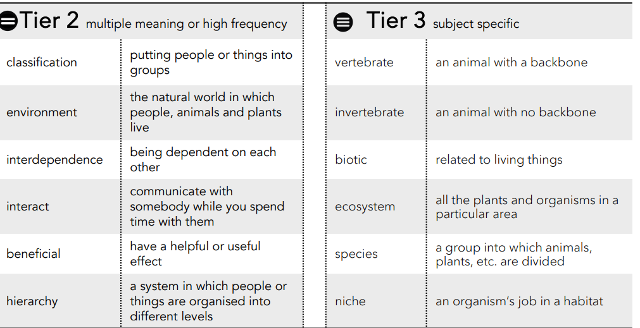
 | Lesson 1 | Lesson 2 | Lesson 3 | Lesson 4 | Lesson 5 | Lesson 6
Learning intention | What are the characteristics of living things? | What animals are vertebrates?  Lesson 2 and 3 can | What animals are invertebrates?  be combined. | What groups are plants classified in? | What is classification? How do I use a key? | What happens if the environment in a habitat changes?
Working Scientifically | gather, record and report | .  Make systematic and careful observations. | Make systematic and careful observations. | Make systematic and careful observations.  record, report findings.  Use results to draw simple conclusions: flowering/non flowering. | Set up simple, practical enquiries.  Record findings using simple scientific language.  Make systematic and careful observations.  record, report findings.  Use results to draw simple conclusions. | observe  identify and classify  ask questions
Recall and retrieval | CQ: 1-2 | CQ: 1-6  Mrs Gren and examples | CQ:7-11 | CQ 7-16 | CQ:17-18 | CQ: 18-20  .
Sequence of knowledge throughout the lesson | Key knowledge  Retrieval: Mrs Gren and meaning.  Know the meaning of biodiversity, organism,  invertebrate and vertebrate.  INVESTIGATIONKnow the difference between living things. | Key knowledge  Know what a vertebrate is, different animal groups that have vertebrates; fish, amphibians, reptiles, mammals and birds.  Know characteristics of each group and animals that are in each group.  CATEGORISE AND COMPARE VERTEBRATE | Key knowledge  Know that insects,Annelids, Arachnids, molluscs are invertebrates, characteristics of each group and examples of animals in each group.  CATEGORISE AND COMPARE INVERTEBRATE | Key knowledge  To classify plants into flowering and non flowering:  Know types of flowering and non flowering plants.  Know plants that reproduce using flowers to make seeds: different types including trees,  non-flowering plants: plants that reproduce using spores and seed cones and examples of these.  CATEGORISE AND COMPARE FLOWERING AND NONFLOWERING PLANTS. | Key knowledge  classification meaning:  sort into groups action of to divide or sort into groups.  Know that Carl Linnaeus invented the way to classify living things in 1737 through taxonomy.  Know origin of taxonomy :Greek: arrange method  Know hierarchy of biological classification (taxonomy)  the top three layers Kingdom animal, plant, fungi…  Phylum invertebrates, vertebrates…  Class mammal, reptile.  Know that a Classification key is a series of questions to identify a living thing that unlocks the identity of the living thing.  CLASSIFY LIVING THINGS USING A KEY. | Key knowledge  Know what a habitat, environment and ecosystem are and how they are affected by biotic and abiotic factors.  Know what a nature reserve is and its role in protecting animals.  Know what POLLUTION is and its negative affect an environment and how it can change the balance of the ecosystem.
Scaffolding | stem sentences | Give example sheet of each and fewer samples. | Give example sheet of each and fewer samples. | Identification code and pictures with simple examples to classify. | Simple classification code to follow.  Support to produce a simple classification. | Simple example to follow with possible options.
Challenge | give reasons for classification. | Greater variety to observe. | Greater variety to observe. | Greater variety and more complex categorising. | More complex classification. | Examples of pollution that have more possibilities and give reasons.
Key Vocabulary  Tier 2 | Classification  Environment  Interdependence  Interact  Beneficial  Hierachy | Classification  Environment  Interdependence  Interact  Beneficial  Hierachy | Classification  Environment  Interdependence  Interact  Beneficial  Hierachy | Classification  Environment  Interdependence  Interact  Beneficial  Hierachy | Classification  Environment  Interdependence  Interact  Beneficial  Hierachy | Classification  Environment  Interdependence  Interact  Beneficial  Hierachy
Key Vocabulary  Tier 3 | Vertebrate  Invertebrate  Biotic  Ecosystem  Species  Niche | Vertebrate  Invertebrate  Biotic  Ecosystem  Species  Niche | Vertebrate  Invertebrate  Biotic  Ecosystem  Species  Niche | Vertebrate  Invertebrate  Biotic  Ecosystem  Species  Niche | Vertebrate  Invertebrate  Biotic  Ecosystem  Species  Niche | Vertebrate  Invertebrate  Biotic  Ecosystem  Species  Niche

