2
Science Year 3 Medium Term Planning – ADVENT 2 (2) Rocks
National Curriculum
• compare and group together different kinds of rocks on the basis of their appearance and simple physical properties
• describe in simple terms how fossils are formed when things that have lived are trapped within rock
• recognise that soils are made from rocks and organic matter
Prior vocabulary knowledge
materials properties physical
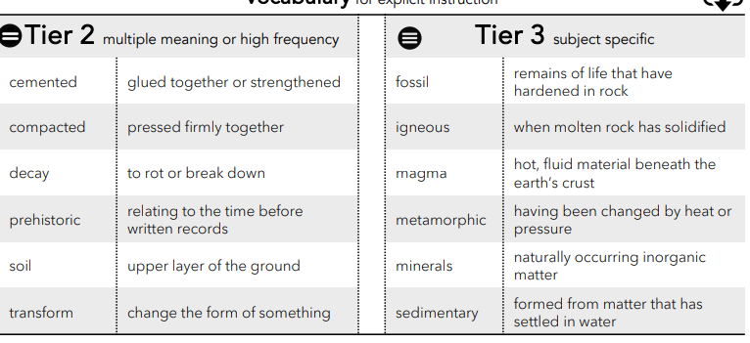
 | Lesson 1 | Lesson 2 | Lesson 3
Learning intention | How are rocks formed and what types are there? | Remember: how can rocks change? | Remember: how are fossils formed and how do we know?
Working Scientifically | identify, describe and compare | identify, describe and compare | identify  and describe
Recall and retrieval | CQ: 1-8 | CQ: 9-16 | CQ:17-19
Sequence of knowledge throughout the lesson | Key knowledge  To know how rocks are formed and examples of different types of rock.  To know how rocks have been changed. | Key knowledge  Retrieval:  How igneous and sedimentary rocks change into metamorphic rock.  To know how mudstone and limestone are formed. | Key knowledge  To know what fossils are and how they are formed.  To know different types of fossils.  To observe draw and describe different fossils.
Scaffolding | match selection of rocks to their names. | Simple explanation of different rock formations using a word mat. | Simple sentences to describe each stage of fossil formation.Draw and label a fossil.
Challenge | Match different rocks to their names and give egs of each. | More detailed explanation with examples of the different types of rock formation and examples of each. | Write a detailed description of the stages of fossil formation.  Draw, label and give detailed description of a fossil.
Vocabulary  Tier 2 | Cemented  Compacted  Decay  Prehistoric  Soil  Transform | Cemented  Compacted  Decay  Prehistoric  Soil  Transform | Cemented  Compacted  Decay  Prehistoric  Soil  Transform
Vocabulary Tier 3 | Fossil  Igneous  Magma  Metamorphic  Minerals  Sedimentary | Fossil  Igneous  Magma  Metamorphic  Minerals  Sedimentary | Fossil  Igneous  Magma  Metamorphic  Minerals  Sedimentary

