2
Science Year 3 Medium Term Planning – Animals, including humans
National Curriculum
.identify that animals, including humans, need the right types and amount of nutrition, and that they cannot make their own food; they get nutrition from what they eat
• identify that humans and some other animals have skeletons and muscles for support, protection and movement
Prior vocabulary knowledge
vertebrates, invertebrates flexible muscles, heart absorb
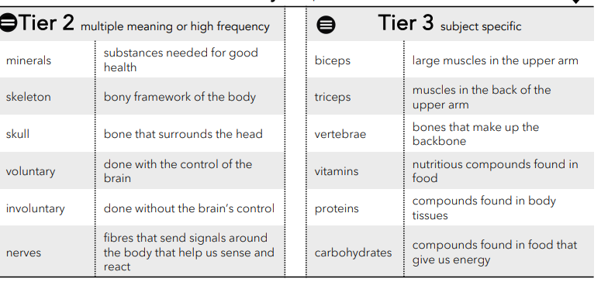
 | Lesson 1 | Lesson 2 | Lesson 3
Learning intention | What effect does the food we eat have? | What is my skeleton and what does it do? | Where are my muscles and what do they do?
Working Scientifically | identify | identify | identify  Make observations.
Recall and retrieval | CQ: 1-6 | CQ: 7-15 | CQ:16-22
Sequence of knowledge throughout the lesson | Key knowledge  To know we are humans.  To know that humans eat plants and sometimes meat.  To know the food pyramid contains food we eat.  To know we should eat more of the bottom layers of the pyramid.  To know the importance of water to humans.  To know that blood, muscles and organs need water to work.  To know that vitamins, minerals and fibre are found in vegetables and fruit and keep us healthy.  To know that carbohydrates give us energy and are in bread, cereals, vegetables and sugar.  To know that protein helps us grow and foods that contain protein.  To know types of fat, that fats give energy, help nerves brain and the absorption of vitamins. Know that humans should eat less fat than other food groups | Key knowledge  To know the definition of vertebrate and invertebrate.  To know the functions of a skeleton are:  To support the body.  protect the heart and lungs.  movement.  To know that bones are alive and contain bone marrow.  To know that bone marrow makes 2m red blood cells every second. | Key knowledge  To know what muscles are.  To know what voluntary and involuntary movement is in relation to muscles.  To know the 3 types of muscle.  To know how smooth muscles are involuntary muscles and they push food through the body to the intestines and bladder.  To know what biceps and triceps are and how they work.
Scaffolding | To label the different food groups and match each food group to how it supports the functions of the body. | Match pictures to functions of the skeleton.  Simple sentence using knowledge notes to describe the functions of bone marrow. | To match word and meaning for voluntary and involuntary.  To give an example of involuntary and voluntary muscles.  To give a simple explanation of why the heart is an involuntary muscle.
Challenge | Give examples of each food group and explain why each food group is important to the healthy functioning of the body. | Explain functions of the skeleton and bone/bone marrow. | To give more examples of involuntary and voluntary muscles and explain how humans control voluntary muscles.
Vocabulary Tier 2 | Minerals  Skeleton  Skull  Voluntary  Involuntary  Nerves | Minerals  Skeleton  Skull  Voluntary  Involuntary  Nerves | Minerals  Skeleton  Skull  Voluntary  Involuntary  Nerves
Vocabulary Tier 3 | Biceps  Triceps  Vertbrae  Protons  Vitamins  Carbohydrates | Biceps  Triceps  Vertbrae  Protons  Vitamins  Carbohydrates | Biceps  Triceps  Vertbrae  Protons  Vitamins  Carbohydrates

