Science Year 3 Medium Term Planning – Advent 1: Rocks
National Curriculum
- compare and group together different kinds of rocks on the basis of their appearance and simple physical properties describe in simple terms how fossils are formed when things that have lived are trapped within rock recognise that soils are made from rocks and organic matter.
Prior vocabulary knowledge
materials properties physical
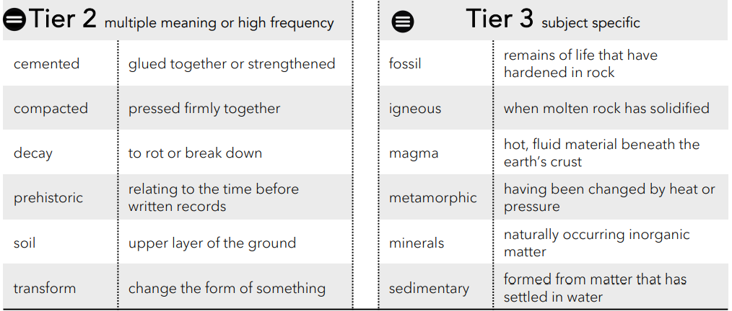
 | Lesson 1 | Lesson 2 | Lesson 3 | Lesson 4 | Lesson 5 | Lesson 6
Learning intention | How are rocks formed? | What types of rocks are there? | Can rocks change?  ENRICHMENT | How can we test a rock to see if it is limestone or chalk?  ENRICHMENT | Is soil just dirt? What makes soil? | How are fossils formed?
Working Scientifically | test, measure, gather, report | set up simple enquiry, gather, record and use results, identify differences. |  | Set up simple, practical enquiries and comparative test.  Record findings using simple scientific language. Report on findings, results and conclusions.  Use results to draw simple conclusions about whether a rock is chalk or limestone. | Set up simple, practical enquiries.  Record findings using simple scientific language. Report on findings, results and conclusions. | observe  identify and classify  ask questions
Recall and retrieval | CQ: 1-4 | CQ: 1-8  Types of igneous rock. | CQ:9-10  Know the meaning and examples of the word metamorphic (Y2) | CQ 11-12 | CQ:9-12  How can you tell the difference between chalk and limestone? | CQ: 17-23
Sequence of knowledge throughout the lesson | Key knowledge  Know the words and the meaning of igneous, moulton and larva.  Know the stages of rock formation.  Know rocks are natural.  Know types of igneous rocks.  DEFINE WHAT A ROCK IS AND TEST FOR HARDNESS.  Create | Key knowledge  Know the types of rock, how they are formed and example of each type.  Igneous, sedimentary and metamorphic.  CATEGORISE TYPES OF ROCK  creating | Key knowledge  Know the different ways igneous and sedimentary rocks can change into metamorphic rock and this occurs.  Know types of metamorphic rock.  Connecting | Key knowledge  Know the characteristics of chalk and limestone.  Know the effect of acid on limestone and chalk.  Set up an investigation:  Using controlled, independent,dependent variables to investigate if rock is limestone or chalk. | Key knowledge  Know soil make up.  Know Geologist term for layers of soil.  Identify the composition of different layers of soil.  Investigate the make up of soil from the local environment. | Key knowledge  Know what fossils are and the process by which fossils are formed.  To know the features of body and trace fossils.
Scaffolding | order and label stages of rock formation | sort and label types of rock. | Stem sentences. | Mixed groups to support each other  Stem sentences. | Matching labels to different layers. | Sequence the stages of fossil formation.
Challenge | Write an explanation of each stage of rock formation. | Write a simple explanation of each type of rock. | Simple explanation of how the changes occur. | Write description of the types of rock. | Independently label the layers. | Simple explanation of each stage.
Key Vocabulary  Tier 2 | Cemented  Compacted  Decay  Prehistoric  Soil  transform | Cemented  Compacted  Decay  Prehistoric  Soil  transform | Cemented  Compacted  Decay  Prehistoric  Soil  transform | Cemented  Compacted  Decay  Prehistoric  Soil  transform | Cemented  Compacted  Decay  Prehistoric  Soil  transform | Cemented  Compacted  Decay  Prehistoric  Soil  transform
Key Vocabulary  Tier 3 | Fossil  Igneous  Magma  Metamorphic  Minerals  Sedimentary | Fossil  Igneous  Magma  Metamorphic  Minerals  Sedimentary | Fossil  Igneous  Magma  Metamorphic  Minerals  Sedimentary | Fossil  Igneous  Magma  Metamorphic  Minerals  Sedimentary | Fossil  Igneous  Magma  Metamorphic  Minerals  Sedimentary | Fossil  Igneous  Magma  Metamorphic  Minerals  Sedimentary

