2
Science Year 2 Medium Term Planning – Animals including humans
National Curriculum
notice that animals, including humans, have offspring which grow into adults
find out about and describe the basic needs of animals, including humans, for survival (water, food and air)
describe the importance for humans of exercise, eating the right amounts of different types of food, and hygiene.
Prior vocabulary knowledge
mammal, amphibian, reptile carnivore, herbivore, omnivore
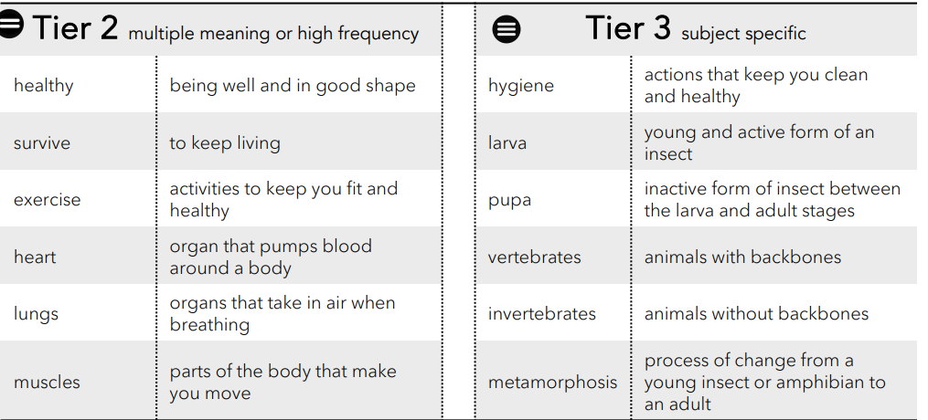
 | Lesson 1 | Lesson 2 | Lesson 3 | Lesson 4 | Lesson 5 | Lesson 6
Learning intention | Retrieval:  What is an animal? | How do animals change as they MATURE? | How do we change as we MATURE? | What do all animals need to stay alive? | Keeping Healthy: Why do we exercise? | Keeping healthy: Why do we eat different types of food?
Working Scientifically | identify | observe  identify  ask questions | observe  identify  ask questions | observe  identify  ask questions | observe  suggest answers  Gather and record | observe  identify and classify  ask questions
Recall and retrieval | CQ: 1-3Identify different animals.  Can you tell me the meaning of: carnivore, herbivore, omnivore and give an example of an animal that is is each group. | CQ: 1-6  What animal groups are there and name the groups and an animal that is in that group. | CQ:7-10 | CQ 11-14 | CQ:11-16 | CQ: 17-23
Sequence of knowledge throughout the lesson | Key knowledge  Categories of animals and sorting animals into vertebrate /invertebrate  Retrieval: MRS GREN what vertebrate and invertebrate means and egs of each.  Generating curiosity question | Key knowledge  Introduce the question metamorphosis Explain the life cycle of a known animals.  Model worked examples through each stage using images and vocabulary.  Know some animals look like parents and some go through metamorphosis and don’t look like parents.  Predicting | Key knowledge  Know they have changed- pictures of them as babies and toddlers.  Order sequence of life cycle of a human.  Be aware of features of different stages of life.  Describing | Key knowledge  Know what is essential to live.  To know water is essential for all life.  To know amphibians absorb water and other animals drink it.  Know why we need nutrients and where we get the nutrients; RETRIEVAL omnivore, herbivore, carnivore and animals in these groups.  Air: How different animals breathe.  Proving | Key knowledge  Know what exercise is and types of exercise.  The parts of the body affected when we exercise.  Why water is important - retrieve from the last session and also specific to exercise.  Effect of not exercising.  What hygiene is, different types and the importance of having good hygiene.  Creating | Key knowledge  Effect on the body of drinking water.  Types of food. and the effect of fruit and vegetables on our body and their importance in keeping us healthy.  Different categories of food, how much of each is needed to be and stay healthy.  What we eat - A healthy plate of food  Deciding
Scaffolding | Fewer animals | Label life cycles | Simple sentences supported to describe each stage of life. | Pictures labelled of amphibians.  Pre learn vocab nutrients. | List exercise they do | Label the food groups
Challenge | Greater explanation. | Write a simple explanation of each stage. | More detailed description of each state of life. | Write a simple explanations. | Greater list | Explanation of the different food groups.
Vocabulary  Tier 2 | Healthy  Survive  Ecercise  Heart  Lungs  muscles | Healthy  Survive  Ecercise  Heart  Lungs  muscles | Healthy  Survive  Ecercise  Heart  Lungs  muscles | Healthy  Survive  Ecercise  Heart  Lungs  muscles | Healthy  Survive  Ecercise  Heart  Lungs  muscles | Healthy  Survive  Ecercise  Heart  Lungs  muscles
Vocabulary  Tier 3 | Hygiene  Larva  Pupa  Vertebrates  Invertebrates  metamorphosis | Hygiene  Larva  Pupa  Vertebrates  Invertebrates  metamorphosis | Hygiene  Larva  Pupa  Vertebrates  Invertebrates  metamorphosis | Hygiene  Larva  Pupa  Vertebrates  Invertebrates  metamorphosis | Hygiene  Larva  Pupa  Vertebrates  Invertebrates  metamorphosis | Hygiene  Larva  Pupa  Vertebrates  Invertebrates  metamorphosis

