Science Year 2 Medium Term Planning – Living things and their habitats
National Curriculum
- explore and compare the differences between things that are living, dead, and things that have never been alive
- identify that most living things live in habitats to which they are suited and describe how different habitats provide for the basic needs of different kinds of animals and plants, and how they depend on each other
- identify and name a variety of plants and animals in their habitats, including microhabitats
- describe how animals obtain their food from plants and other animals, using the idea of a simple food chain, and identify and name different sources of food

Prior vocabulary knowledge
Habitat,animal, plant, living, carnivore, herbivore ,omnivore
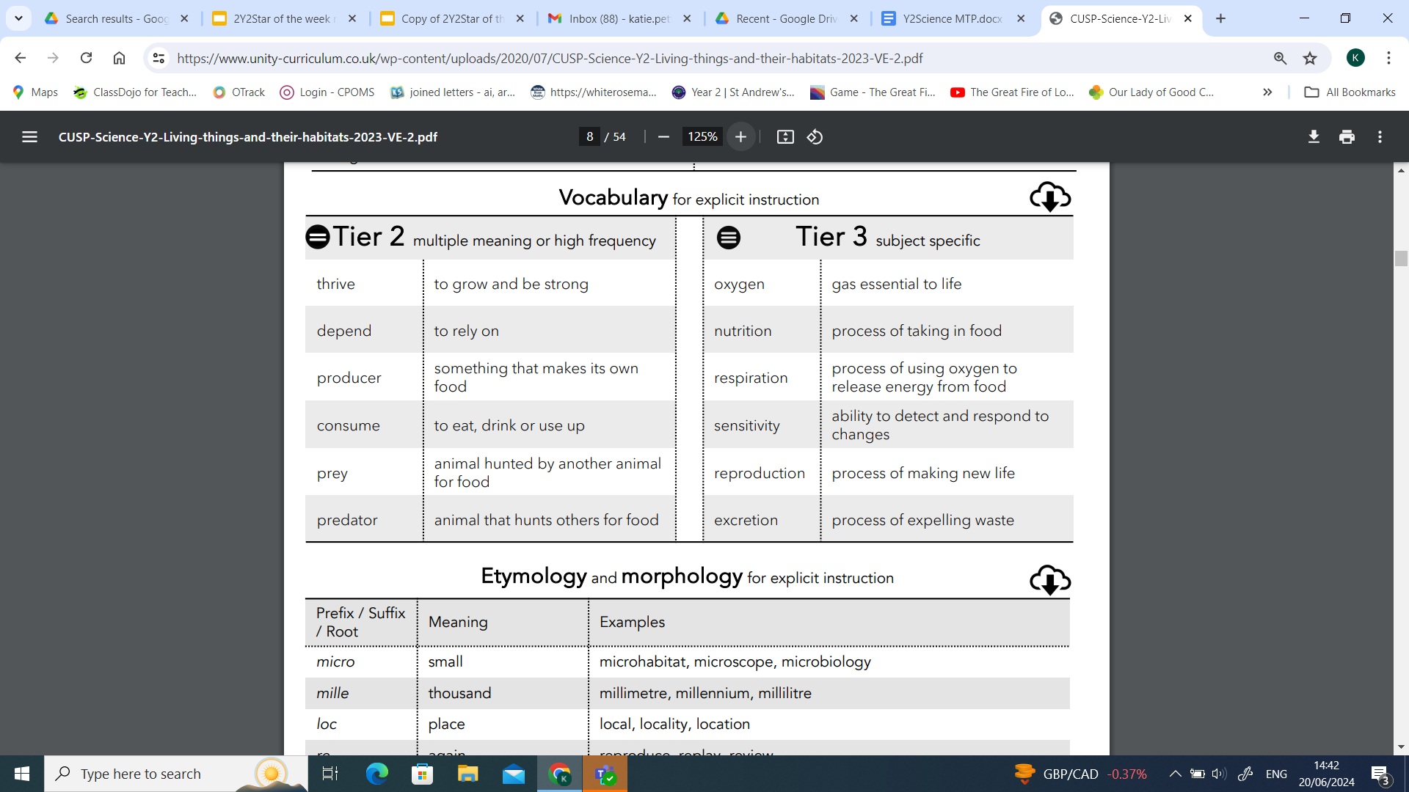
 | Lesson 1 | Lesson 2 | Lesson 3 | Lesson 4 | Lesson 5 | Lesson 6
Learning intention | What is alive and what is not? | What do all living things have  in common? | Where do plants and animals live? | What plants and animals live in our local environment? | What are food chains? How are they connected? | Why do plants and animals need each other?
Working Scientifically | identify | observe  identify  ask questions | observe  identify  ask questions | observe  identify  ask questions | observe  identify  ask questions | observe  identify  ask questions
Recall and retrieval | CQ: 1-3Identify different animals.  Can you tell me the meaning of: carnivore, herbivore, omnivore and give an example of an animal that is is each group. | CQ: 1-6  What animal groups are there and name the groups and an animal that is in that group. | CQ:7-10 | CQ 11-14 | CQ:11-16 | CQ: 17-23
Sequence of knowledge throughout the lesson | Key knowledge  suggesting  deciding  Generating curiosity  exploring  generating ideas | Key knowledge  identifying  explaining  creating  questioning | Key knowledge  listing  predicting  exploring  deducing  concluding  suggesting  questioning | Key knowledge  generating curiosity  comparing  handling data  questioning  suggesting | Key knowledge  sequencing  explaining  comparing  deciding  justifying | Key knowledge  questioning  sorting  justifying  interpreting
Scaffolding | Fewer animals | Label life cycles | Simple sentences supported to describe each stage of life. |  | List exercise they do | Label the food groups
Challenge | Greater explanation. | Write a simple explanation of each stage. | More detailed description of each state of life. |  | Greater list | Explanation of the different food groups.
Key Vocabulary  Tier 2 | Healthy  Survive  Exercise  Heart  Lungs  Muscles | Healthy  Survive  Exercise  Heart  Lungs  Muscles | Healthy  Survive  Exercise  Heart  Lungs  Muscles | Healthy  Survive  Exercise  Heart  Lungs  Muscles | Healthy  Survive  Exercise  Heart  Lungs  Muscles | Healthy  Survive  Exercise  Heart  Lungs  Muscles
Key Vocabulary  Tier 3 | Hygiene  Larva  Pupa  Vertebrates  Unvertebrates  Metamorphosis | Hygiene  Larva  Pupa  Vertebrates  Unvertebrates  Metamorphosis | Hygiene  Larva  Pupa  Vertebrates  Unvertebrates  Metamorphosis | Hygiene  Larva  Pupa  Vertebrates  Unvertebrates  Metamorphosis | Hygiene  Larva  Pupa  Vertebrates  Unvertebrates  Metamorphosis | Hygiene  Larva  Pupa  Vertebrates  Unvertebrates  Metamorphosis

