2
Science Year 1 Medium Term Planning – Animals including humans
National Curriculum
• identify and name a variety of common animals including fish, amphibians, reptiles, birds and mammals
• identify and name a variety of common animals that are carnivores, herbivores and omnivores
Prior vocabulary knowledge
animal, human, living, plant
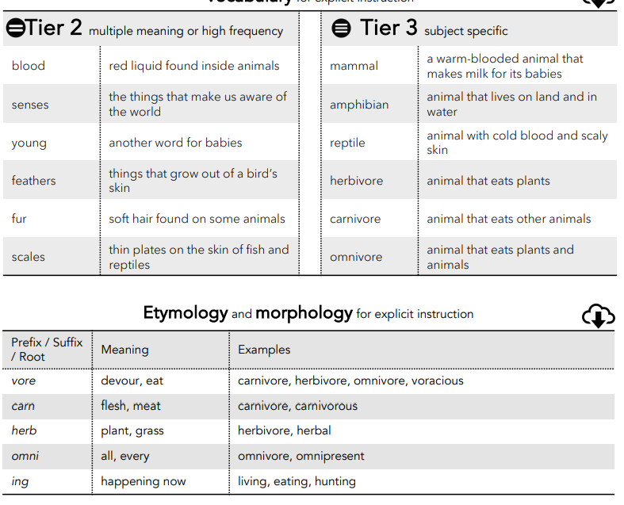
 | Lesson 1 | Lesson 2-3 | Lesson 4 | Lesson 5 | Lesson 6
Learning intention | What is an animal? | What types of animals are there? | What is similar and what is different? | What does food tell us about an animals? | ENRICHMENT:  What makes me an animal?  What senses do I have?
Working Scientifically | identify  observe  ask questions | observe  identify  ask questions  record | observe  identify  ask questions  record | observe  identify  ask questions | observe  suggest answers  Gather and record
Recall and retrieval | CQ: 1-6 | CQ: 7-11 | CQ:7-11 | CQ 12-14 | CQ:17-18
Sequence of knowledge throughout the lesson | Key knowledge  To know what makes an animal an animal.  To know the differences between an animal and a plant.  To use knowledge of what makes an animal an animal to categorise different things. | Key knowledge  To know there are different types of animal and the characteristics of;  mammals  birds  amphibians  reptiles  fish | Key knowledge  To know similarities and differences between animals.  To sort animals into different groups.  To sort into groups according to given criteria:  blood  covering  babies  breathing  To observe animals closely and record observations. | Key knowledge  To know the characteristics of;  a carnivore  herbivore  omnivore  and animals that can be sorted into each group.  To know that an omnivore would be in both groups. | Key knowledge  To know the features of humans.  To know they are humans,  To know we have senses and what they are.  To investigate using different senses.
Scaffolding | Fewer animals. Pre teach vocabulary. | fewer animals. Key vocabulary for each animal group. | Pictures to support and record characteristics in a list. | pre teach vocabulary.  List of food eaten by that animal. | Pictures to support knowledge of body part for each sense.  Match part with sense.
Challenge | Greater election of animals. Give reasons for choice of group. | Match criteria for each group and sort more animals. | Simple explanation of why an animal is a group. | Write a simple example of food eaten to explain why an animal is in which group. | Give egs of features of each sense. Ie I see with my eyes. I look at books.
Vocabulary Tier 2 | Blood  Senses  Young  Feather  Fur  scales | Blood  Senses  Young  Feather  Fur  scales | Blood  Senses  Young  Feather  Fur  scales | Blood  Senses  Young  Feather  Fur  scales | Blood  Senses  Young  Feather  Fur  scales
Vocabulary Tier 3 | Mammal  Amphibian  Reptile  Herbivore  Carnivore  Ominvore | Mammal  Amphibian  Reptile  Herbivore  Carnivore  Ominvore | Mammal  Amphibian  Reptile  Herbivore  Carnivore  Ominvore | Mammal  Amphibian  Reptile  Herbivore  Carnivore  Ominvore | Mammal  Amphibian  Reptile  Herbivore  Carnivore  Ominvore

