Science: Advent 1: Year 1 Medium Term Planning – Seasonal changes-Plants(trees)
National Curriculum
- observe changes across the four seasons
- observe and describe weather associated with the seasons and how day length varies.
- Plants
- identify and name a variety of common wild and garden plants, including deciduous and evergreen trees
- identify and describe the basic structure of a variety of common flowering plants, including trees.
Prior vocabulary knowledge
sun,snow,rain,cloud,day,night plant, tree, root, flower, leaves,garden, living, grow, fruit
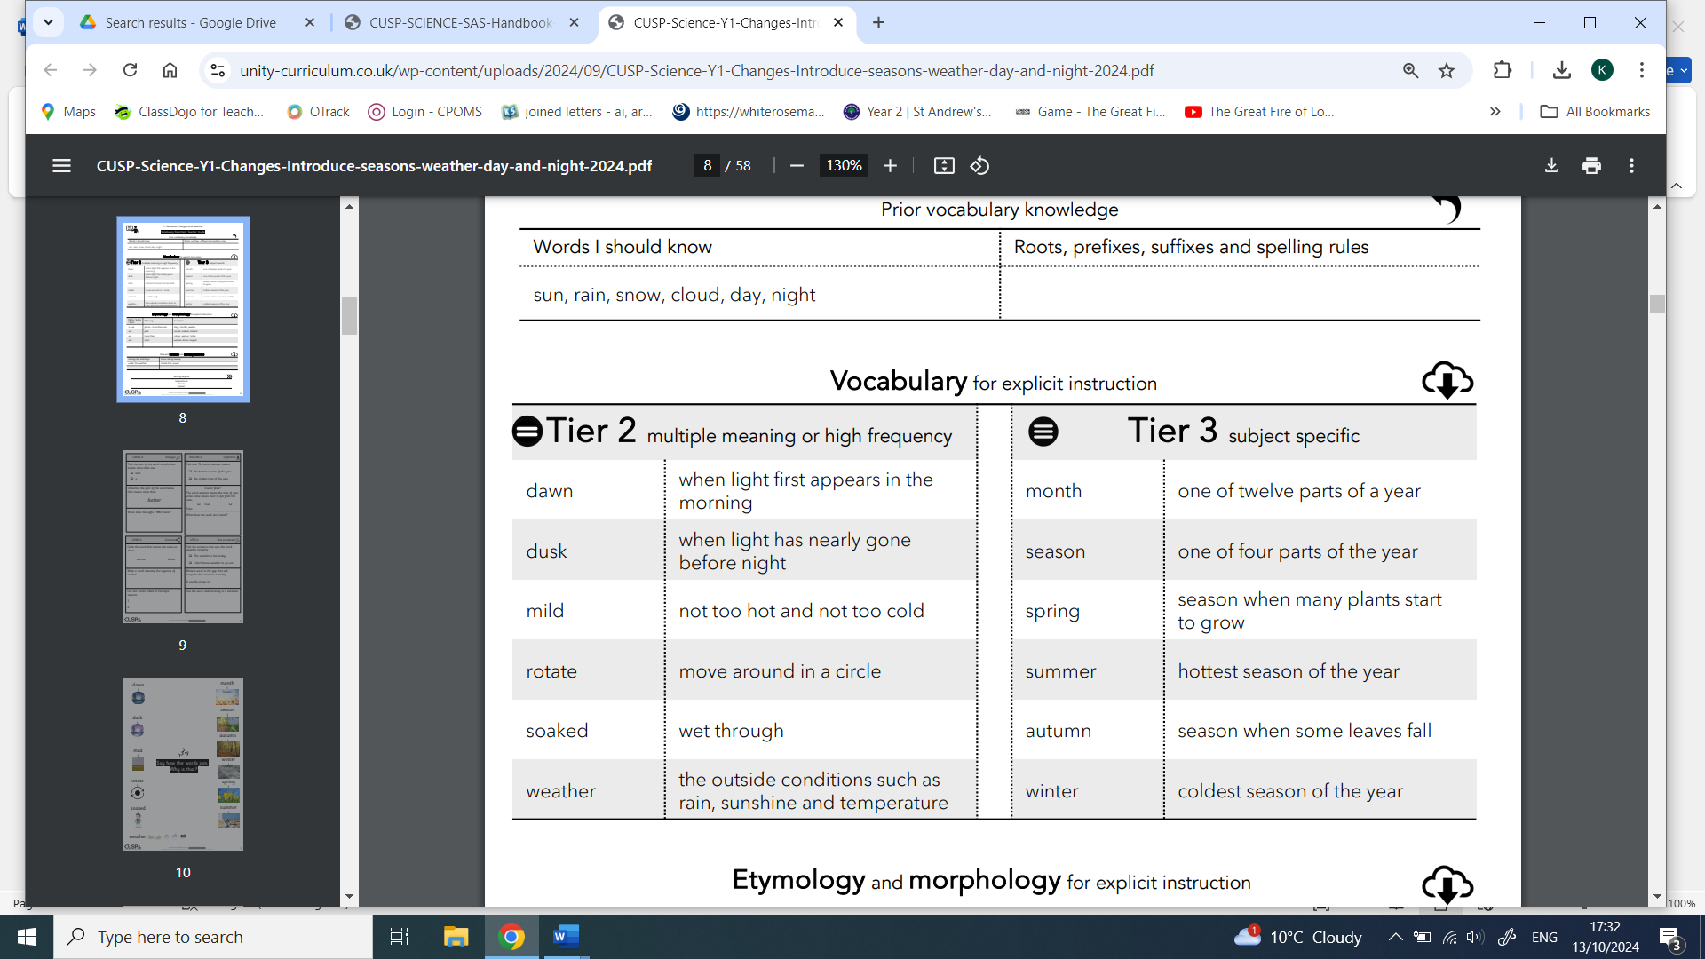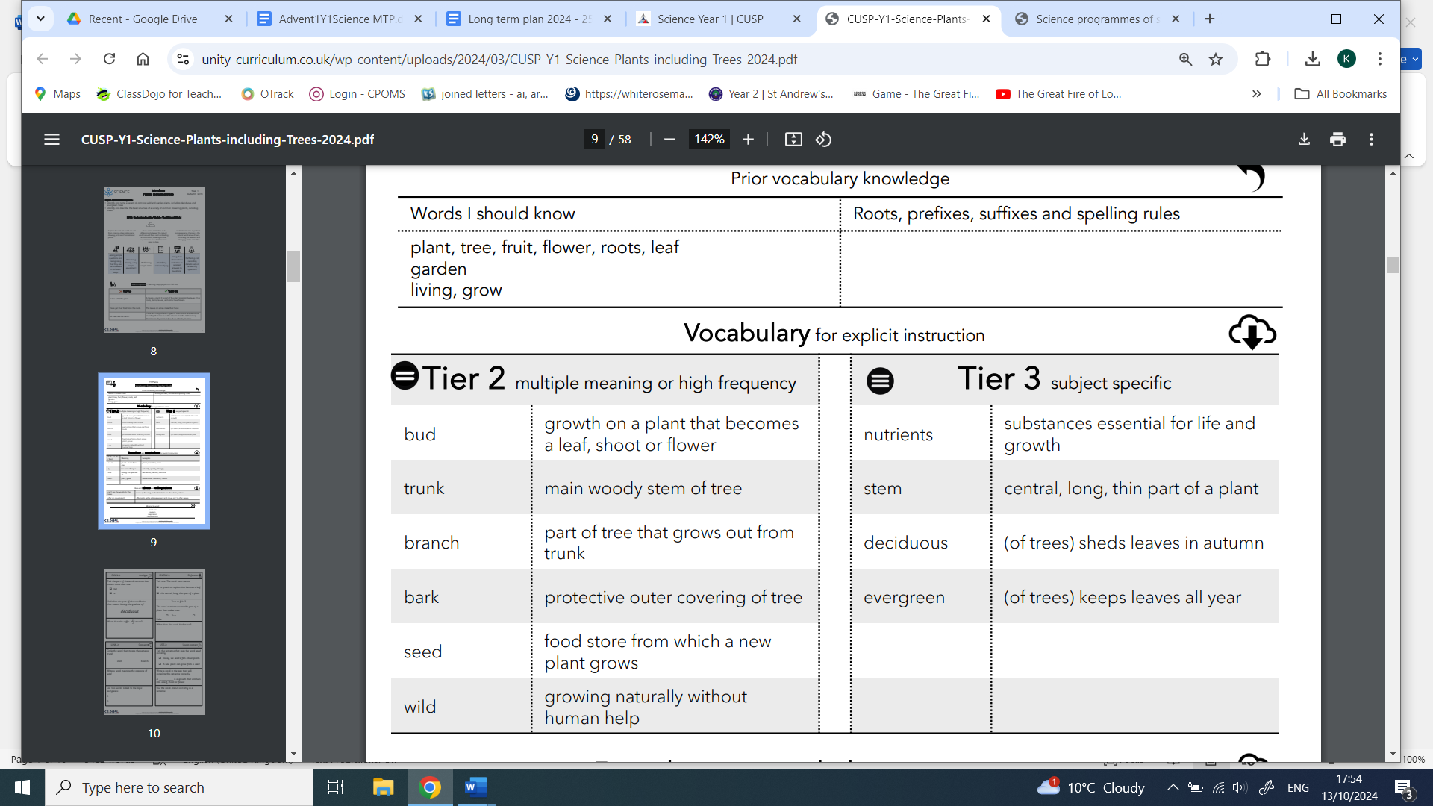

 | Lesson 1 | Lesson 2 | Lesson 3 | Lesson 4 | Lesson 5 | Lesson 6
Learning intention | What are the 4 seasons? | What’s the weather like in Autumn, Winter, Spring and Summer? | Why does day become night? | Plants  What makes a tree? | Plants  What types of trees are there? | Plants  What’s the difference between trees?
Working Scientifically | Observing
Recall and retrieval | hygiene, going to the toilet  Cluster questions: 1-8 | basic needs  Cluster questions: 9-12 | healthy food choices  Cluster questions: 13-15 | Cluster questions:  1-4 | Cluster questions:  5-8 | Cluster questions:  5-8
Sequence of knowledge throughout the lesson | Key knowledge  Know the names of the 4 seasons.  Know which months are in which season.  Be able to identify some of the observable features of each season. | Key knowledge  Name different types of weather and the symbols that represent them.  Sort different weathers into the different seasons. | Key knowledge  Know day is when it is light and where the light originates.  Know night is the absence of day and that at night it is dark.  Explain the earth spins and the sun remains in the same place to create day and night. | Key knowledge  know what a tree is.  Identify parts of a tree.  Know the function of each part of the tree. | Key knowledge  To be able to identify specific trees, the leaves, seeds and whether they are deciduous or evergreen and | Key knowledge  To know the features of an evergreen tree.  To know the features of a deciduous tree.  To be able to identify trees that are deciduous and evergreen.
Scaffolding | pre learning of vocabulary.  Picture of seasons. Match features to the season. | Support to know the different weathers- using pictures clues and pictures of the seasons. | To match day and night words and pictures. | Label matching with picture prompt. | Match trees, leaves and seeds.  Use pictures of evergreen and deciduous. | Sort trees into evergreen and deciduous trees.
Challenge | List of features of each seasons. | Describe the different weathers in each season. | To write about what and day are. | Simple description of the function of the parts of the tree. | Match more trees with leaves, seeds. | Name the features of evergreen and deciduous trees.
Key vocabulary
Tier 2
Key vocabulary Tier 3

