OUR LADY OF GOOD COUNSEL CATHOLIC PRIMARY SCHOOL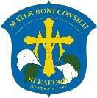

**The Drove, Sleaford, Lincolnshire. NG34 7AT**

**Tel: 01529 304373 ∙ Email:** [**office.admin@our-lady.lincs.sch.uk ∙**](mailto:office.admin@our-lady.lincs.sch.uk) **Website: our-lady.lincs.sch.uk**

**School Terms and Holiday Dates 2025/2026**

|  |  |  |  |
| --- | --- | --- | --- |
|  | INSET days | First teaching day | Last teaching day |
| Term 1 | Tuesday 2nd and  Wednesday 3rd September 2025 | Thursday 4th September 2025 | Friday 24th October 2025 |
| Term 2 | Monday 3rd November 2025 | Tuesday 4th November 2025 | Friday 19th December 2025 |
| Bank Holidays | 25th & 26th December 2025 and 1st January 2026 | | |
| Term 3 | Friday 13th February 2026 | Monday 5th January 2026 | Thursday 12th February 2026 |
| Term 4 |  | Monday 23rd  February 2026 | Thursday 2nd April 2026 |
| Bank Holidays | 3rd and 6th April 2026 | | |
| Term 5 | Friday 22nd May | Monday 20th April 2026 | Thursday 21st May 2026 |
| Bank Holidays | 4th and 25th May 2026 | | |
| Term 6 | Monday 1st  June 2026 | Tuesday 2nd June 2026 | Wednesday 22nd July 2026 |

Our Lady of Good Counsel is part of the

 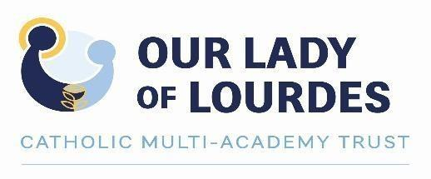  

1st Floor, Loxley House, Riverside Business Park, Tottle Rd, Nottingham NG2 1RT