Dates | week 1  06/01 | week 2  13/01 | week 3  20/01 | week 4  27/01 | week 5  03/02 | week 6  10/02
Events / info | Term begins Tues 7th Jan |  | Thurs 23rd Jan The Gruffalo Hunt- Around the field |  |  | Thurs 8th Feb - Trip to Lincolnshire Wildlife Park.  Fri 14th Feb - Inset Day
Nursery Rhymes / Songs | I’m a Little Hedgehog  Walking in the Forest | 5 Little Speckled Frogs  Five little monkeys  Five candles on a birthday cake rhyme  I spy song - number recognition  Walking in the Forest | Hop Little Bunnies  The Gruffalo song  Crocodile splash  5 little snowmen standing in a row  5 little peas | Down in the Jungle  What will we see in the rainforest?  Walking in the Jungle | 5 Little Monkeys  Walking in the Jungle  One man went to mow  8 in the bed | The Animal Fair  Walking in the Jungle  6 little ducks
UTW Sticky Knowledge | I know a woodland has many trees. | I know that owls, rabbits and foxes live in the woods. | I know that owls, snakes, mice, rabbits and foxes live in the woods. | I know that parrots live in the rainforest. I know that parrots can be many different colours. | I know that rainforests are much bigger than woods. I know that the trees in a rainforest are much taller than those in a woods. | I know that parrots live in the rainforest. I know that parrots like to eat nuts!
UTW Learning Intentions  Under the Canopy | I am beginning to know that a woodland is a habitat covered with trees and vegetation. I am beginning to know some animals which live there. | I am beginning to know woodland sounds and what is making them. I can recall some woodland animals on an outdoor ‘animal hunt’ and use the clues to answer a riddle. | I am beginning to know how to follow a basic map.  l know some animals which can be found in a woodland. I know what a woodland looks like in the winter. | I am beginning to know how a rain forest is different from a woodland and know some animals which live in the rainforest. | I am beginning to know how a rainforest is different from a woodland.  I know how to group animals who live in the woodland and animals who live in the rainforest.  I am beginning to know some sounds of the rainforest. | Trip to Lincolnshire Wildlife Park. I am beginning to know how to follow a basic map of the park. I can recognize some animals which can be found in a rainforest.
Book links |  | A Fox found a box – Ged Adamson | The Gruffalo | The Amazon Rainforest - Geography Planet | Rainforest Adventure - Tony Mitton
Development Matters Links- UtW | Three and four year olds will:  Reception children will be able to:
Expressive Arts and Design  *Creative Area* |  | Pipe cleaner snakes  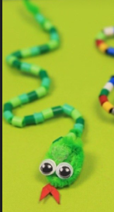 | Paper plate snakes  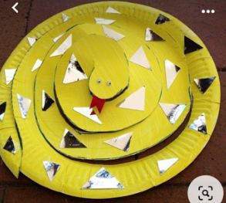 |  | Gruffalo Crumble Tuff tray. | Photographs of animals printed out - tracing, painting opportunities.
Expressive Arts and Design  *Adult-led creative activity* | Woodland scene, cut, paste and colour:  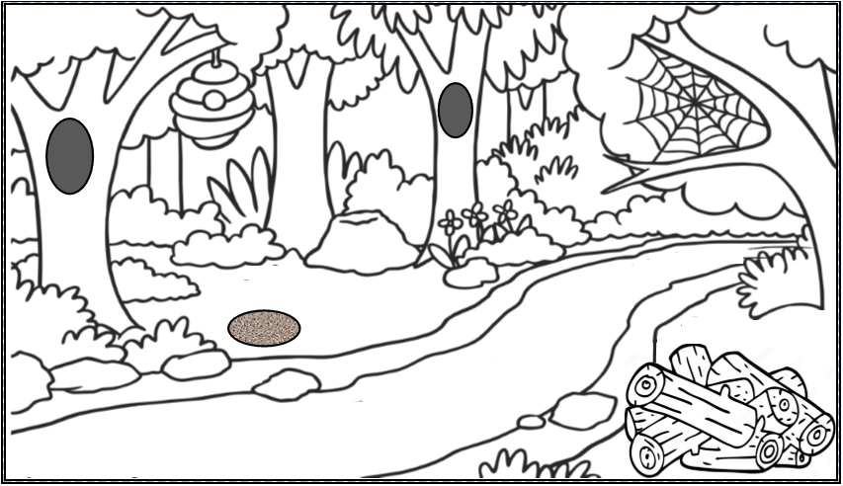 | Tree weaving with plastic needles and wool.   | pop-up snake in a log-pile  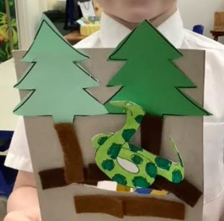 | Parrot mixed media art (focussing on careful colour observation and colouring mixing.) |  | Photography with IPADs at the wildlife park. On return print out and use as reference for craft table.
Development Matters Links-  Expressive Arts and Design- creative table | Expressive arts & design:  Three and four year old will:  - Explore different materials freely, to develop their ideas about how to use them and what to make.  - Develop their own ideas and then decide which materials to use to express them.  - Join different materials and explore different textures.  Reception children will:  - Explore, use and refine a variety of artistic effects to express their ideas and feelings.  - Return to and build on their previous learning, refining ideas and developing their ability to represent them.  - Create collaboratively, sharing ideas, resources and skills  - Sing in a group or on their own  - Develop story-lines in pretend play
Jigsaws / Games | Phonics CVC word jigsaws | Phonics CVC word jigsaws  Scrambled Eggs online game (Twinkl)  0-5 matching pairs using different representations  Five frame - race to zero game  Zero and you’re out circle game  Gruffalo puzzle | Phonics CVC word jigsaws  Woodland Animal Jigsaw puzzles.  The Gruffalo forest game  Online game - Help Panda find one more  Number bonds to 5 online game   | Phonics CVC word jigsaws  Rainforest jigsaw 1-10  Capacity tuff tray game  Online capacity game  Happy Camel . Games . peg + cat | PBS KIDS  Volume, Capacity | Game | TinyTap | Phonics CVC word jigsaws  Jungle snakes and ladders  Jungle 1-10 jigsaw | Phonics CVC word jigsaws  Jungle snakes and ladders  Jungle floor jigsaw
Role play & Small World | Home Corner will remain constant this term - seasonal enhancements  - pretend hot chocolate making
 | ‘The Gruffalo’ Role Play & Small world. |  |  | Rainforest Role Play & Small world.
Development Matters Links-  Small world/ topic table | Communication and Language:  Three and four year olds will:  - Use a wider range of vocabulary.  - Understand a question or instruction that has two parts, such as: “Get your coat and wait at the door”.  - Understand ‘why’ questions, like: “Why do you think the caterpillar got so fat?”  Reception children will:  - Use new vocabulary through the day  - Articulate their ideas and thoughts in well-formed sentences  - Connect one idea or action to another using a range of connectives.  Expressive arts & design:  Three and four year olds will:  - Take part in simple pretend play, using an object to represent something else even though they are not similar.  - Begin to develop complex stories using small world equipment like animal sets, dolls and dolls houses etc.  - Make imaginative and complex ‘small worlds’ with blocks and construction kits, such as a city with different buildings and a park.  Reception children will:  - Explore, use and refine a variety of artistic effects to express their ideas and feelings.  - Develop storylines in their pretend play  Understanding the world:  Three and four year olds will:  - Use all their senses in hands-on exploration of natural materials.  - Explore collections of materials with similar and/or different properties.  - Talk about what they see, using a wide vocabulary.  Reception children will  - Explore the natural world around them.  - Compare and contrast characters from stories.
Maths (enhanced provision) |  | Zero pictures (based on book read ‘Zero is the leaves on the tree)  Zero or not zero sorting activity  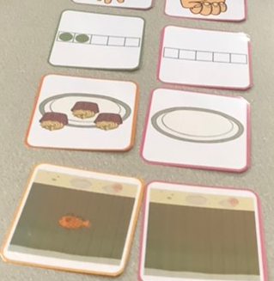  Numicon 1-5 cut and stick  Numicon pictures in tuff tray | Musical instrument beats - 1 more  Ordering 1-5 on washing line - which number is missing? How do you know?  1 less dice game  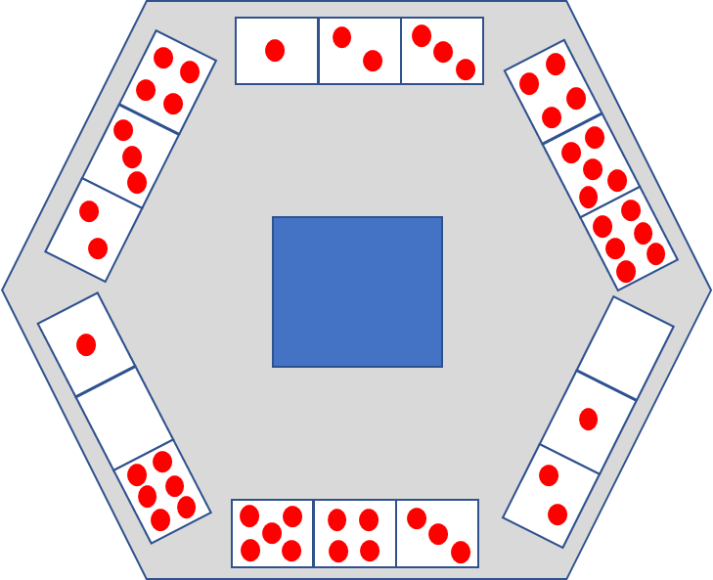  Ladybird number bonds game.  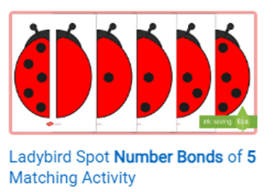 | 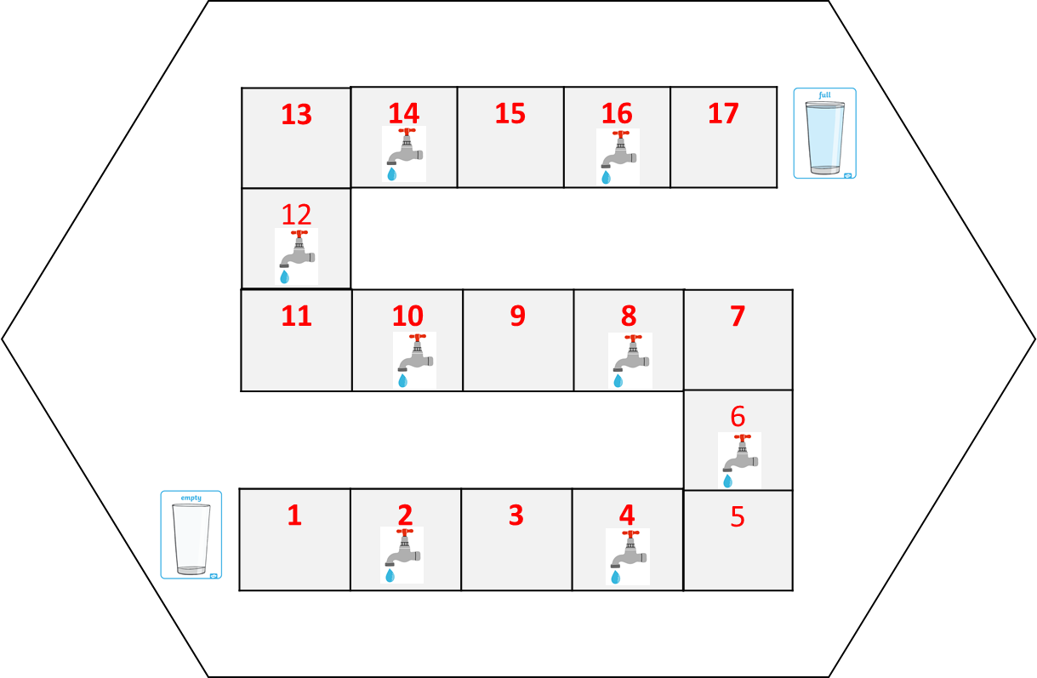  Capacity game  Capacity ordering  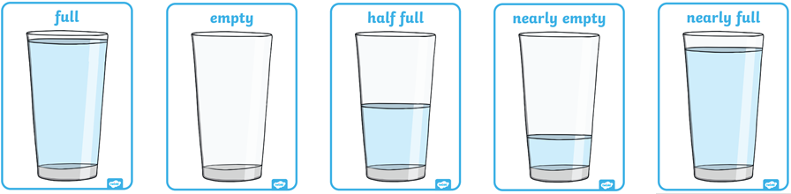 | Ordering 1-8 on washing line - which number is missing? How do you know?  Ordering 1-8 ten frames (one man went to mow.)  Spin the wheel 10 frame game | Tuff tray 6, 7 and 8 numicon templates - making different combinations.  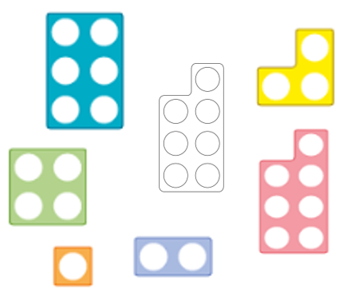
Objective Led WR Maths-  Learning Intentions | 3 day week - No formal maths (maths games during provision.) | I know the concept of zero. I can notice where I see zero. I know that the name ‘zero’ and the numeral ‘0’ can be used to represent this idea.  I know how to use my knowledge of zero to find an amount to five, including zero.  I am beginning to know how to use my skills of perceptual subitising to recognise numbers 1-5 without counting.  I know how to use both counting and subitising skills as a way of checking number representations. | I know how to build on my knowledge of ‘1 more’ working with the numbers to 5, including zero. I can recognise that zero can be a starting point for counting and the number after 0 is 1.  L.I: I know how to build on my knowledge of ‘1 less’ from 1−5 working with the numbers to five including zero. I can recognise that when counting back, I can include zero after 1  I am continuing to develop my understanding that all numbers are made up of smaller numbers and that this can include zero.  I can build on my learning of composition to five and perceptual subitising to develop my understanding of conceptual subitising. | I know how to compare the mass of two objects using the vocabulary ‘heavier’ and ‘lighter’ using a balance scale.  I know that the scales are balanced when the objects on each side have the same mass.  I know how to use non-standard units to measure capacity.  I know how to make direct comparisons about capacity by pouring from one container to another. | I am beginning to know how to find different representations of the numbers 6, 7 and 8.  I am beginning to know how to make my own representations of the numerals 6, 7 and 8  I am beginning to know how to add 1 more when working with numbers up to and including 8.  I am beginning to know that as we count backwards, the numbers get smaller, because we are taking 1 away. | I am beginning to know how my skills of perceptual subitising and counting can be used to see and represent the composition of 6 in different ways.  I am beginning to know how my skills of perceptual subitising and counting can be used to see and represent the composition of 7 in different ways.  I am beginning to know how my skills of perceptual subitising and counting can be used to see and represent the composition of 8 in different ways.
Maths DM/WRM links | Three- and four-year-olds will:  - Develop fast recognition of up to 3 objects, without having to count them individually (‘subitising’).  - Say one number for each item in order: 1,2,3,4,5.  - Know that the last number reached when counting a small set of objects tells you how many there are in total (‘cardinal principle’).  - Show ‘finger numbers’ up to 5.  - Link numerals and amounts: for example, showing the right number of objects to match the numeral, up to 5.  - Solve real world mathematical problems with numbers up to 5.  - Compare quantities using language: ‘more than’, ‘fewer than’.  - Talk about and explore 2D and 3D shapes (for example, circles, rectangles, triangles and cuboids) using informal and mathematical language: ‘sides’, ‘corners’; ‘straight’, ‘flat’, ‘round’.  - Make comparisons between objects relating to size, length, weight and capacity.  - Talk about and identify the patterns around them. For example: stripes on clothes, designs on rugs and wallpaper. Use informal language like ‘pointy’, ‘spotty’, ‘blobs’, etc. Extend and create ABAB patterns – stick, leaf, stick, leaf. Notice and correct an error in a repeating pattern.  Reception children will:  - Count objects, actions and sounds.  - Subitise.  - Link the number symbol (numeral) with its cardinal number value.  - Compare numbers.  - Understand the ‘one more than/one less than’ relationship between consecutive numbers.  - Explore the composition of numbers to 10, focusing on composition of 2, 3, 4 and 5 before moving onto larger numbers.  - Continue, copy and create repeating patterns.  - Compare length, weight and capacity.
Maths-Linked Storytime Books. |  | Zero is the leaves on the tree.  None the number | The ugly 5 | Who sank the boat  Balancing Act  A beach for Albert | Handa’s surprise  Six dinner Sid  Kipper’s toy box | Quack and Count
RWI Phonics | In group 1, children are learning to:  - Read the first 25 Set 1 sounds.  - Blend orally.  - Learn to blend: Word Time 1.1 to 1.3.  - Spell using Fred Fingers.  In group 2, children are learning to:  - Read Set 1 Special Friends  - Read words with Set 1 Special Friends in: Word Time 1.5 and 1.6  - Read Word Times 1.1 to 1.4  - Read 3-sound nonsense words  - Spell using Fred Fingers
Objective Led Literacy-
Talk for Writing Learning Intentions
Adult led literacy outcome
Literacy DM links | Three- and four-year-olds will:  ● Understand the five key concepts about print: print has meaning - print can have different purposes - we read English text from left to right and from top to bottom - the names of the different parts of a book - page sequencing  ● Develop their phonological awareness, so that they can: spot and suggest rhymes - count or clap syllables in a word - recognise words with the same initial sound, such as money and mother  ● Engage in extended conversations about stories, learning new vocabulary.  ● Use some of their print and letter knowledge in their early writing. For example: writing a pretend shopping list that starts at the top of the page; writing ‘m’ for mummy. Write some or all of their name.  ● Write some letters accurately.  Reception children will:  ● Read individual letters by saying the sounds for them.  ● Blend sounds into words, so that they can read short words made up of known letter– sound correspondences.  ● Form lower-case and some capital letters correctly.  ● Read simple phrases and sentences made up of words with known letter–sound correspondences and, where necessary, a few exception words.  - Spell words by identifying the sounds and then writing the sound with letter/s.
Role-play DM links | Communication and Language:  Three- and four-year-olds will:  - Enjoy listening to longer stories and can remember much of what happens.  - Pay attention to more than one thing at a time, which can be difficult.  - Use a wider range of vocabulary.  - Understand ‘why’ questions, like: “Why do you think the caterpillar got so fat?”  - Know many rhymes, be able to talk about familiar books, and be able to tell a long story.  - Use longer sentences of four to six words.  - Use talk to organise themselves and their play: “Let’s go on a bus... you sit there... I’ll be the driver.”  Reception children will:  - Learn new vocabulary and use new vocabulary throughout the day.  - Articulate their ideas and thoughts in well-formed sentences  - Connect one idea or action to another using a range of connectives.  - Develop social phrases.  Expressive arts & design:  Three and four year olds will:  - Take part in simple pretend play, using an object to represent something else even though they are not similar.  - Begin to develop complex stories using small world equipment like animal sets, dolls and dolls houses etc.  - Make imaginative and complex ‘small worlds’ with blocks and construction kits, such as a city with different buildings and a park.  Reception children will:  - Explore, use and refine a variety of artistic effects to express their ideas and feelings.  - Develop storylines in their pretend play.

