Dates | week 1  28/10 | week 2  4/11 | week 3  11/11 | week 4  18/11 | week 5  25/11 | week 6  2/12 | week 7  9/12 | week 8  16/12
Events / info | Leaf Hunt | Bonfire Night  Remembrance Day  6/11 Becky - Forest Skills 4-6  7/11 Becky - Balance Bike CPD 9-11am Bluecoat school, Stamford  Fri 8/11 Open Day  9.30am - 10.30am & 2.30pm - 3.30pm  No formal RSHE - 2 x UTW | Diwali  Anti-bullying week.  Mon 11 /11 Remembrance Day Service in school 10.45am  Fri 15/11 Open Day  9.30am - 10.30am & 2.30pm - 3.30pm | No formal UTW  Fri 22/11 Celebration of Learning Day  8.30am - 9.30am & 2.30pm - 3.30pm | Christmas Traditions (Classroom Decorations) | The Christmas Story (Christmas Card)  Tues 3/12 Pantomime  Fri 6/12  Cosy Craft Afternoon 1.30 - 3 | Thurs 12th Christmas Dinner  Fri 13/12 Celebration Assembly | Tues 17/12 Nativity afternoon 2PM.  Weds 18/12 Nativity Evening 5PM  20/12 Last day of school.
Nursery Rhymes / Songs | 5 Little Speckled Frogs  5 Little Ducks  Autumn Leaves are falling down  Firework song / dance | My hat, it has three corners  Remembrance Day Song | 3 Blind Mice  3 Little Kittens  3 Men in a Tub | 1, 2, 3, 4, 5 Once I caught a fish alive.  The Number 4 | Jack and Jill  One man went to mow.  5 Currant Buns  5 Little Men in a flying saucer  Jingle Bells | Twinkle Twinkle Little Star  Where is it? Preposition song  Where’s the Monkey? Preposition song | Humpty Dumpty | The Grand Old Duke of York
UtW Sticky Knowledge | I know some trees lose their leaves in Autumn.  I know we celebrate bonfire night with bonfires, fire-works and sparklers. | I know that we wear Poppies on Remembrance Day. | I know that Diwali is a festival - also known as ‘The festival of Lights.’ | No Topic this week (2 x RSHE.) | I know some common Christmas traditions in the U.K are decorating the tree and giving gifts to our loved ones. | I know that Jesus was born on what is now known as ‘Christmas Day.’ | No formal UTW - Christmas Nativity | No formal UTW - Christmas Party
UTW Learning Intentions  Seasonal Celebrations | Leaf Hunt - Autumn  I am beginning to know that Autumn is a season.  I know that in Autumn some leaves change colour and some trees lose their leaves.  I know it gets colder in Autumn and we might have to wrap up warm when we go outside. | Bonfire night  I am beginning to know that people in Great Britain celebrate bonfire night every year on 5th November.  I know that some ways we celebrate are by lighting a bonfire, watching fireworks and holding sparklers.  Remembrance Day  I know that we wear a flower called a poppy for Remembrance Day. I know that this is to honour (say thank you to) our brave soldiers. | Diwali  I am beginning to know that Diwali is a Hindu festival and that it is also called a ‘festival of lights.’ I know how to make a Diya lamp and a Rangoli pattern. | No Topic this week (2 x RSHE.) | I am beginning to know that Christmas is a Christian holiday to celebrate the birth of Jesus.  I am beginning to know that many people celebrate Christmas whatever their religious beliefs.  I know some common Christmas traditions in the U.K, for example decorating the tree, singing Christmas carols, putting a stocking out for Father Christmas and putting on a nativity play. | I am beginning to know the Christmas story.  I know that baby Jesus was born in a barn in a town called Bethlehem.  I know Jesus is known by Christians as the son of God.  I know that Jesus’s mother was called Mary. | No formal UTW - Christmas Nativity | Christmas Party (Weds pm)  No RSHE this week.
Book links | We’re going on a Leaf Hunt  Sparks in the sky | Ava’s Poppy | Dipal’s Diwali | No topic this week. | Christmas traditions in the U.K | The Christmas story | The Chtistmas story and other Christmas stories.
Development Matters Links- UtW | Three and four year olds will:  - Begin to understand the need to respect and care for the natural environment and all living things  Reception children will be able to:  - Explore the natural world around them  - Describe what they see, hear and feel whilst outside  - Understand that some places are special to members of their community.
Expressive Arts and Design  *Creative Area* | Autumn Leaf crafts (following leaf hunt on Wednesday.)  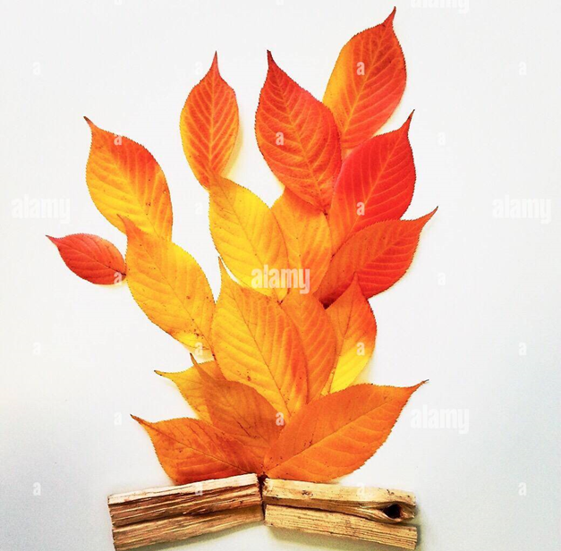  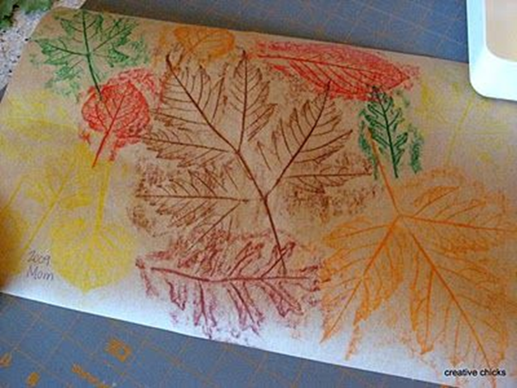  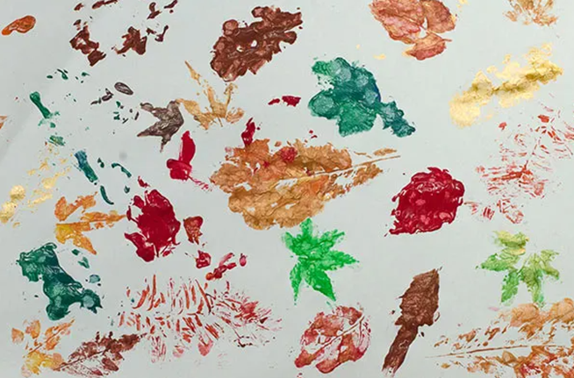  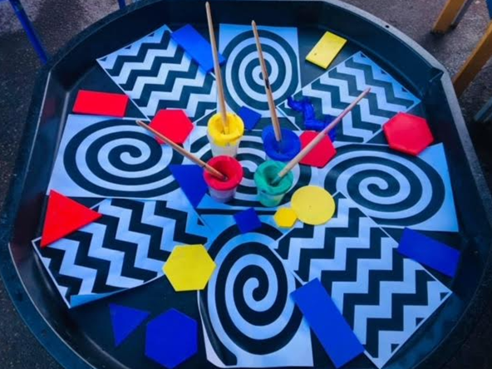 | Fire-work art (continued from the end of week 2)  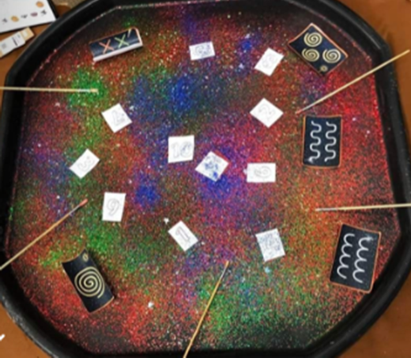  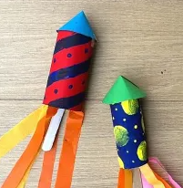  Poppy plate:  (using apple to stamp poppy)  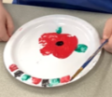 | Bead Rangoli patterns:  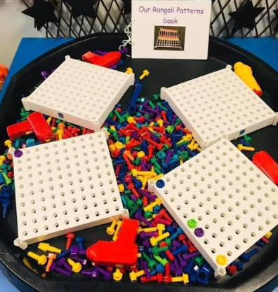  Hama bead Rangoli patterns  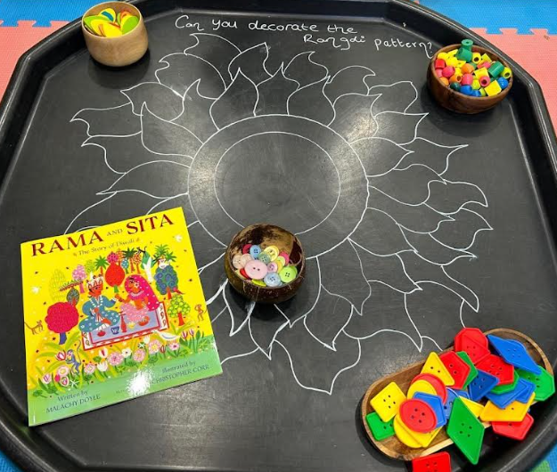  Rangoli design:  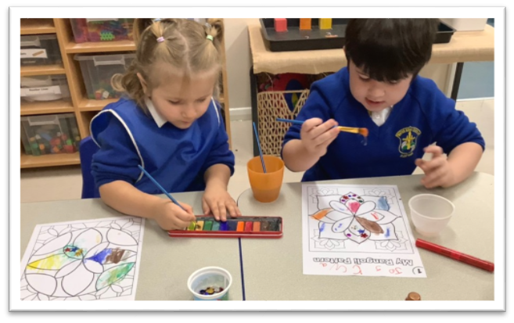 | Room on the Broom crafts:  Witches face.  Witch dress up scratch art  Witches necklaces threading (coloured pasta shells.) | Room on the Broom crafts:  Witch themed sun-catchers.  Witch themed mosaic art. | Christmas crafts:  Shrinkles  Scratch art tree decorations  Angel craft  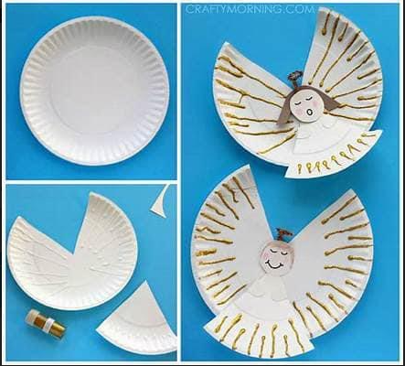 | Christmas crafts.  Snowmen  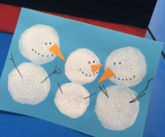  Christmas tree collage    Make a wise man crown  fern painting  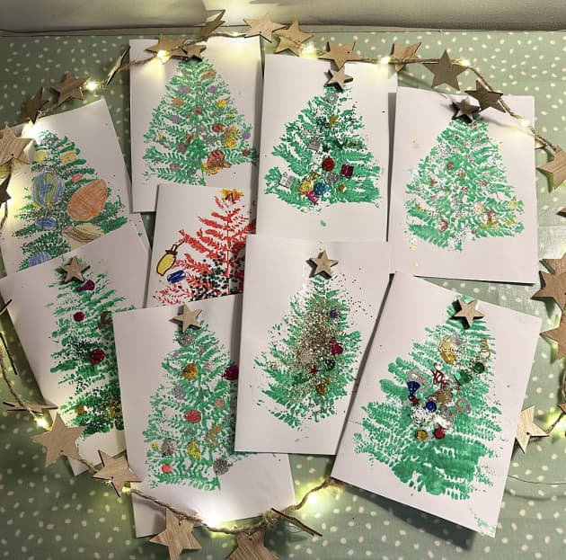  Christmas lights tuff tray.  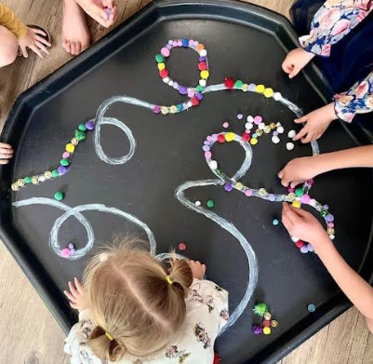  Christmas tree tuff tray  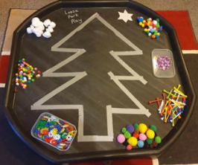  Christmas snowflakes tuff tray  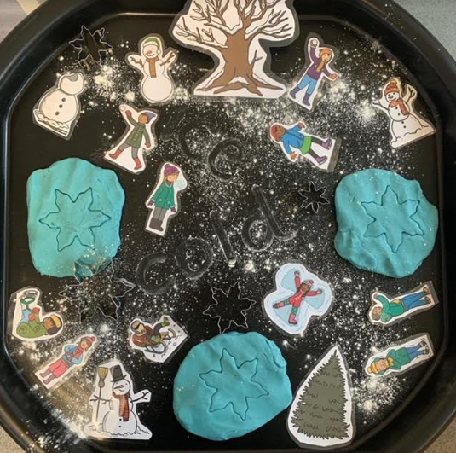 | Gingerbread man tuff tray  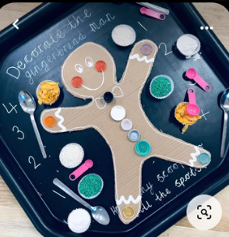  Winter jumper tuff tray  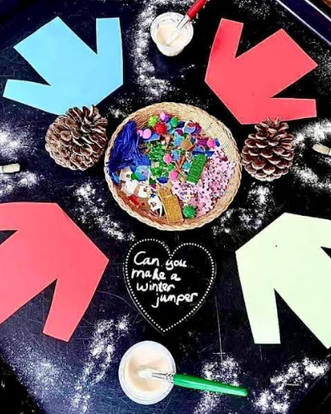  Cosy Christmas crafts afternoon:  Tree decorations  Paper-chains  Gingerbread men cards  Decorate gingerbread men  Christmas tree wool craft:  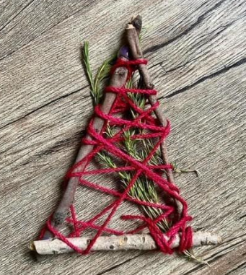  Snowmen:  
Expressive Arts and Design  *Adult-led creative activity* | Leaf art:  Experimenting mixing Autumn colours and adding leaves from leaf hunt around the frame.    Firework art:  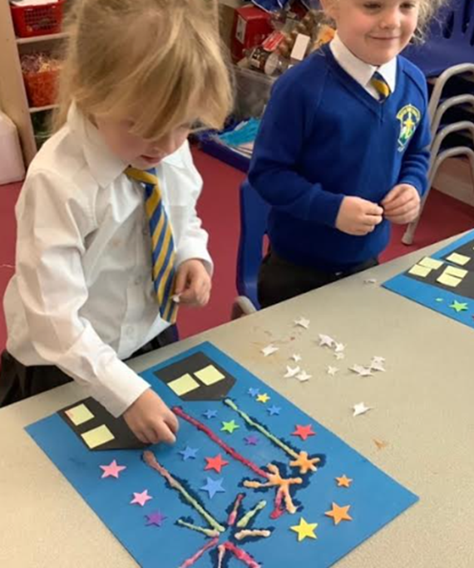  Firework dancing | Poppy stone:    Poppy life drawings  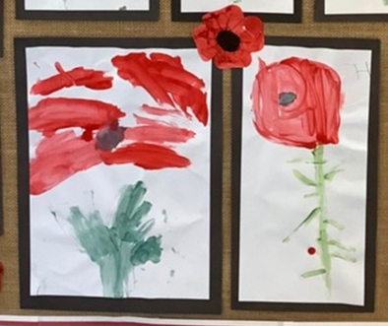 | Diya lamp:  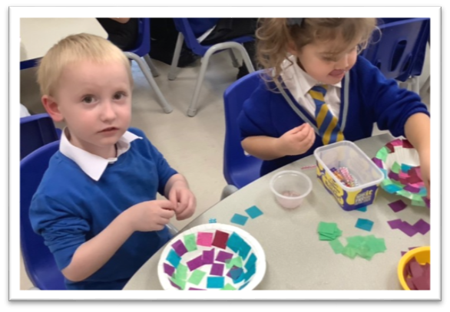  Salt Dough Rangoli  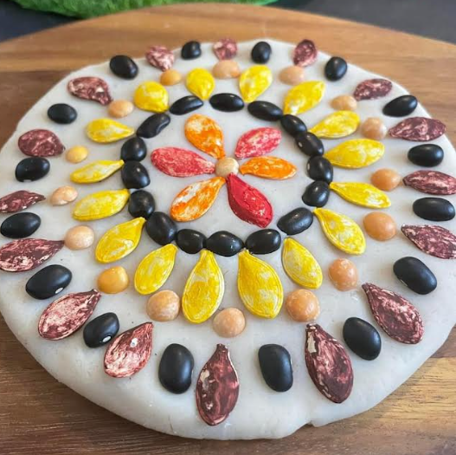  Diwali Dancing:  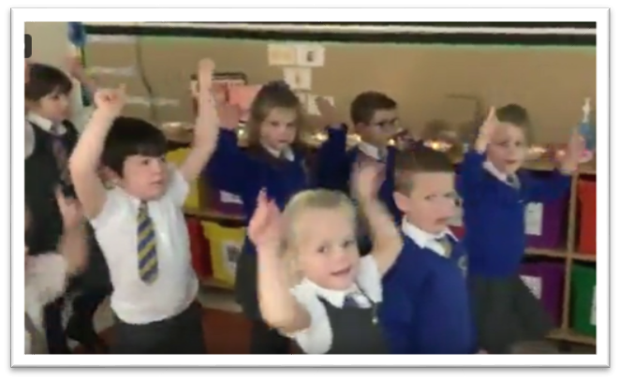 | RSHE sadness:  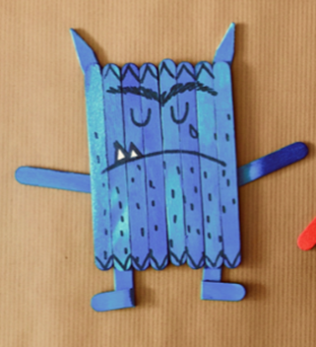  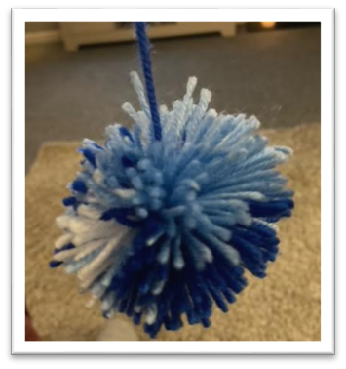  RSHE Happiness:  Happiness monster. | Christmas suncatcher decorations x 4 (in groups) These are to decorate the classroom.  (Pictures to follow)  Red anger colour monster sensory bottles.  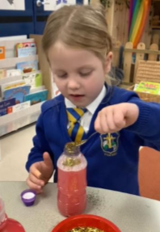 | Christmas card - nativity scene.  Colour monster - Worry. | Christmas baking.
Development Matters Links-  Expressive Arts and Design- creative table | Expressive arts & design:  Three and four year old will:  - Explore different materials freely, to develop their ideas about how to use them and what to make.  - Develop their own ideas and then decide which materials to use to express them.  - Join different materials and explore different textures.  Reception children will:  - Explore, use and refine a variety of artistic effects to express their ideas and feelings.  - Return to and build on their previous learning, refining ideas and developing their ability to represent them.  - Create collaboratively, sharing ideas, resources and skills  - Sing in a group or on their own  - Develop story-lines in pretend play
Jigsaws / Games | Room on the broom jigsaws  Duck ‘one less’ track game | Room on the broom jigsaws | Maths Bingo  Online matching pairs | Room on the broom wands and broomsticks. | Five currant buns track game.  Help panda find one more online game.  Number street:  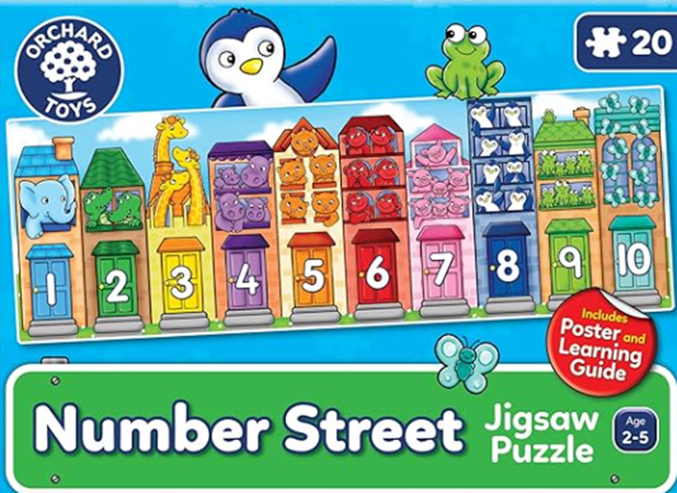 | Colour monster emotion bingo | Online shape matching pairs.  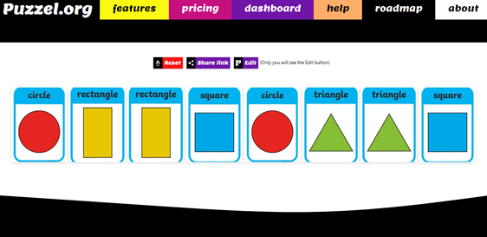  Elf numicons  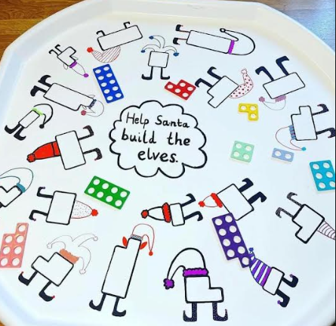
Role play & Small World | Home Corner will remain constant this term - seasonal celebration enhancements.
 | Room on the Broom Role Play & Small world. |  |  |  | Winter Wonderland.
Development Matters Links-  Small world/ topic table | Communication and Language:  Three and four year olds will:  - Use a wider range of vocabulary.  - Understand a question or instruction that has two parts, such as: “Get your coat and wait at the door”.  - Understand ‘why’ questions, like: “Why do you think the caterpillar got so fat?”  Reception children will:  - Use new vocabulary through the day  - Articulate their ideas and thoughts in well-formed sentences  - Connect one idea or action to another using a range of connectives.  Expressive arts & design:  Three and four year olds will:  - Take part in simple pretend play, using an object to represent something else even though they are not similar.  - Begin to develop complex stories using small world equipment like animal sets, dolls and dolls houses etc.  - Make imaginative and complex ‘small worlds’ with blocks and construction kits, such as a city with different buildings and a park.  Reception children will:  - Explore, use and refine a variety of artistic effects to express their ideas and feelings.  - Develop storylines in their pretend play  Understanding the world:  Three and four year olds will:  - Use all their senses in hands-on exploration of natural materials.  - Explore collections of materials with similar and/or different properties.  - Talk about what they see, using a wide vocabulary.  Reception children will  - Explore the natural world around them.  - Compare and contrast characters from stories.
Maths (enhanced provision) | Building towers to illustrate stories with ‘one more’ concepts.  Acting out stories with a ‘one less’ concept, using a five frame / cubes to represent characters.  Hook a duck - make the number on the bottom - what is one less?  Duck track game.  Double sided counters - explore different variations of 3 (extend to 5)  Potions for ‘Room on the broom’ discussions ‘how many spoonfuls are you going to add? Can you add one more? etc. | Sorting triangles and circles tuff tray.  ‘Circle to the rescue’ colouring.  Shape printing.  Circle and triangle 2D shape tangrams.  Matching pairs online game.  Circle and triangle shape hunt around the school.  Shape monsters online game.  ‘Triangle to the rescue’ colouring.  Witch cut and stick (circles and triangles)  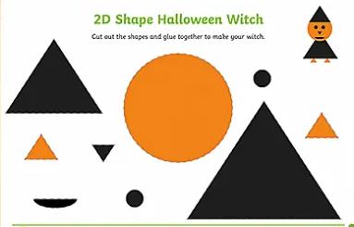 | Small world tuff trays exploring the composition of 1-3:  3 little kittens  3 blind mice  3 men in a tub  3 little pigs | 4 & 5 sorting game.  1-5 matching pairs.  5 and you’re out circle game.  Tile arrangements (4 & 5)  Numerals 0-5 peg boards. | One more block activity:  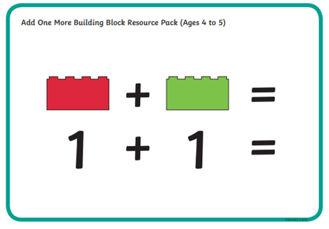  Currant bun track game:  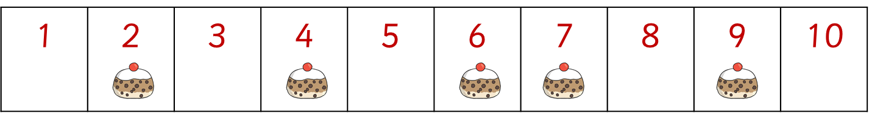  Count down 5-0  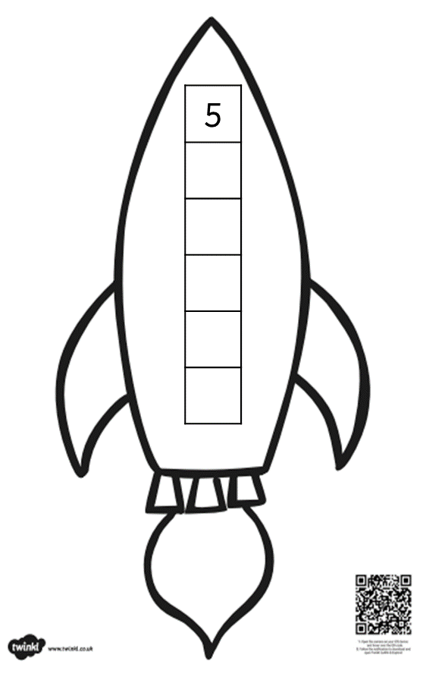  Tuff Tray - numicon, different ways to make 5 (rockets) | Count & Colour  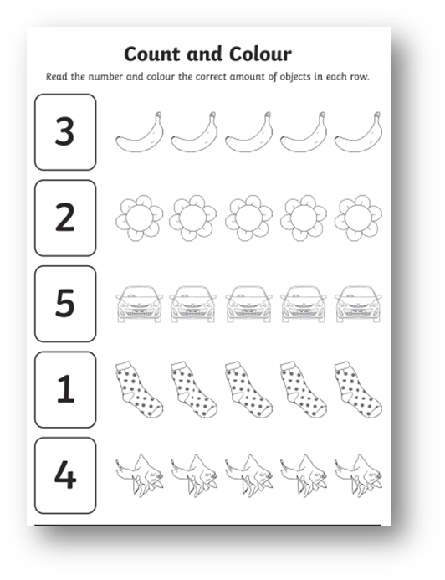  Rosie’s Walk Tuff Tray  Repeating patterns  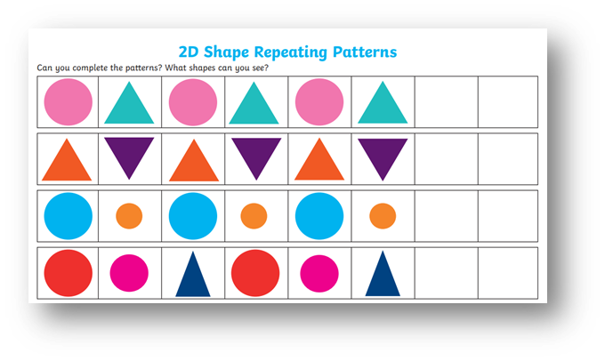  Shape pictures  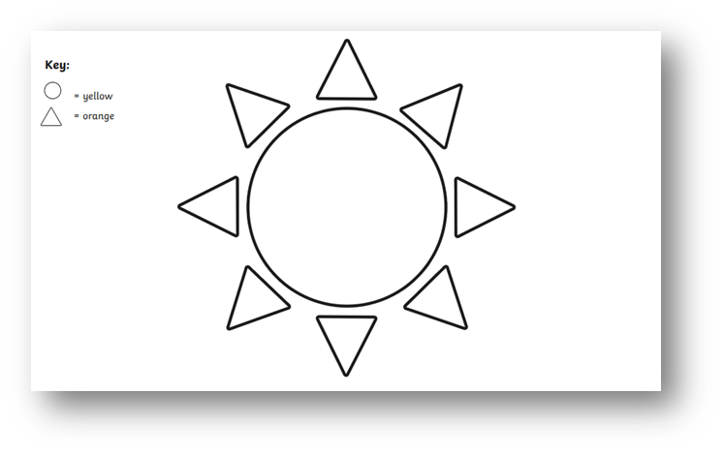 | Square and rectangle lolly-pop sticks  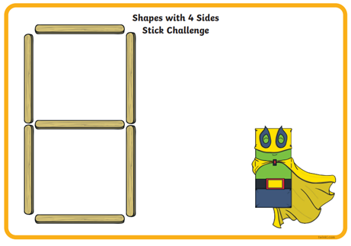  Square and rectangle tuff tray
Objective Led WR Maths-  Learning Intentions | To know the principle of one more.  To know the principle of one more.  To begin to know that all numbers are made up of smaller numbers. | To begin to know the properties of circles and triangles and notice them around.  I am beginning to know how to compare circles and triangles.  I am beginning to know how to find circles and triangles in the environment. | Week consolidation of number composition 1-3 in preparation for moving on next week.  I know that all numbers are made up of small numbers. | I am beginning to know different representations of 4 and 5.  I am continuing to develop the skill of perceptual subitising.  I know how to make my own representations of 4 and 5 using different objects. | I am beginning to know the concept of 1 more, working with numbers up to 5.  I am beginning to know the concept of 1 less, working with numbers up to 5. | I am beginning to use positional language to describe how items are positioned in relation to other items. | I am beginning to notice squares and rectangles all around me and begin to describe their properties.  I am beginning to know how shapes can be combined to make new shape.  I am beginning to identify squares and rectangles in the environment.
Maths DM/WRM links | Three- and four-year-olds will:  - Develop fast recognition of up to 3 objects, without having to count them individually (‘subitising’).  - Say one number for each item in order: 1,2,3,4,5.  - Know that the last number reached when counting a small set of objects tells you how many there are in total (‘cardinal principle’).  - Show ‘finger numbers’ up to 5.  - Link numerals and amounts: for example, showing the right number of objects to match the numeral, up to 5.  - Solve real world mathematical problems with numbers up to 5.  - Compare quantities using language: ‘more than’, ‘fewer than’.  - Talk about and explore 2D and 3D shapes (for example, circles, rectangles, triangles and cuboids) using informal and mathematical language: ‘sides’, ‘corners’; ‘straight’, ‘flat’, ‘round’.  - Make comparisons between objects relating to size, length, weight and capacity.  - Talk about and identify the patterns around them. For example: stripes on clothes, designs on rugs and wallpaper. Use informal language like ‘pointy’, ‘spotty’, ‘blobs’, etc. Extend and create ABAB patterns – stick, leaf, stick, leaf. Notice and correct an error in a repeating pattern.  Reception children will:  - Count objects, actions and sounds.  - Subitise.  - Link the number symbol (numeral) with its cardinal number value.  - Compare numbers.  - Understand the ‘one more than/one less than’ relationship between consecutive numbers.  - Explore the composition of numbers to 10, focusing on composition of 2, 3, 4 and 5 before moving onto larger numbers.  - Continue, copy and create repeating patterns.  - Compare length, weight and capacity.
Maths-Linked Storytime Books. | Just one more!  3 Billy Goats Gruff | Triangle by Mac Barnett  Circle by Mac Barnett | The 3 Little Pigs | Witches 4  Pete the cat and his 4 groovy buttons.  Kipper’s Birthday by Mick Inkpen | The Very Hungry Caterpillar by Eric Carle  Stella to Earth! by Simon Puttock and Philip Hopman | We’re Going on a Bear Hunt.  Rosie’s Walk  Hide & Seek (introduction to prepositions.) | Bear in a Square by Stella Blackstone  Square by Mac Barnett and Jon Klassen  Shapes, Shapes, Shapes by Tana Hoban  Night Monkey, Day Monkey by Julia Donaldson  The Fox in the Dark by Alison Green
RWI Phonics | Children are learning to:  - Read the first 25 Set 1 sounds.  - Blend orally.  - Learn to blend: Word Time 1.1 to 1.4.  - Spell using Fred Fingers. |  |  |  | Children are learning to:  - Read 25 Set 1 single-letter sounds speedily.  - Blend independently using Phonics Green Word cards: Word Time 1.1 to 1.4  - Spell using Fred Fingers.
Objective Led Literacy-  Talk for Writing Learning Intentions | To spell words by identifying the sounds and then writing the sounds with the corresponding letter. | To know how to sequence events in a familiar story. |  | To spell words by identifying the sounds and then writing the sounds with the corresponding letter. | To spell words by identifying the sounds and then writing the sounds with the corresponding letter. |  | To spell words by identifying the sounds and then writing the sounds with the corresponding letter.
Adult led literacy outcome | Potion making - drawing & writing ingredients. | Learning the story, adding actions, practising with props.  Story sequencing. |  | Creating story maps with labels. | Innovated story maps.  Character descriptions. |  | Writing the innovated story using sequenced pictures, following the innovated story map.
Literacy DM links | Three- and four-year-olds will:  ● Understand the five key concepts about print: print has meaning - print can have different purposes - we read English text from left to right and from top to bottom - the names of the different parts of a book - page sequencing  ● Develop their phonological awareness, so that they can: spot and suggest rhymes - count or clap syllables in a word - recognise words with the same initial sound, such as money and mother  ● Engage in extended conversations about stories, learning new vocabulary.  ● Use some of their print and letter knowledge in their early writing. For example: writing a pretend shopping list that starts at the top of the page; writing ‘m’ for mummy. Write some or all of their name.  ● Write some letters accurately.  Reception children will:  ● Read individual letters by saying the sounds for them.  ● Blend sounds into words, so that they can read short words made up of known letter– sound correspondences.  ● Form lower-case and some capital letters correctly.  ● Read simple phrases and sentences made up of words with known letter–sound correspondences and, where necessary, a few exception words.  - Spell words by identifying the sounds and then writing the sound with letter/s.
Role-play DM links | Communication and Language:  Three- and four-year-olds will:  - Enjoy listening to longer stories and can remember much of what happens.  - Pay attention to more than one thing at a time, which can be difficult.  - Use a wider range of vocabulary.  - Understand ‘why’ questions, like: “Why do you think the caterpillar got so fat?”  - Know many rhymes, be able to talk about familiar books, and be able to tell a long story.  - Use longer sentences of four to six words.  - Use talk to organise themselves and their play: “Let’s go on a bus... you sit there... I’ll be the driver.”  Reception children will:  - Learn new vocabulary and use new vocabulary throughout the day.  - Articulate their ideas and thoughts in well-formed sentences  - Connect one idea or action to another using a range of connectives.  - Develop social phrases.  Expressive arts & design:  Three and four year olds will:  - Take part in simple pretend play, using an object to represent something else even though they are not similar.  - Begin to develop complex stories using small world equipment like animal sets, dolls and dolls houses etc.  - Make imaginative and complex ‘small worlds’ with blocks and construction kits, such as a city with different buildings and a park.  Reception children will:  - Explore, use and refine a variety of artistic effects to express their ideas and feelings.  - Develop storylines in their pretend play.

