Dates | week 1  4/9 | week 2  9/9 | week 3  16/9 | week 4  23/9 | week 5  30/9 | week 6  7/10 | week 7  14/10
Events / info | 04/09 & 05/09 inset days | Ask parents for any envelope donations for our post-office. | Ask parents to bring in a postal stamp. | Trip to post-box to post letter | Ask parents for boxes (for fire-engines week 7.) | Fire-fighter visit  11/10 Friday 1.30pm
Nursery Rhymes | Dingle Dangle Scarecrow (Harvest)  Happy and You Know It | Dingle Dangle Scarecrow (Harvest)  Head, Shoulders, Knees and Toes | Dingle Dangle Scarecrow (Harvest) | Dingle Dangle Scarecrow (Harvest)  Head, Shoulders, Knees and Toes | Dingle Dangle Scarecrow (Harvest)  Dr Foster Went to Gloucester | Dingle Dangle Scarecrow (Harvest)  Happy and You Know It | Dingle Dangle Scarecrow (Harvest)  Dr Foster Went to Gloucester
Sticky Knowledge | IN CLASS  I am beginning to know my way around the classroom and outdoor spaces.  No Topic | AT SCHOOL  I know who my teachers are. I know who the head teacher is. I can find my way to the lunch hall and back.  2 x Topic | DOCTORS  I know that doctors help us when we feel poorly.  1 x Topic | POSTAL WORKERS  I know that postal workers help us by delivering our letters and parcels.  2 x Topic | DENTISTS  I know that dentists help us to keep our teeth healthy.  1 x Topic | FIRE-FIGHTERS  I know that fire-fighters help us by putting out fires and keeping us safe.  2 x Topics | No Topic - begin nativity songs practise.
UTW Learning Intentions  People Who Help Us. | I am beginning to know how to talk about myself and my family to others.  I am beginning to know that our classroom is a safe space where we are a family.  I am beginning to know my way around the classroom and outdoor spaces. | I am beginning to know my way around parts of the school.  I know that teachers are there to help me.  I know the names of the adults in my class. | I am beginning to know that doctors and nurses look after us in hospital if we hurt ourselves or get sick.  I am beginning to know that a hospital is a safe place to help us get better. | I am beginning to know that we can post letters through a post box.  I am beginning to know that letters need a stamp.  I am beginning to know that the postal worker collects the letters and delivers them around the town. | I am beginning to know what a dentist surgery looks like.  I am beginning to know that too many sugary foods and drinks are harmful for our teeth.  I am beginning to know that healthy foods such as fruits, vegetables, cheese, milk and water are good for our teeth. | I know that fire-fighters help put out fires.  I know that a fire-fighter wears special safety wear.  I know what it feels like to aim and spray a fire-fghters hose.  I am beginning to know what the inside of a fire truck looks like.
Book links | Our class is a family  https://youtu.be/rw9NstM1Q4E  The family book https://youtu.be/AyVL9bH0guk  Howard Wrigglebottom learns to listen.  https://youtu.be/HH0rQiwKtSs  A letter from your teacher on the first day of school  https://youtu.be/AwCJ_Kf2hBk  This school year will be the best  https://youtu.be/sByRm6EPSzU  Schools first day at school  https://youtu.be/OND71PGW67Q | Owl babies  The invisible string  Teachers Rock https://youtu.be/lPz7rlTmyx4  Because I had a teacher https://youtu.be/IfJjiotHotA | Hard back books:  At the Hospital  Busy Ambulance  We’re going to the Doctor  I want to be a Doctor | Hard back books:  Postman Pat - Pat’s busy day  I want to be a postal worker  It came in the mail:  https://youtu.be/lz0KD4feq8A?si=eLYEki_taXkpvmG0 | Hard back books:  Let’s brush our teeth  We’re going to the dentist  Peppa Pig at the dentist | Hard back books:  I want to be a fire-fighter  How a fire engine works
Development Matters Links- UtW | Three and four year olds will:  - Understand the key features of the life cycle of a plant and an animal  - Begin to understand the need to respect and care for the natural environment and all living things  Reception children will be able to:  - Explore the natural world around them  - Describe what they see, hear and feel whilst outside  - Understand that some places are special to members of their community.
Expressive Arts and Design  *Creative Area* | All about me crafts:  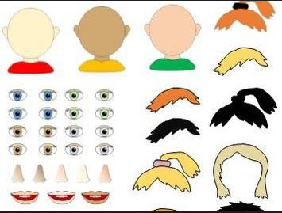  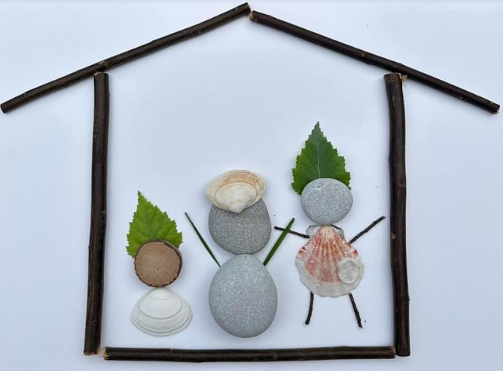  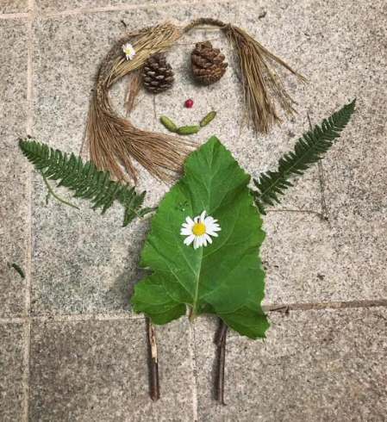 | All about me crafts:  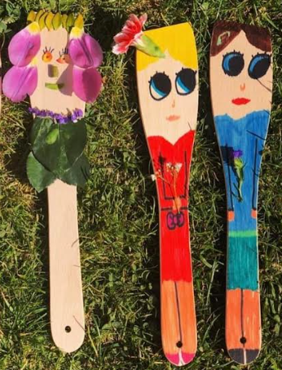  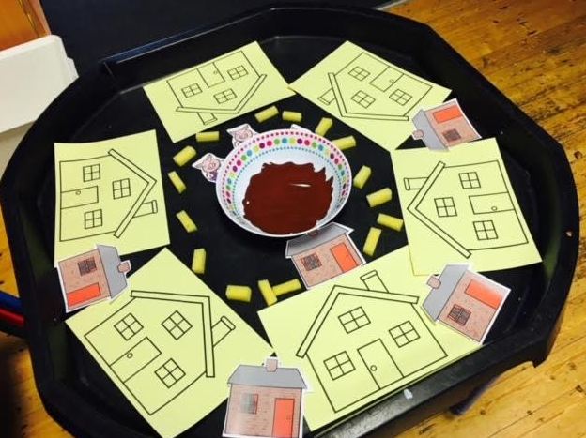  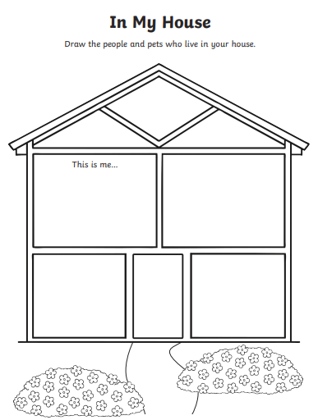 | Hospital Crafts:  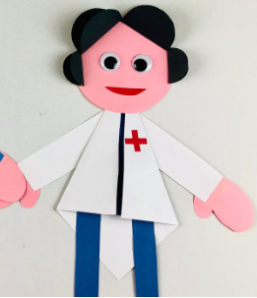  Colouring in:  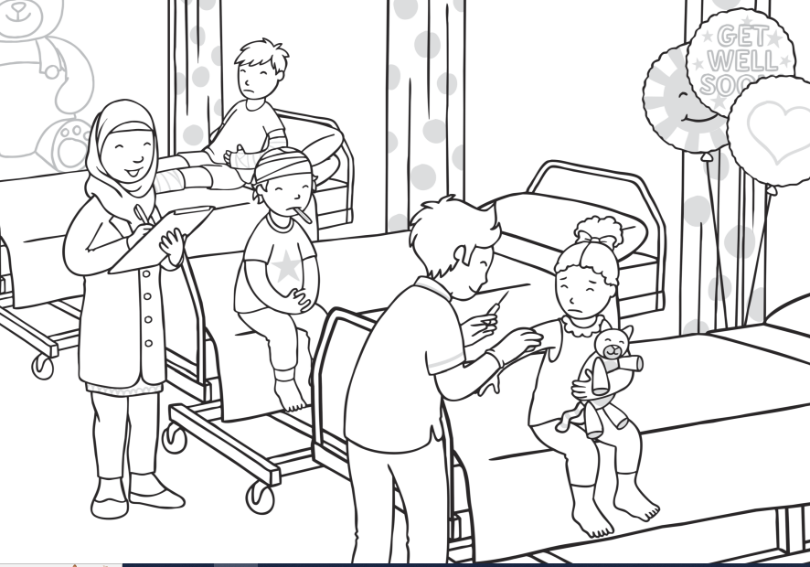  Colour by numbers  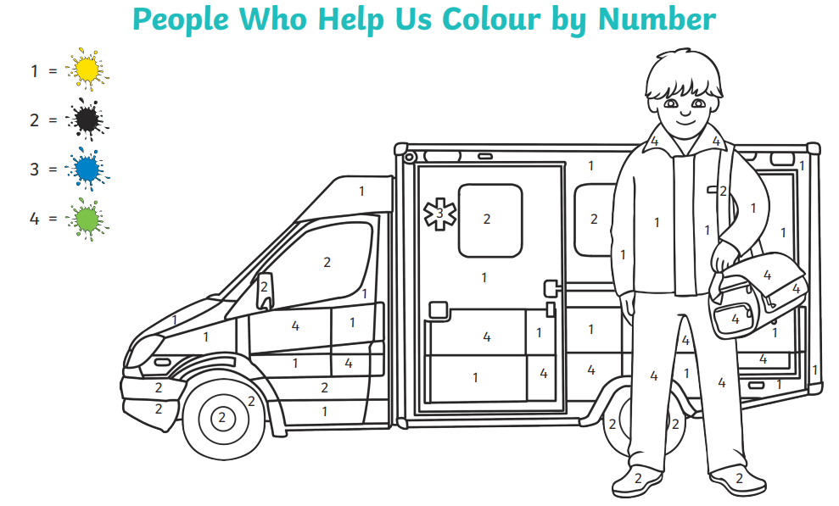  Ambulance cur & paste  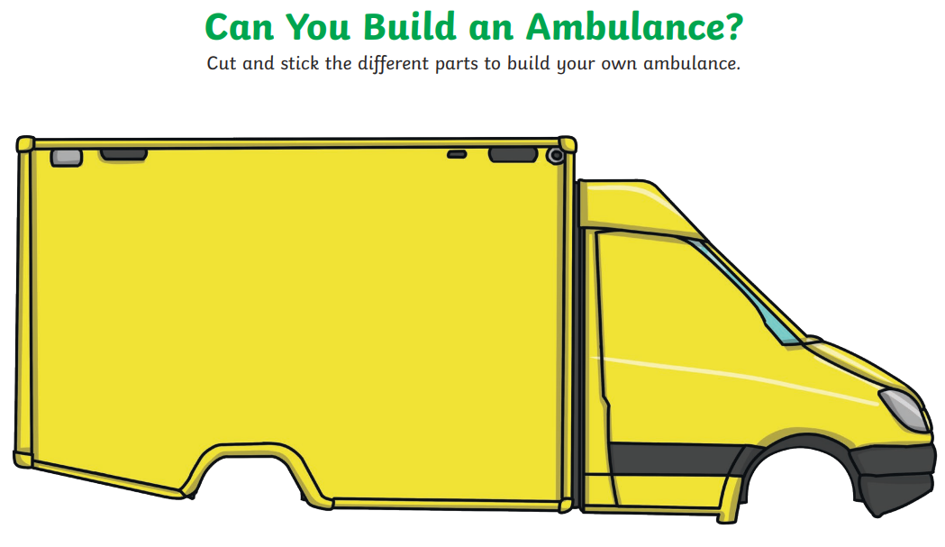 | .Colouring in:  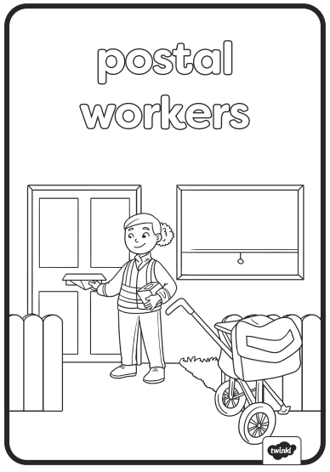  Cone people:  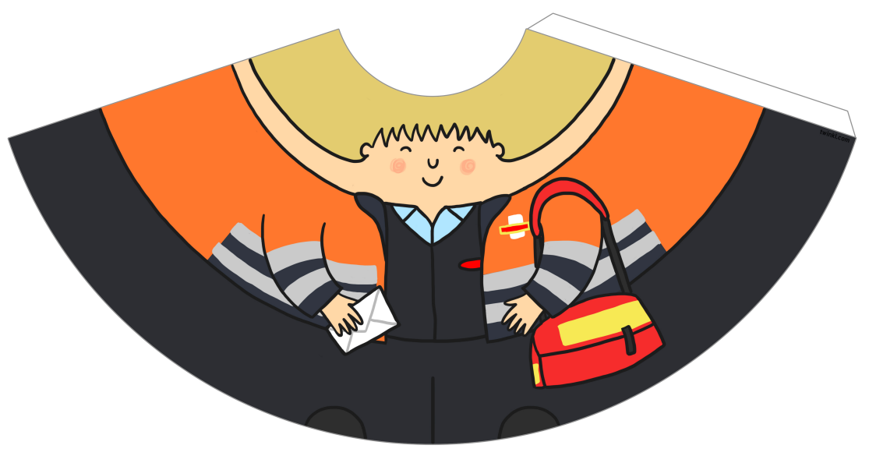 | Colouring in:  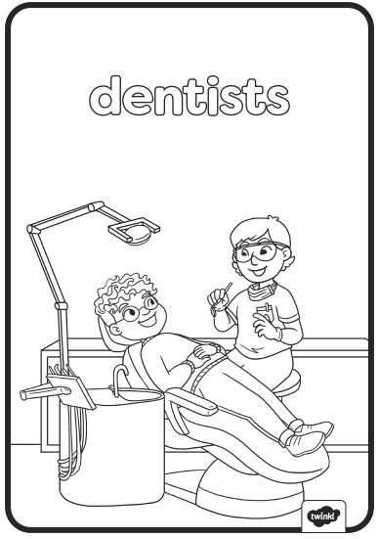  Paper plate smile:  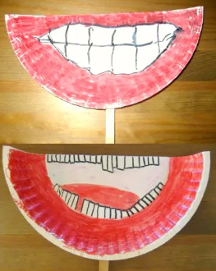  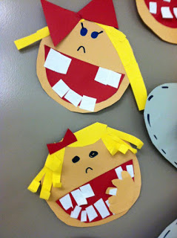  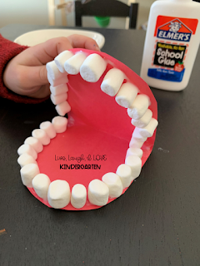 | Colouring in:  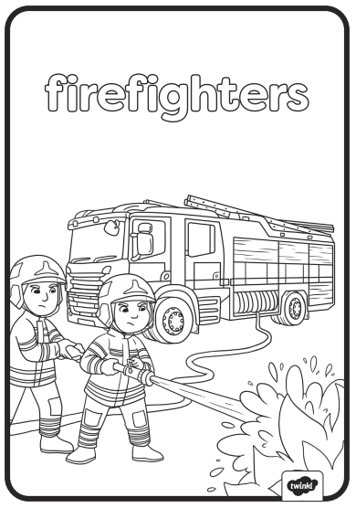  Fire-Engine cut and stick  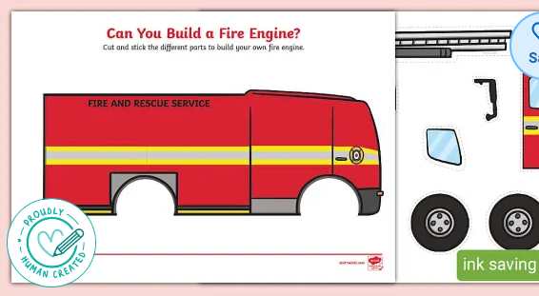  Fire-fighter cut and stick:  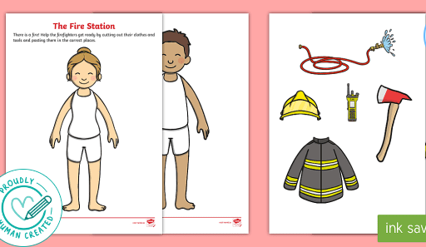  Fire-Engine:  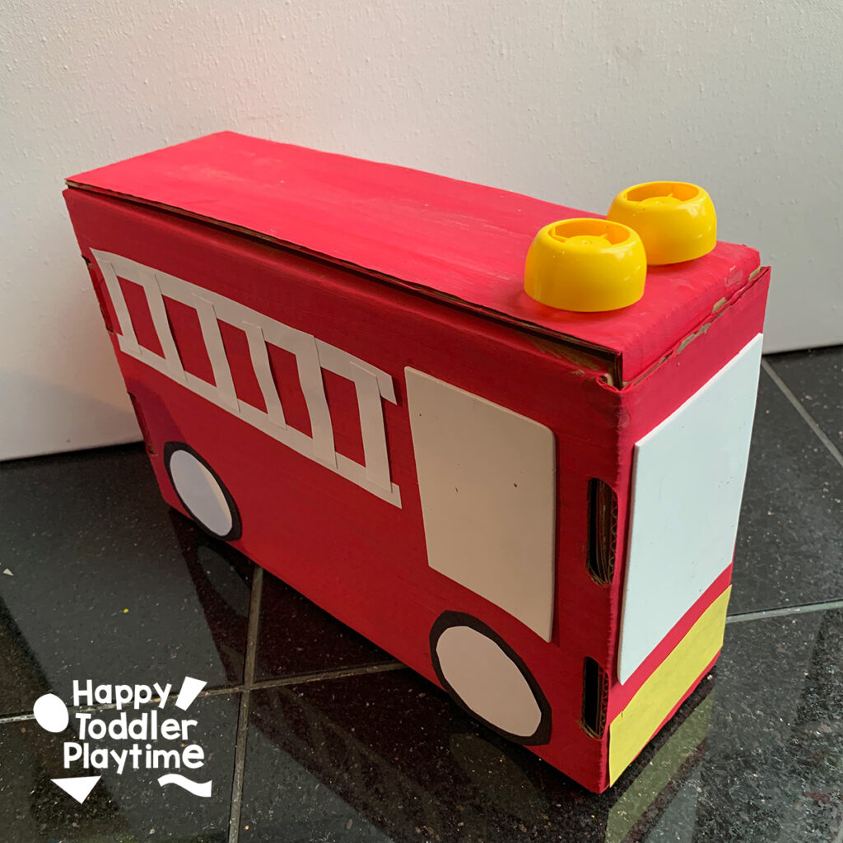
Expressive Arts and Design  *Adult-led creative activity* | Self-portrait paper chain cut-out:  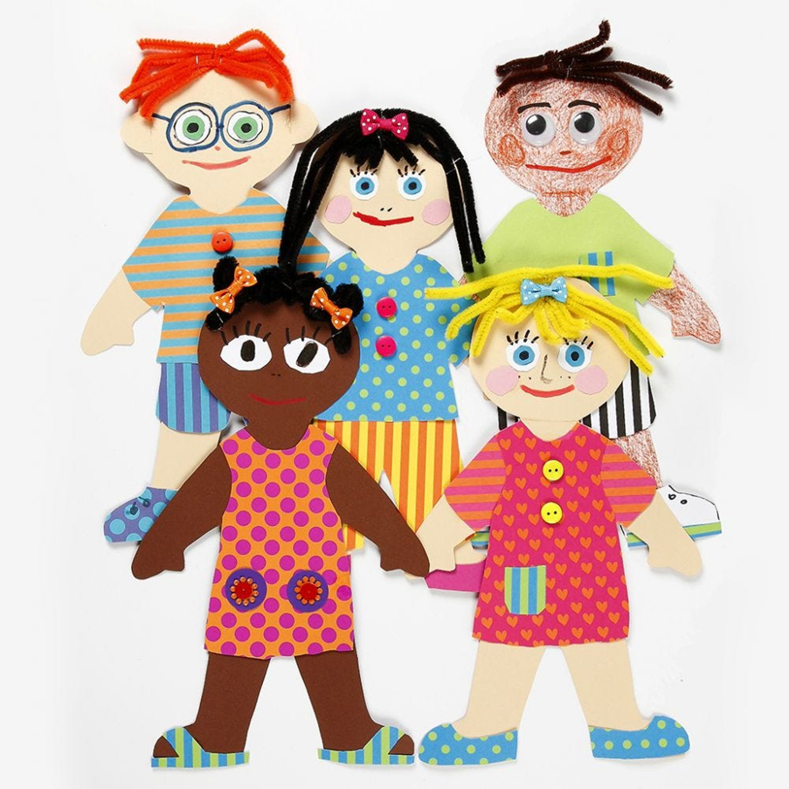  Who lives in my house?  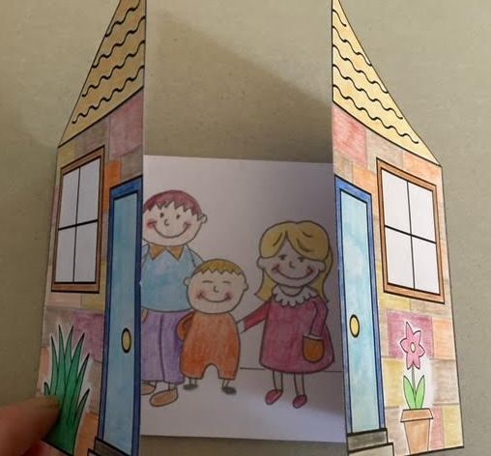  First Day at school song: https://youtu.be/Oq61TxejZ5g | Owl babies  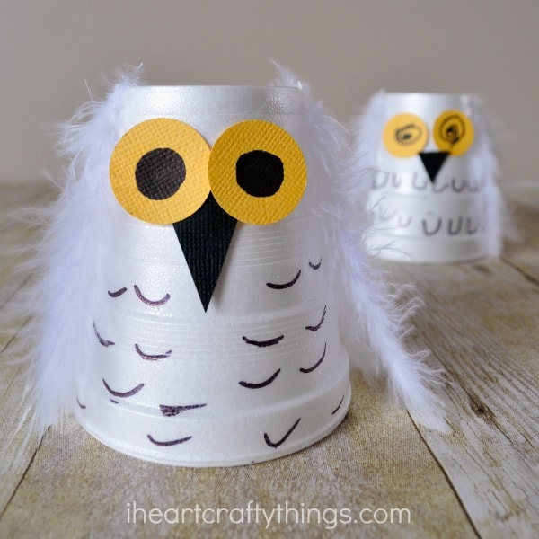  The invisible string  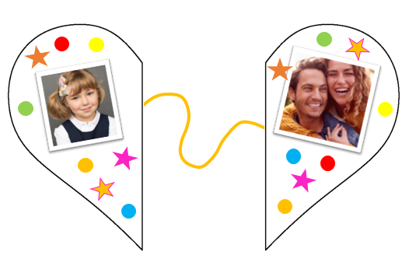  The Bear and the scary night  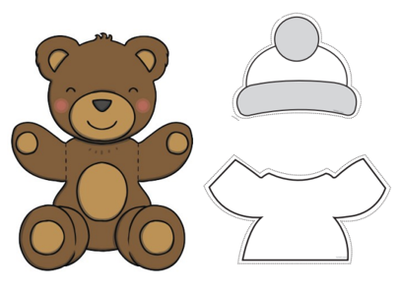  Self-portrat painting for display (using colouring-in app.) | Ambulance weaving:  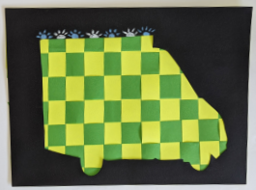 |  |  | Paper bag puppets  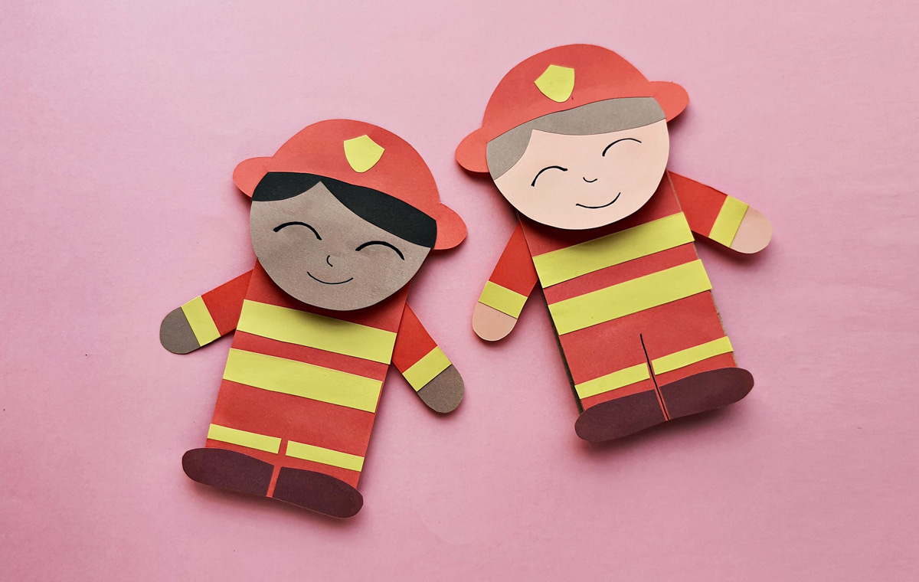  Quiver Fire engine colouring.
Development Matters Links-  Expressive Arts and Design- creative table | Expressive arts & design:  Three and four year old will:  - Explore different materials freely, to develop their ideas about how to use them and what to make.  - Develop their own ideas and then decide which materials to use to express them.  - Join different materials and explore different textures.  Reception children will:  - Explore, use and refine a variety of artistic effects to express their ideas and feelings.  - Return to and build on their previous learning, refining ideas and developing their ability to represent them.  - Create collaboratively, sharing ideas, resources and skills  - Sing in a group or on their own  - Develop story-lines in pretend play )
Small world/ topic table | Indoors:  Small world village  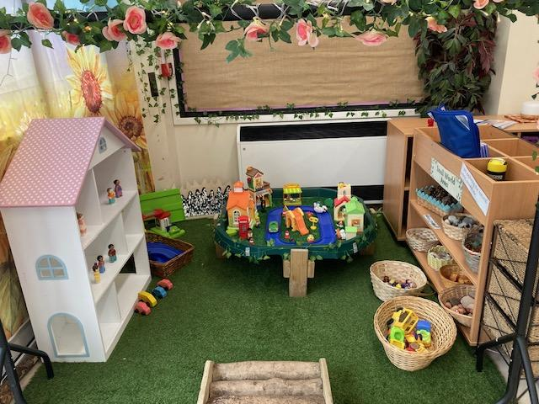  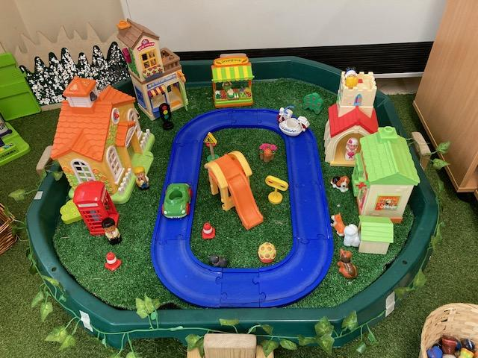  Outdoors - pouring / mixing / water  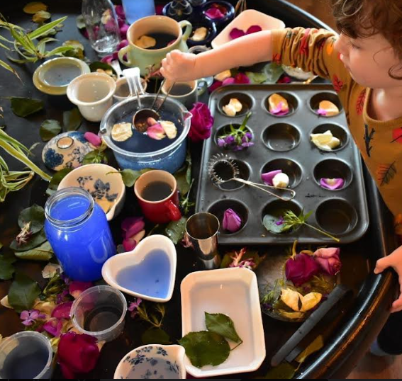  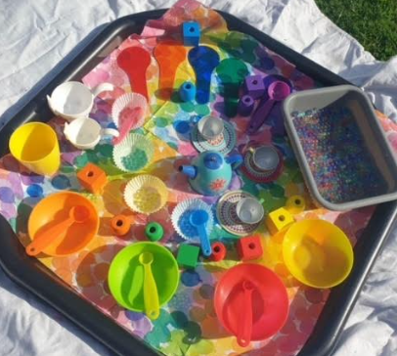 | Indoors:  Small world village  (As left.)  Teachers - introduce school role play area - set up with teddies and books.  Outdoors:  Building Blocks ‘Let’s build my house.’ | 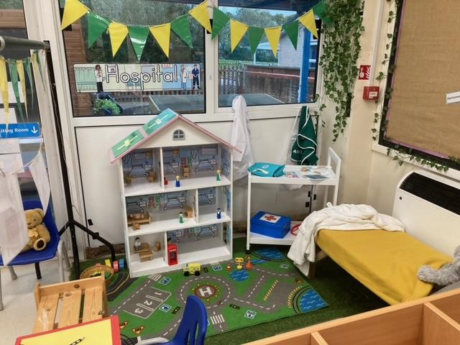 | Postman / village small world  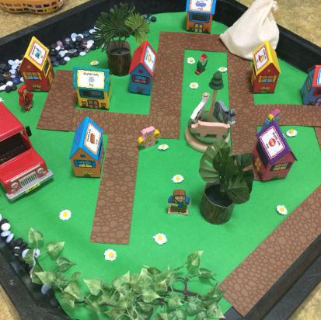 |  | 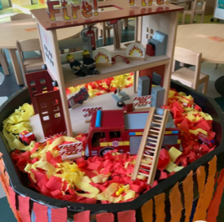fire station small world
jigsaws / Games | My House jigsaw  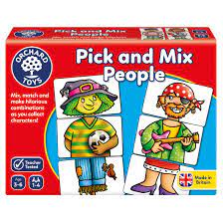 | Peppa Pig classroom jigsaw  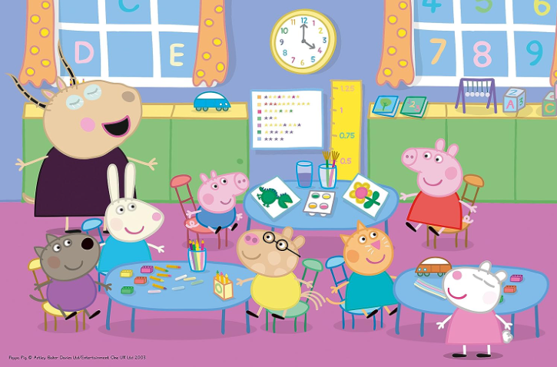Counting to 5 game  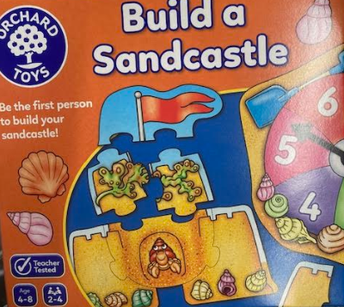  ‘5 and you’re out’ circle time | 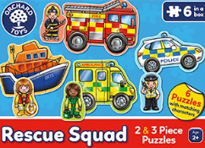Ambulance jigsaw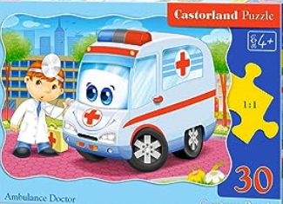  Hospital Race game  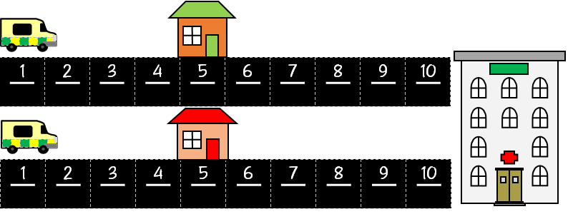 | Postman game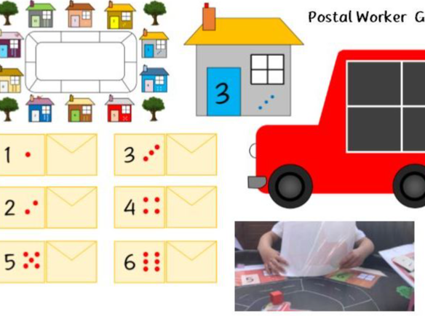  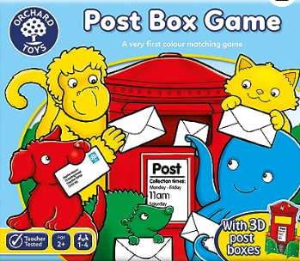  10 frame game  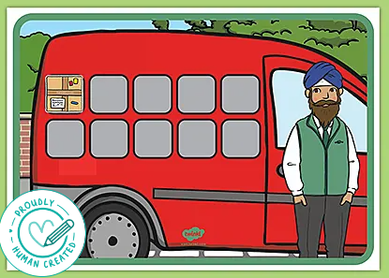 | Crocodile Dentist  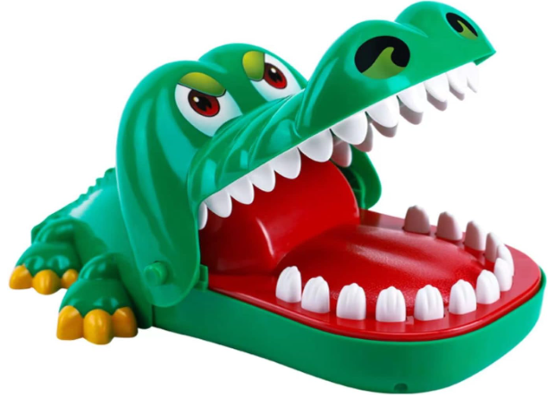  Teeth cleaning game. | Big fire engine  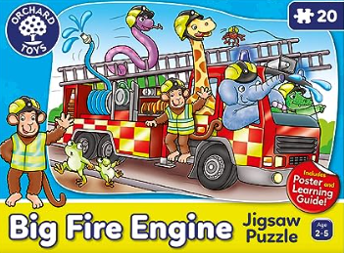  Ladders & hoses,  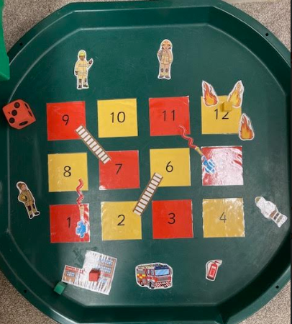
Role play & Small World | Home Corner will remain constant this term
 |  | School classroom | 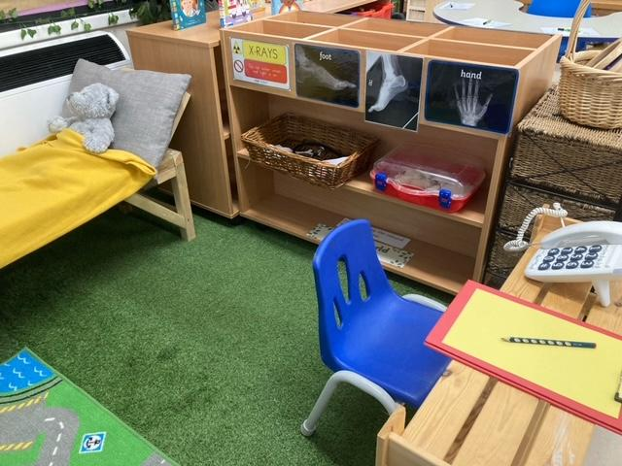 | Additional RP In small world area this week:  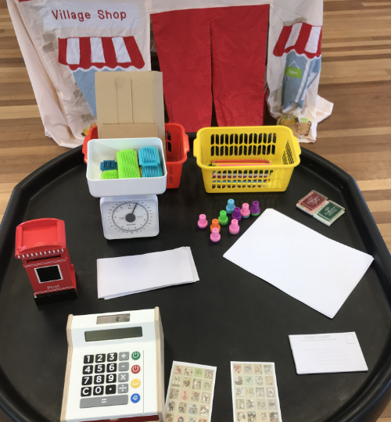 | Dentist Surgery | Fire-station
Development Matters Links-  Small world/ topic table | Communication and Language:  Three and four year olds will:  - Use a wider range of vocabulary.  - Understand a question or instruction that has two parts, such as: “Get your coat and wait at the door”.  - Understand ‘why’ questions, like: “Why do you think the caterpillar got so fat?”  Reception children will:  - Use new vocabulary through the day  - Articulate their ideas and thoughts in well-formed sentences  - Connect one idea or action to another using a range of connectives.  Expressive arts & design:  Three and four year olds will:  - Take part in simple pretend play, using an object to represent something else even though they are not similar.  - Begin to develop complex stories using small world equipment like animal sets, dolls and dolls houses etc.  - Make imaginative and complex ‘small worlds’ with blocks and construction kits, such as a city with different buildings and a park.  Reception children will:  - Explore, use and refine a variety of artistic effects to express their ideas and feelings.  - Develop storylines in their pretend play  Understanding the world:  Three and four year olds will:  - Use all their senses in hands-on exploration of natural materials.  - Explore collections of materials with similar and/or different properties.  - Talk about what they see, using a wide vocabulary.  Reception children will  - Explore the natural world around them.  - Compare and contrast characters from stories.
Maths (enhanced provision) | - Filling and emptying in the water and sand trays  - Sorting and matching during tidying up time and in small world area  - Counting how many children are here at all opportunities throughout the day  - Playing board games  - Numeral and amount matching puzzles  - Counting snack, cups for milk, etc  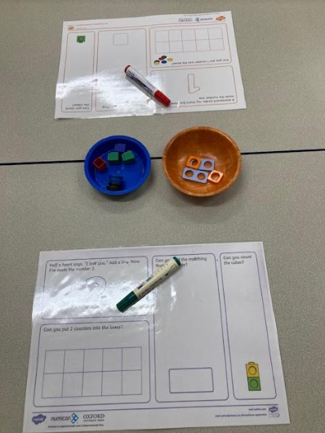  Numbers 1-5 Numberblocks. |  | Matching Pairs  Red Dog Blue Dog matching game.  Matching picture cards to objects  Making sets (buttons / food / place settings for tea party.) | Children sorting themselves into different groups with different attributes.  To sort dry pasta shapes.  Daily routines: To join the line based on different attributes.  To sort picture cards into sets. | Giant balancing scales for water outside and sand inside.  Potion-making with a variety of bottle shapes and sizes.  Different size boxes to weigh (ensure some small boxes are heavier than some larger ones to address misconceptions.)  Different size boxes and animals - which animal can fit in which boxes?  Duplo & animals - making different sized houses for the animals to live in. | Fruit kebab patterns at snack  Coloured beads for threading and making AB or ABC pattern bracelets.  Building block patterns.  Musical instrument sound patterns.  In and out the dusty bluebells. | Matching cards - numerals to picture representations - Can be played as snap / matching pairs.  track game (using 3 dice)  1, 2, 3 learning game on IPAD  3 and you’re out circle game.  Baby bear’s third birthday small world set up
Objective Led WR Maths-  Learning Intentions | N/A- Baselining/ ‘Getting to Know You’  Counting Activities |  | To know how to find and match objects which are the same.  To know how to match pictures which are the same.  To know how to identify a set.  To know how to sort objects to a type.  To know how to explore sorting techniques.  To know how to create sorting rules.  To know how to compare amounts. |  | To know how to compare size.  To know how to compare mass.  To know how to compare capacity. | To know how to explore simple patterns.  To know how to copy, create and continue simple AB patterns.  To know how to copy, create and continue simple ABC patterns. | To know different representations of 1, 2 and 3.  To know the number of objects or items in a group without needing to count them.  To begin to know the principle of one more.
Maths DM/WRM links | Three- and four-year-olds will:  - Develop fast recognition of up to 3 objects, without having to count them individually (‘subitising’).  - Say one number for each item in order: 1,2,3,4,5.  - Know that the last number reached when counting a small set of objects tells you how many there are in total (‘cardinal principle’).  - Show ‘finger numbers’ up to 5.  - Link numerals and amounts: for example, showing the right number of objects to match the numeral, up to 5.  - Solve real world mathematical problems with numbers up to 5.  - Compare quantities using language: ‘more than’, ‘fewer than’.  - Talk about and explore 2D and 3D shapes (for example, circles, rectangles, triangles and cuboids) using informal and mathematical language: ‘sides’, ‘corners’; ‘straight’, ‘flat’, ‘round’.  - Make comparisons between objects relating to size, length, weight and capacity.  - Talk about and identify the patterns around them. For example: stripes on clothes, designs on rugs and wallpaper. Use informal language like ‘pointy’, ‘spotty’, ‘blobs’, etc. Extend and create ABAB patterns – stick, leaf, stick, leaf. Notice and correct an error in a repeating pattern.  Reception children will:  - Count objects, actions and sounds.  - Subitise.  - Link the number symbol (numeral) with its cardinal number value.  - Compare numbers.  - Understand the ‘one more than/one less than’ relationship between consecutive numbers.  - Explore the composition of numbers to 10, focusing on composition of 2, 3, 4 and 5 before moving onto larger numbers.  - Continue, copy and create repeating patterns.  - Compare length, weight and capacity.
Maths-Linked Storytime Book- Taken from WRM | Favourite stories/chosen stories at home time for the first two weeks. |  | • A Pair of Socks by Stuart J. Murphy  •Seaweed Soup by Stuart J. Murphy | • The Button Box by Margarette S. Reid  • Beep Beep, Vroom Vroom! by Stuart J. Murphy | •Where’s My Teddy? by Jez Alborough  •It’s the Bear! by Jez Alborough | • Dear Zoo by Rod Campbell  • We’re Going on a Bear Hunt by Michael Rosen  My Pattern book | •Anno’s Counting Book by Mitsumasa Anno  •How to Count to One by Casper Salmon
RWI Phonics | Baselining. |  | Establishing routines and activities within RWI lessons.  Learning Set 1 single sounds.  Learning to blend: Word Time 1.1 to 1.3.  Learning to spell using Fred Fingers.
Objective Led Literacy-  Talk for Writing Learning Intentions | N/A- Baselining |  | To know how to investigate by asking ‘what, where, who, why’ questions.
Adult led writing outcome | From week 2 or 3, each morning every child will practise writing their name with some numbers and known letters.
Adult led writing outcome | N/A- Baselining |  |  | Writing cards to post.
Phonics / writing (enhanced provision) | N/A- Baselining | School colouring in  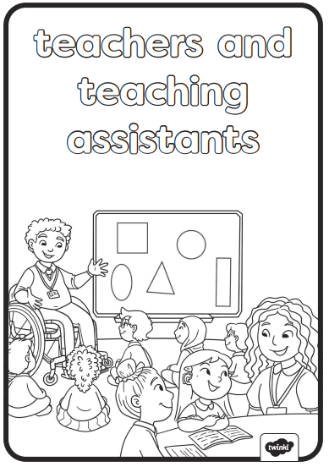 |  | Duck Bingo  2 Player game in water tray.  Post box / cards / envelopes | Initial sound cards:  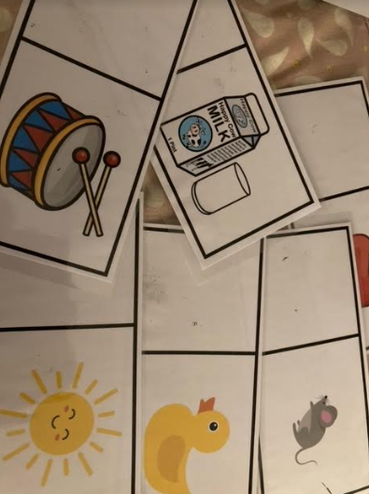 | Colour by phoneme  m, d, i , n  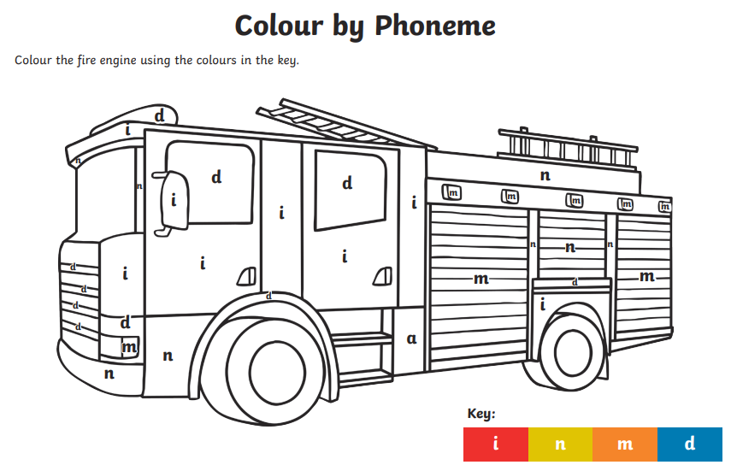
Writing and phonics DM links | Three- and four-year-olds will:  - Understand the five key concepts about print: print has meaning - print can have different purposes - we read English text from left to right and from top to bottom - the names of the different parts of a book - page sequencing  - Develop their phonological awareness, so that they can: spot and suggest rhymes - count or clap syllables in a word - recognise words with the same initial sound, such as money and mother  - Engage in extended conversations about stories, learning new vocabulary.  - Use some of their print and letter knowledge in their early writing. For example: writing a pretend shopping list that starts at the top of the page; writing ‘m’ for mummy. Write some or all of their name.  - Write some letters accurately.  Reception children will:  - Read individual letters by saying the sounds for them.  - Blend sounds into words, so that they can read short words made up of known letter– sound correspondences.  - Form some lower-case and capital letters correctly.
Role-play DM links | Communication and Language:  Reception children will:  - Use new vocabulary through the day  - Articulate their ideas and thoughts in well-formed sentences  - Connect one idea or action to another using a range of connectives.  - Develop social phrases.  Expressive arts & design:  Reception children will:  - Develop storylines in their pretend play

