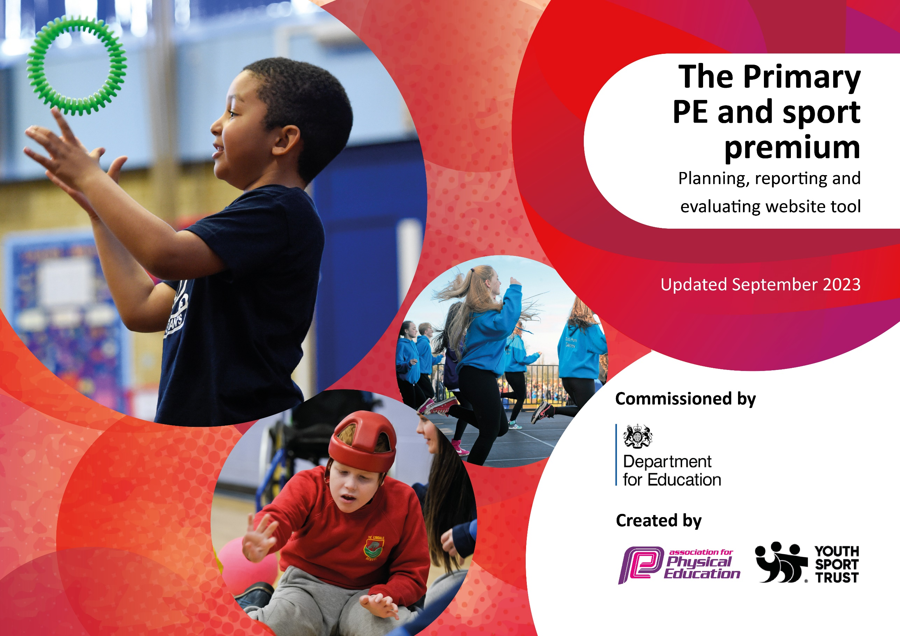

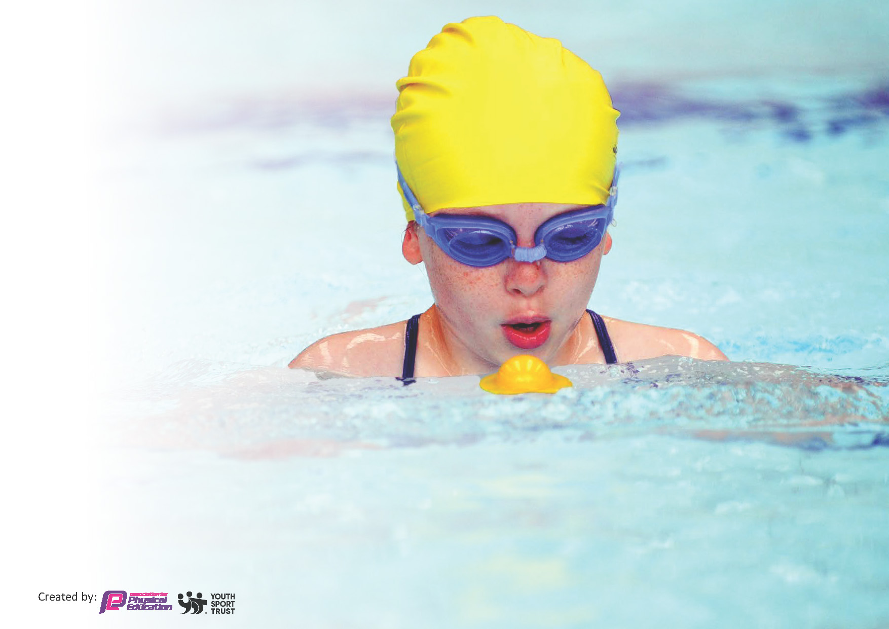
This template can be used for multiple purposes:
by:
- It enables schools to effectively plan their use of the Primary PE and sport premium
- It helps schools to meet the requirements (as set out in guidance) to publish information on their Primary PE and sport premium
- It will be an effective document to support Ofsted inspections enabling schools to evidence progress in Physical Education (PE) and evidence swimming attainment, which forms part of the PE National Curriculum. We would recommend schools consider
the Intent, Implementation and Impact of any spend, as examined within the Education Inspection Framework.

It is important that your grant is used effectively and based on school need.

Schools must use the funding to make additional and sustainable
improvements to the quality of the PE, School Sport and Physical Activity (PESSPA)
they offer. This means that you should use the Primary PE and sport premium to:

- Build capacity and capability within the school to ensure that improvements made now will benefit pupils joining the school in future years
- Develop or add to the PESSPA activities that your school already offers.

The Primary PE and sport premium should not be used to fund capital spend projects; the school’s core budget should fund these. Further detail on capital expenditure can be found in the updated Primary PE and sport premium guidance.

The Primary PE and sport premium guidance, outlines 5 key priorities that funding should be used towards. It is not

necessary that spending has to meet all the key priorities, you should select the priorities that you aim to use any funding towards.

Although completing this template is not a requirement for schools, schools are required to publish details of how they spend this funding. Schools must also outline what the impact this funding has had on pupils’ PE and sport participation and attainment and how any spending will be sustainable in the future. All funding must be spent by 31st July 2024.

The Department for Education has worked closely with the Association for Physical Education (afPE) and the Youth Sport Trust (YST) to develop this template and encourages schools to use it. This template is an effective way of meeting the reporting requirements of the Primary PE and sport premium.
Review of last year’s spend and key achievements (2022/2023)

We recommend you start by reflecting on the impact of current provision and reviewing your previous spend.

Activity/Action | Impact | Comments

Key priorities and Planning
This planning template will allow schools to accurately plan their spending.

Action – what are you planning to do | Who does this action impact? | Key indicator to meet | Impacts and how sustainability will be achieved? | Cost linked to the action
Young Ambassador Programme | Year 5/6 students to support the PE Lead with promoting healthy, happy, active opportunities in schools and run events/assemblies.  This year inspire+ will have more contact sessions with your BYA’s throughout the year as well as coaches catching up with them in school. | Key Outcome Indicator 1  The engagement of all pupils in regular physical activity – kick-starting healthy active lifestyles | More pupils meeting their daily physical activity goal, more pupils encouraged to take part in PE and Sport Activities. | Apart of Inspire+ Membership
Talented Athlete Programme Grant Scheme & PE clothing scheme | Supported a pupil access sporting opportunities – swimming  Purchase PE clothing to support families from deprived backgrounds access PE. | Key Outcome Indicator 1  The engagement of all pupils in regular physical activity – kick-starting healthy active lifestyles | Giving pupils the opportunity to have sports kit and opportunities. | + £250  + £100  Donated back to school
Talented Athlete 3 x half-day workshops | 3 x half-day workshops working with groups of children from KS1, Yr3,4 and Yr 5,6. Each workshop will focus on different non-sport specific areas including communication, team work, resilience and fitness testing | Key Outcome Indicator 1  The engagement of all pupils in regular physical activity – kick-starting healthy active lifestyles | Working on life skills through sport as a vehicle to carry those skills into day to day activities. | Apart of Inspire+ Membership
Paralympic Sports Taster sessions, 4 x half-day workshops | 4 half-day workshops with our paralympic sports coach, there will be a half-day in each of the following sports: Boccia, New Age Kurling, Seated Volleyball and Goalball. | Key Outcome Indicator 1  The engagement of all pupils in regular physical activity – kick-starting healthy active lifestyles | Expose pupils to sports accessible to all to raise awareness of equity in sport. | Apart of Inspire+ Membership
Inspire+ Cadets 6-week block of sessions aimed at KS1 (6x1 hour) | A KS1 programme using sport as the vehicle to support the development of other key life skills in young people using key values. Schools can choose the themes/topics to focused on | Key Outcome Indicator 1  The engagement of all pupils in regular physical activity – kick-starting healthy active lifestyles | This was carried out in line with our learners code and at the end of the 6 weeks all learners achieved BRONZE level status | Apart of Inspire+ Membership
FA Girls inspired SEND / Non-active focused club or intervention, 6-week block | Utilising the FA Girls Disney Inspired resources to run a club with literacy links to groups of chosen children. A new addition for this year is a SEND specific 6 week programme to increase levels of activity. | Key Outcome Indicator 1  The engagement of all pupils in regular physical activity – kick-starting healthy active lifestyles | Pupils would have gained confidence to continue with sport and become more engaged. | Apart of Inspire+ Membership
Little Movers 6 week EYFS/KS1 coaching block. (6x1 hour) | A EYFS/KS1 coaching scheme developing pupils FUNdamental sporting skills in a fun, energetic and engaging way with links to the EYFS framework. | Key Outcome Indicator 1  The engagement of all pupils in regular physical activity – kick-starting healthy active lifestyles | To encourage a healthy and active lifestyle of movement. | Apart of Inspire+ Membership
Teach Active, maths & literacy. 6 x 1 hour sessions for a club or intervention making maths or literacy active | This takes your normal maths and literacy lessons and turns them into an active lesson where studies have shown to be a more effective way of learning and retaining knowledge. | Key Outcome Indicator 1  The engagement of all pupils in regular physical activity – kick-starting healthy active lifestyles | Enhance academic ability in an active way to increase engagement. | Apart of Inspire+ Membership
Playground Leadership Training | Helping to enhance playtimes to become more organised with structured, active play.  Support for lunchtime supervisors & training young people to become playground leaders. | Key Outcome Indicator 1  The engagement of all pupils in regular physical activity – kick-starting healthy active lifestyles | Train role models of physical activity to support structured play. | Apart of Inspire+ Membership
Inspire+ ambassador whole school assembly Joe Roebuck | New whole school assembly with relevant themes and messages to all year groups.  Ambassadors are also able to personalise assemblies to meet themes or focuses of the school. | Key Outcome Indicator 2  The profile of PE and sport being raised across the school as a tool for whole school improvement | Inspire pupils to be engaged in sport and to be resilient. | Apart of Inspire+ Membership
Inspire+ ambassador whole school assembly Dai Greene | New whole school assembly with relevant themes and messages to all year groups.  Ambassadors are also able to personalise assemblies to meet themes or focuses of the school. | Key Outcome Indicator 2  The profile of PE and sport being raised across the school as a tool for whole school improvement | Inspire pupils to be engaged in sport and to be resilient. | Apart of Inspire+ Membership
Aspire to Inspire mentoring programme | Aimed to engage & enthuse disengaged or struggling pupils. It has been designed to positively impact aspirations, confidence, self-esteem, and behaviour, through various tasks and challenges. Delivery will be six weekly contact sessions, for up to 12 pupils in KS2. | Key Outcome Indicator 2  The profile of PE and sport being raised across the school as a tool for whole school improvement | Working on life skills through sport as a vehicle to carry those skills into day to day activities. | Apart of Inspire+ Membership
Wake & Shake engagement mentoring | A 30 minute physically active programme delivered once a week for the duration of 1 term. This programme is for a group of children (from any year groups/max 20 children) who will take part in a structured but high energy session to build on their FUNdamental skills but also give them a release of energy helping them to return to class more focused ready to learn. Our mentor will then pop into the classes from the sessions to see how they are getting on with their work and offer a small amount of support to each child. | Key Outcome Indicator 2  The profile of PE and sport being raised across the school as a tool for whole school improvement | To help pupils learn how to regulate in preparation for classroom work. Teaching emotional regulation they can continue to use. | Apart of Inspire+ Membership
Continuous Professional Development Courses | A wide range of CPD courses, all included in the membership, available to access by any school employees. The planner will be sent out in blocks throughout the year. Courses include sport specific and Key stage specific. | Key Outcome Indicator 3  Increased confidence, knowledge and skills of all staff in teaching PE and sport | Teaching staff became more confident in sport specific knowledge to deliver high quality PE to all pupils. | Apart of Inspire+ Membership
Team teach with a specialist coach |  | Key Outcome Indicator 3  Increased confidence, knowledge and skills of all staff in teaching PE and sport | Teaching staff became more confident in sport specific knowledge to deliver high quality PE to all pupils. | Apart of Inspire+ Membership
Forest School training on school site | Great Wood Farm Forest School experts will support facilitation of staff training and CPD events either at their site or on your own school grounds. | Key Outcome Indicator 3  Increased confidence, knowledge and skills of all staff in teaching PE and sport | Teaching staff became more confident in sport specific knowledge to deliver high quality PE to all pupils. | Apart of Inspire+ Membership
inspire+ PE Forum’s | Updates from inspire+ and sign posting schools to additional resources and opportunities. These forums also provide a chance to share good practice amongst schools. | Key Outcome Indicator 3  Increased confidence, knowledge and skills of all staff in teaching PE and sport | PE Lead attended and distribute information to teaching staff as appropriate. | Apart of Inspire+ Membership
Termly impact reports & strategic meetings | Regular update meetings with the PE to ensure services are having the required impact and make changes if required. This includes reminders of up-coming dates and deadlines. | Key Outcome Indicator 3  Increased confidence, knowledge and skills of all staff in teaching PE and sport | PE Lead works closely to keep up to date with government strategies and ideas to disseminate with staff. | Apart of Inspire+ Membership
Mini Olympics | End of year mass participation event for all our schools to come together. Aimed at pupils in year 3 and/or 4 plus the involvement of your Bronze Young Ambassadors.  A non-competitive event of Olympic & Paralympic sports including their very own opening and closing ceremonies. | Key Outcome Indicator 4  Broader experience of a range of sports and activities offered to all pupils | Successful event that has inspired an entire year group to take part in more sport and attend more events. | £315 coach transport
£5305
Inspire+ membership
Specialist sports coaching | Before school, lunchtime clubs and after school clubs are available along with the curriculum. | Key Outcome Indicator 4  Broader experience of a range of sports and activities offered to all pupils |  | £4000
Brownlee Foundation triathlon |  | Key Outcome Indicator 5  Increased participation in competitive sport
SGO competitive events

Key achievements 2023-2024
This template will be completed at the end of the academic year and will showcase the key achievements schools have made with their Primary PE and sport premium spending.

Activity/Action | Impact | Comments
Provide staff with CPD opportunities throughout the year to increase their confidence, knowledge and skills in teaching PE and Sport so pupils can benefit from their expertise.  PE lead to attend Young Ambassador Training with our 4 Young Ambassadors to provide a year of successful young leadership.  Provide a wide variety of extra-curricular clubs across all 6 terms lead by staff and pupil leaders  Support children’s mental health and well-being continuing to follow the school’s core values and Church School ethos. Inspire+ Ambassador visits during assembly times and workshops for whole school.  Continue to provide a high quality PE and PA offer to all pupils from EYFS to Y6  Mini Olympics for Young Ambassador | PE lead attended the inspire+ Conference – organising this year’s PE and Sporting offer. Refreshed skills in choreographing dance using fundamental skills.  PE lead to lead and inspire staff to use real PE as a skills based tool to promote multi ability skills including physical, coordination, social, knowledge of fitness and health, personal, creative skills.  Young Ambassadors have learned the importance of good leadership and discussed the skills needed with Young Ambassadors from local Primary Schools. Children have taught these lessons to the Sports Committee and planned a year’s program of fun and competitive sporting events to encourage all to be active.  We have 35 clubs across the year.  39% 59/157 taking part in extra-curricular sporting clubs.  % of SEND children taking part in an extra-curricular sporting club 50% 12/24.  Ambassador assemblies booked in and this year’s extra-curricular coaching booked. Whole school assembly themes and newsletter articles showing impact: . Dai Green, Joe Roebuck  Teachers, supported by PE lead, will be teaching outstanding PE lessons including the 4 key elements of: - Acquiring and Developing - Selecting and Applying - Evaluating and Improving - Knowledge and Understanding of Fitness and Health  Y4 class and Young Ambassadors to Mini Olympics and research school country of ‘Japan’ making banner and commonwealth flame torch. | PE is a skill-based curriculum where skills can be transferred into different sports allowing children to learn from building on skills as stepping stones throughout their school life and having the confidence to be physically literate through a PE curriculum that allows them to learn in a multi ability skilled way including physical, coordination, social, knowledge of fitness and health, personal, creative skills.  100% of children have taken part in a wide variety of sporting events across the year including; Sports Day, Legacy Tour Relay, mini Olympics, Brownlee Triathlon. Continue to train teams prior to events to ensure children as confident before the competition day  Continue to evaluate our extra-curricular provision for next academic year. Continue to train young leaders to lead next year’s clubs and ensure staff clubs coincide with the term’s sporting fixtures  Continue to encourage and promote the values discussed by each ambassador and offer healthy minds and bodies throughout our curriculum and extra-curricular offer.  All children are accessing 2 hours of timetabled PE. Teachers are supported throughout the year. PE lesson Data Analysis across all three terms shows children are making outstanding progress. Class teachers and subject leader have discussed the first 20% in each class that need support and teachers use the ‘suggested support for children with additional needs’ section  Year 4 represented Japan at this year’s Mini Olympics at the Meres Leisure Centre Stadium. What a fabulous day! The day began with a party atmosphere as we paraded into the stadium and past the crowds of waiting supporters. We were greeted by the fabulous carnival acts and introduced to the VIP, before moving off to our first activities. Throughout the day, the children experienced badminton, multi-skills, problem solving and dancing with ‘The Royal Opera House’ and football tricks. The children also had the opportunity to meet 'the Stars' for autographs before taking part in the Closing Ceremony. It was wonderful to be involved in such a big event and to see so many Young Ambassadors from across the schools come together to support the younger children. Prior to the event, each school had been asked to make a banner to represent their country. Ours was designed by members of our class.

Swimming Data
Meeting National Curriculum requirements for swimming and water safety.
Priority should always be given to ensuring that pupils can perform safe self-rescue even if they do not fully meet the first two requirements of the National Curriculum programme of study

Question | Stats: | Further context  Relative to local challenges
What percentage of your current Year 6 cohort can swim competently, confidently and proficiently over a distance of at least 25 metres? | 62.5% | High percentage of pupils had never been to a swimming pool before. Some were new to the country. All non-swimmers were in receipt of Pupil Premium.
What percentage of your current Year 6 cohort can use a range of strokes effectively [for example, front crawl, backstroke, and breaststroke]? | 50% | Some only experience school swimming so only build on the skill during lessons therefore only secure one stroke.

What percentage of your current Year 6 cohort are able to perform safe self-rescue in different water-based situations? | 62.5% | Only the swimmers secure on all strokes successfully demonstrated safe self-rescue.
If your schools swimming data is below national expectation, you can choose to use the Primary PE and sport premium to provide additional top-up sessions for those pupils that did not meet National Curriculum  requirements after the completion of core lessons. Have you done this? | Yes/No
Have you provided CPD to improve the knowledge and confidence of staff to be able to teach swimming and water safety? | Yes/No

Signed off by:

Head Teacher: | (Name)
Subject Leader or the individual responsible for the Primary PE and sport premium: | Stephanie Osborn PE LEAD
Governor: | (Name and Role)
Date:

