Year 3
Advent term 1
Curriculum Newsletter
English | Historical Narrative – Stone Age Boy  - This is a fiction piece of text, where pupils will have the opportunity to rewrite their own version, learning new writing techniques such as expanded noun phrases.  Non-chronological report – link to science: skeletons  - We will write a newspaper article based on a real life discovery of human skeletons! Pupils will focus on how to construct a newspaper article into paragraphs.
Maths | Place value  - This will involve looking at hundreds, tens and ones.  Addition and subtraction  - We will learn new methods, helping us successfully add and subtract larger 3-digit and 2-digit numbers!
RE | Homes  - During ‘homes’, we will focus our reflections on what makes a home and how God and Jesus have made a home for everybody.  Promises  - Pupils will explore how important promises are in forming relationships with God and those around us.
Science | Rocks and soils  - We will learn the 3 main types of rocks and how they are formed and also think about what soil really is.
Computing | Connecting computers  - We will look at input and outputs of computer devices and understand just how they work. We will learn how digital devices benefit us each day.
History | Stone Age to Iron Age  - Children will step back in time and learn about how Stone Age people lived and survived every day life!
Design technology | Textiles  - Children will be put to the ultimate test and will be asked: can you make a box out of cloth?
Art | Drawing and Painting  - We look at Van Gogh and how his work has inspired many people today. We will use his famous painting techniques in our own art pieces.
Music | Developing notation and improvisation  - Pupils will learn about how they can create music using improvisation and their prior knowledge of different notes and music styles.
French | Little Red Riding Hood  - We will revisit the story in English and then learn how to say lots of the key vocabulary but in French!
PE | Fundamentals  - We will be focussing on balance and all of the skills children will need to be able to apply to further topics in the year.  Ball skills  - We will be learning how to throw and catch successfully, being able to apply this to topics such as netball.
RSHE | Created by God  - This will focus on how we have been created by God and how we can continue to look after ourselves and those around us.
Curriculum enrichment | This time will be used to revisit either art, design and technology, science or history to further deepen children’s knowledge or to close any gaps in their learning and understanding.

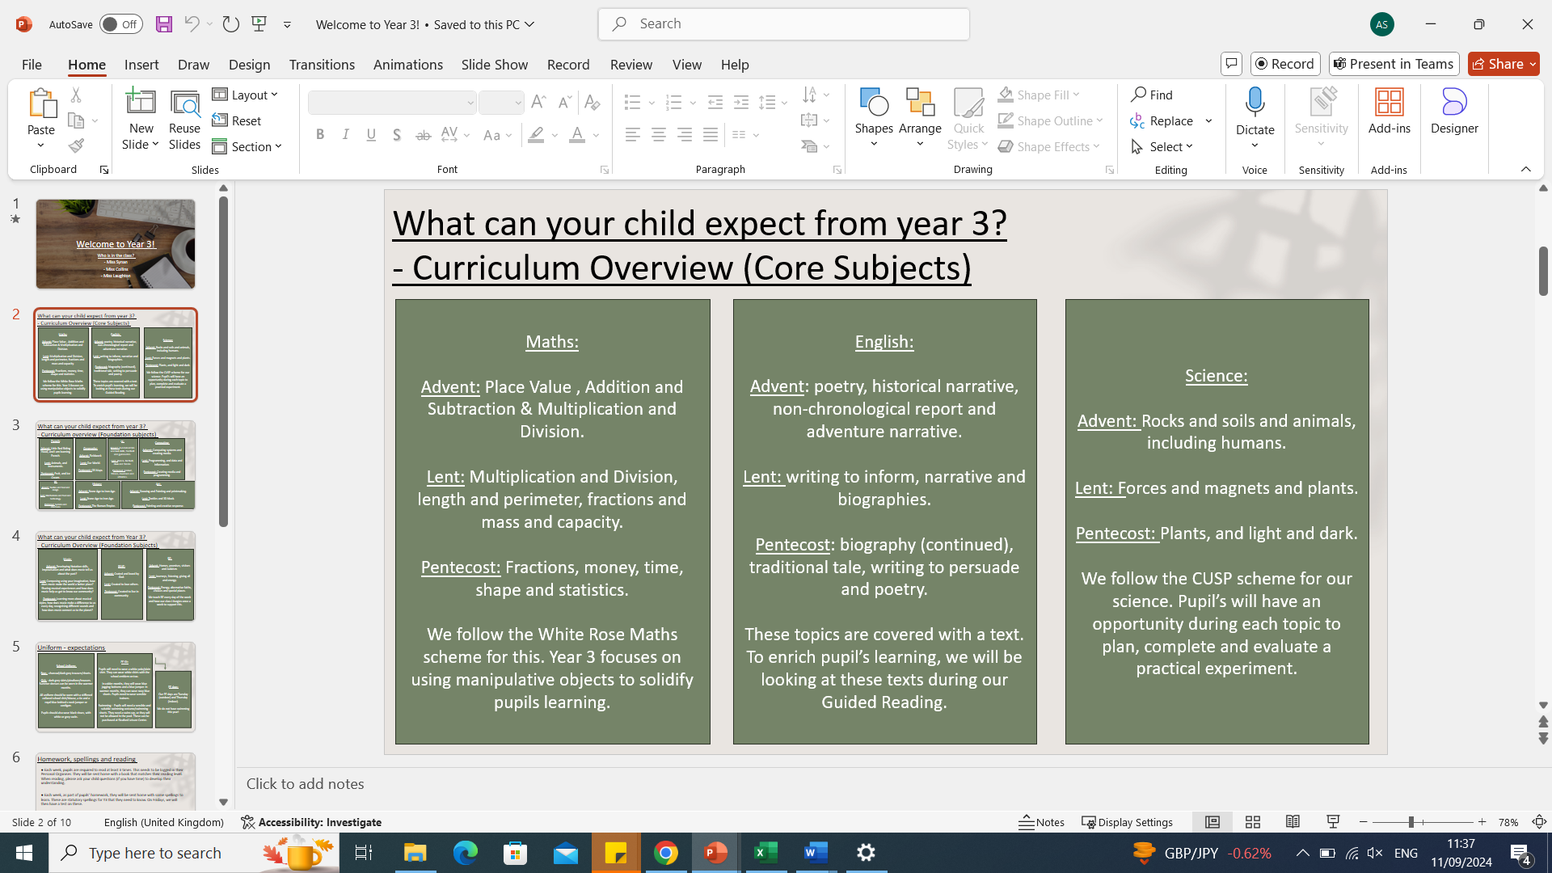
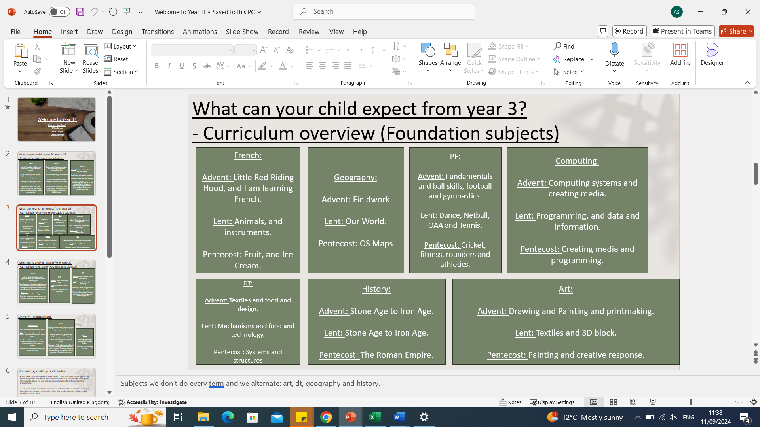
information about the year:

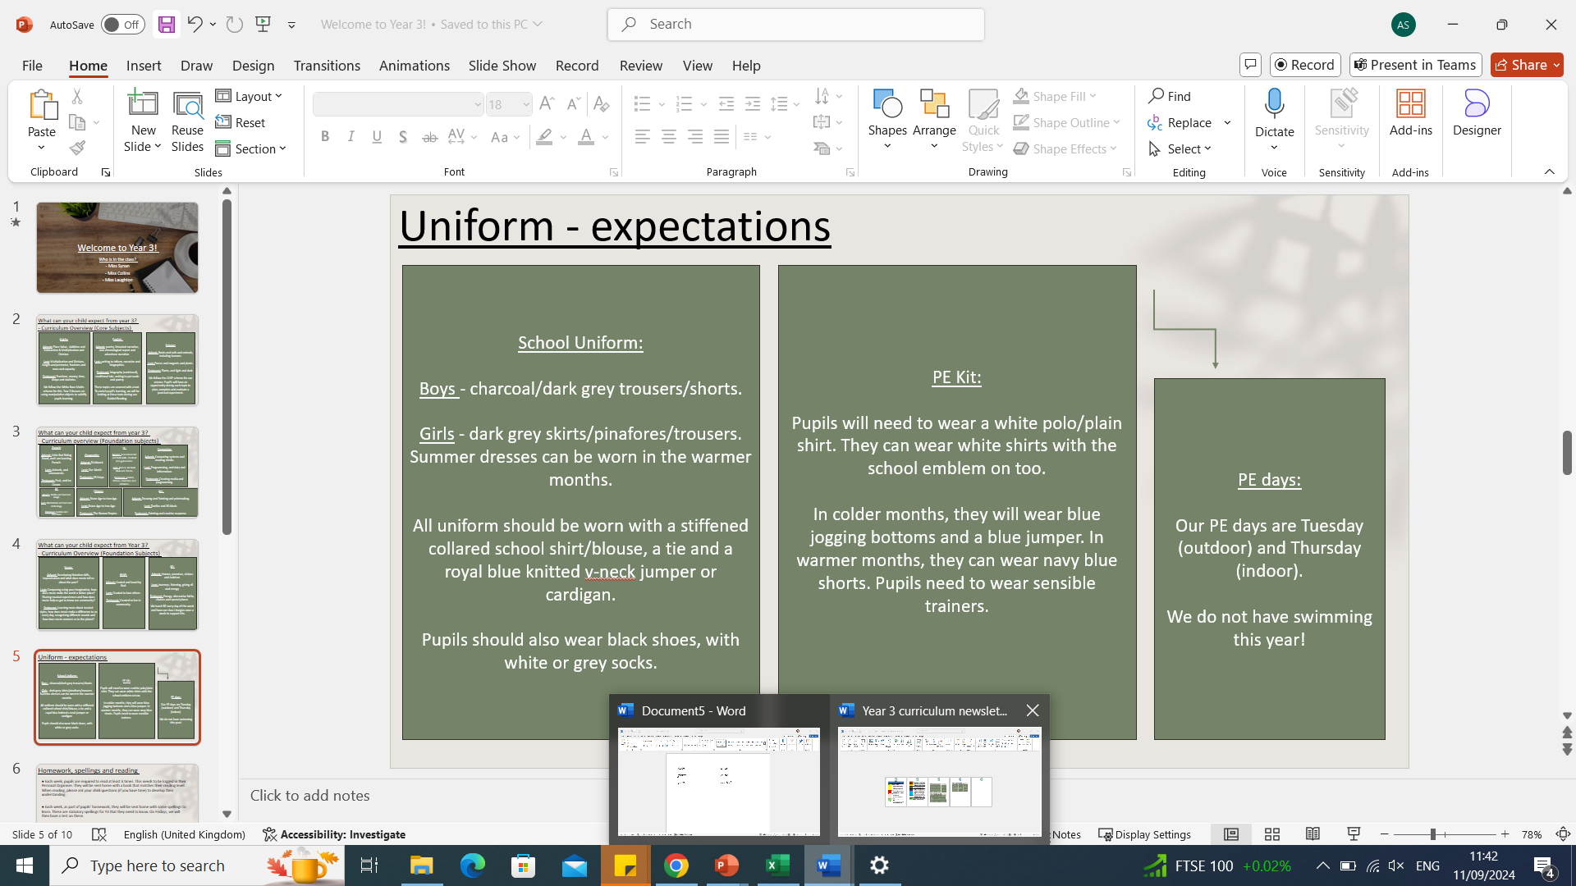
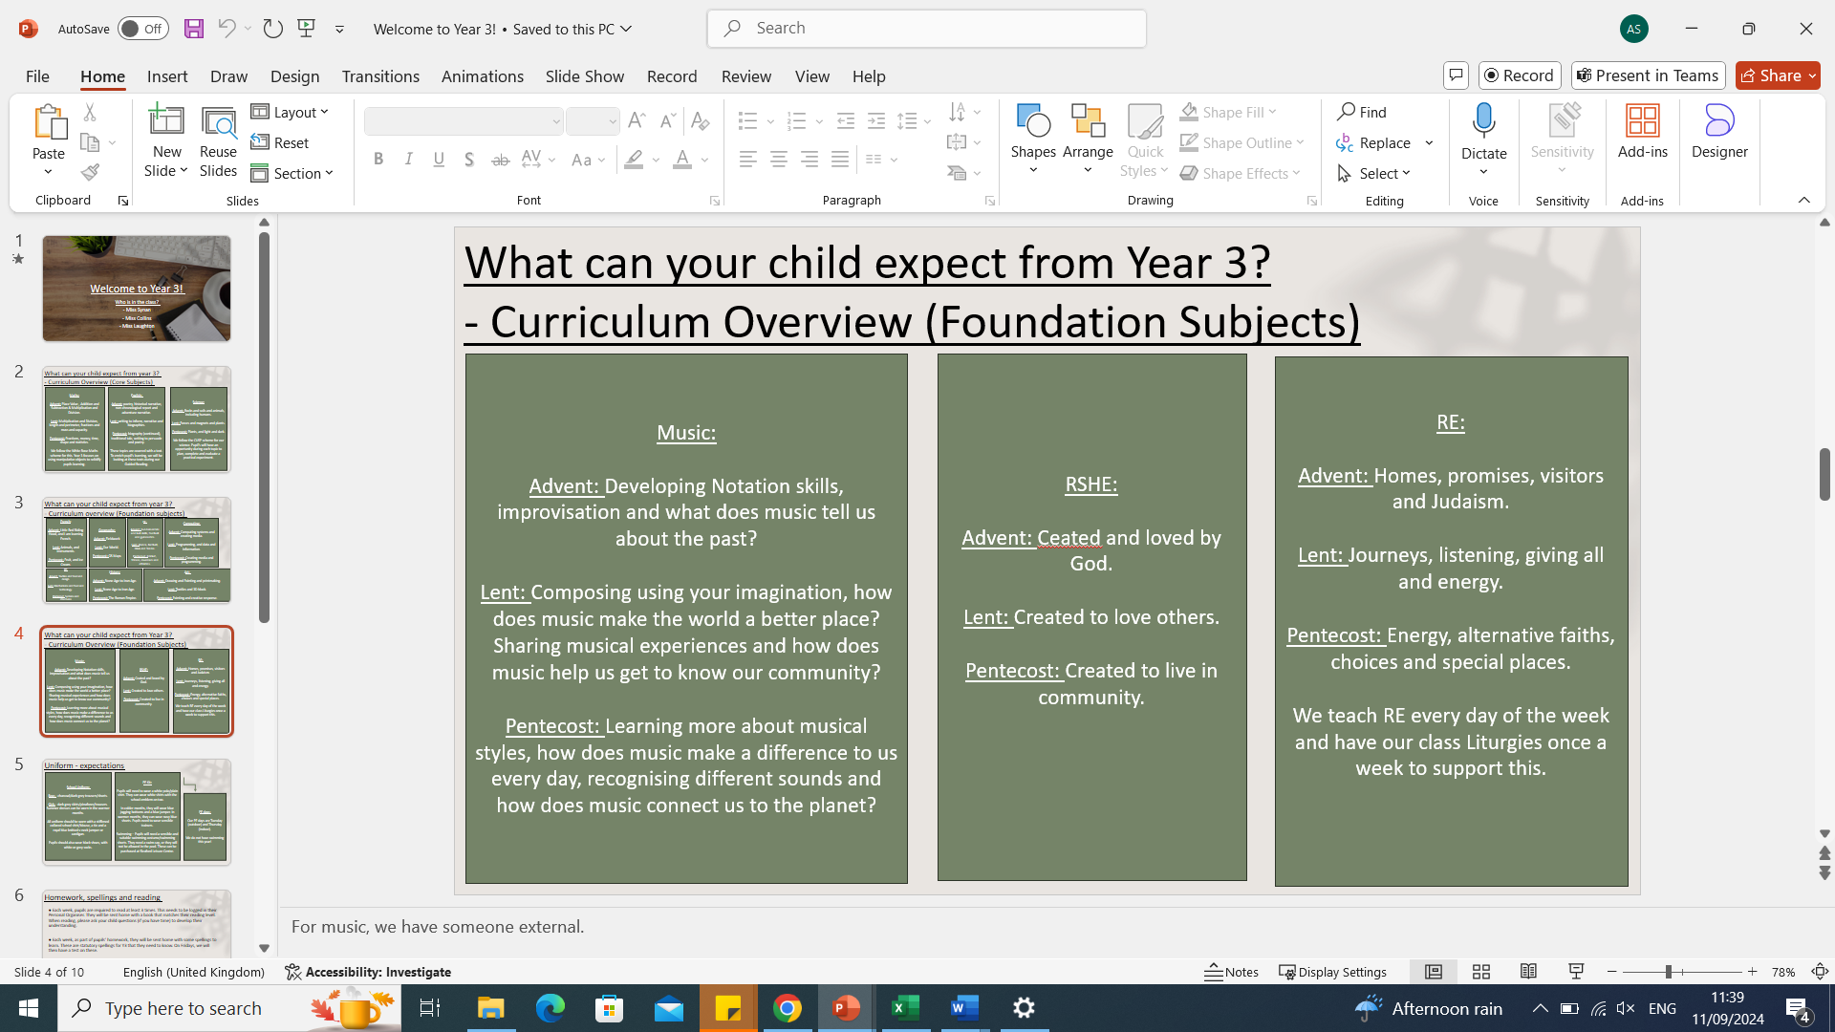

● Each week, pupils are required to read at least 3 times. This needs to be logged in their Personal Organiser. They will be sent home with a book that matches their reading level. When reading, please ask your child questions (if you have time) to develop their understanding.
● Each week, as part of pupils’ homework, they will be sent home with some spellings to learn. These are statutory spellings for Y3 that they need to know. On Fridays, we will then have a test on these.
● Alongside their spellings, pupils should be completing at least 10-20 minutes on TTRS. All logins are in their personal organisers. If at any point you feel this is not possible, please come and speak to me.

● We will continue to use Class Dojo to communicate with each other.
● There is also the opportunity to stop at my door in the morning and discuss anything if needed.
● If you ever need to discuss anything with me, please do not hesitate. I am here to help and reassure if there are any issues. Please appreciate home time is a very busy time, so if I am not able to discuss something with you, I apologise.

● Please ensure your child is sent to school with a water bottle every day. The school sells Our Lady water bottles for £1, which you can purchase at the office. Alternatively, pupils can bring in a water bottle from home. Their water bottle must only have water, and no squash.
● Children are encouraged to have a snack at breaktimes. Please make sure this is a healthy snack, such as a piece of fruit.

Thank you,
Miss Synan and Miss Collins

