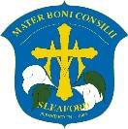OUR LADY OF GOOD COUNSEL CATHOLIC PRIMARY SCHOOL

The Drove, Sleaford, Lincolnshire. NG34 7AT

Tel: 01529 304373 ∙ Email: [office.admin@our-lady.lincs.sch.uk ∙](mailto:office.admin@our-lady.lincs.sch.uk) Website: our-lady.lincs.sch.uk

**School Terms and Holiday Dates 2024/2025**

|  |  |  |  |
| --- | --- | --- | --- |
|  | INSET days | First teaching day | Last teaching day |
| Term 1 | Monday 2nd and  Tuesday 3rd September 2024 | Wednesday 4th September 2023 | Friday 18th October 2024 |
| Term 2 | Monday 28th October 2024 | Tuesday 29th October 2024 | Friday 20th December 2024 |
| Bank Holidays | 25th & 26th December 2024 and 1st January 2025 | | |
| Term 3 | Monday 6th January 2025  Friday 14th February 2025 | Tuesday 7th January 2025 | Thursday 13th February 2025 |
| Term 4 |  | Monday 24th February 2025 | Friday 4th April 2025 |
| Bank Holidays | 18th and 21st April 2025 | | |
| Term 5 |  | Tuesday 22nd April 2025 | Friday 23rd May 2025 |
| Bank Holidays | 5th and 26th May 2025 | | |
| Term 6 | Monday 30th  June 2025 | Monday 2nd June 2025 | Tuesday 22nd July 2025 |

Our Lady of Good Counsel is part of the

 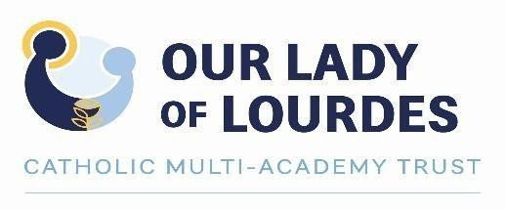  

1st Floor, Loxley House, Riverside Business Park, Tottle Rd, Nottingham NG2 1RT