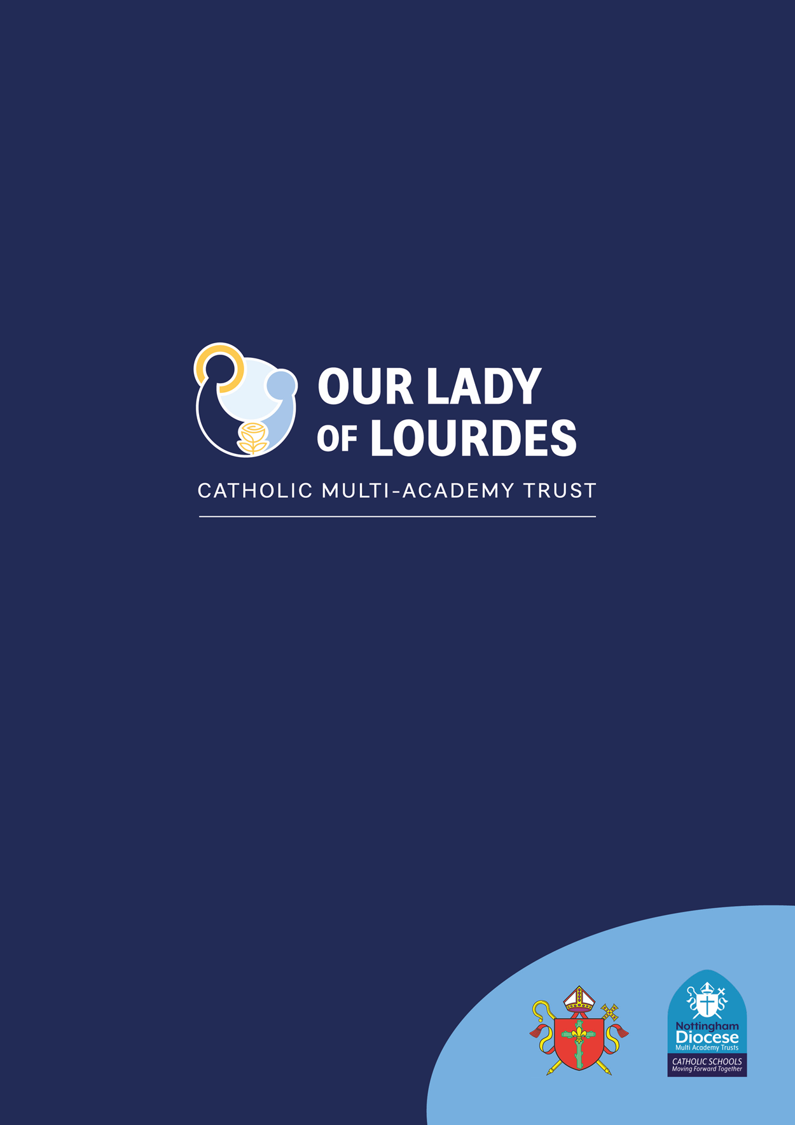

Student Mental Health and Wellbeing Policy

November 2023

Our Lady of Lourdes Catholic Multi-Academy Trust - Company Number: 7743523

Registered Office: 1st Floor, Loxley House, Riverside Business Park, Tottle Road, Nottingham NG2 1RT

**Contents Page:**

Our Lady of Lourdes Mission Statement 2

Mental Health Statement 3

Key Personnel 3

Policy Statement 4

Scope  4

Policy Aims 4

Lead Members of Staff and all Staff Responsibilities 5

Teaching About Mental Health  5

Signposting  6

Warning Signs 6

Managing Disclosures 7

Confidentiality 7

Working with Parents & Carers  8

Supporting Peers  9

Training 9

**Appendix A** Further information about common mental Health issues 10

**Appendix B** Guidance and Advice documents 12

**Appendix C** Sources of support at school and in the local community 13

**Appendix D** Mental Health First Aid England– MHFA 16

**Appendix E** CAMHS referrals 18

**Appendix F** Mental health conditions, warning signs and risk factors 21

**Our Lady of Lourdes Catholic Multi Academy Trust Mission Statement**

We are a partnership of Catholic schools, and our aim is to provide the very best Catholic education for all in our community and so improve life chances through spiritual, academic, and social development.

***By placing the person and teachings of Jesus Christ at the centre of all that we do, we will****:*

* Follow the example of Our Lady of Lourdes by nurturing everyone in a spirit of compassion, service, and healing.
* Work together so that we can all achieve our full potential, deepen our faith, and realise our God-given talents.
* Make the world a better place, especially for the most vulnerable in our society, by doing ***‘little things with great love’****St Thérèse of Lisieux*



 *Corinthians 1:3-4 “Praise be to the God and Father of our Lord Jesus Christ, the Father of compassion and the God of all comfort, who comforts us in all our troubles, so that we can comfort those in any trouble with the comfort we ourselves receive from God”.***

**Document Control**

|  |  |
| --- | --- |
| **Date Issued** | November 2023 |
| **Governors’ Committee Responsible**: | OLoL Trust Standards Committee/Executive Board |
| **Mental Health Lead**: | Pauline Chawner |
| **Status & Review Cycle:** | Statutory Annual |
| **Next Review Date:** | September 2024 |
| **Authors** | Helen Flint (Trust Youth Mental Health First Aid Lead)  Fiona McGinty (Trust Adult Mental Health First Aid Lead)  Lisa Floate (Director of Performance & Standards – Trust Mental Health Lead) |

**Mental Health Statement**

Our Lady of Lourdes Catholic Multi Academy Trust Executive Board recognise their moral and statutory responsibility to promote the mental health of all pupils and staff together with Our Lady of Good Counsel’s Local Governing Body. The Executive Trust Board and Local Governing Body will endeavour to provide an environment where all children and adults feel they can share Mental Health issues. They will make sure that all children and young people have the same access to Mental Health support regardless of age, disability, gender reassignment, race, religion or belief, sex, or sexual orientation. They follow procedures to ensure that children and adults receive effective support, protection and justice and recognise the additional needs of children from minority ethnic groups and disabled children and the barriers they may face, especially around communication. Our faith impels us to extend a helping hand to those who may be marginalised or facing difficulties, mirroring the love, and understanding exemplified by Christ. Mental Health forms part of the school and Trust’s responsibilities. The school’s Mental Health policy is available on the school website: <https://www.our-lady.lincs.sch.uk/>

|  |
| --- |
| **Key Personnel**  **Mental Health Lead:** Pauline Chawner  Contact details: email: paulinechawner@our-lady.lincs.sch.uk Telephone: 01529 304373  **The Mental Health First Aider team:**  Liza Allen  Contact details: email: liza.allen@our-lady.lincs.sch.uk Telephone:01529 304373  Kelly Cockerill  Contact details: email: kelly.cockerill@our-lady.lincs.sch.uk Telephone: 01529 304373  Sharon Robson  Contact details: email: sharon.robson@our-lady.lincs.sch.uk Telephone: 01529 304373  **The nominated Mental Health governor is:** Sophia Allen  Contact details: email: sophia.allen@our-lady.lincs.sch.uk Telephone: 01529 304373  **The Headteacher is:** Paul Tibble  Contact details: email: paul.tibble@our-lady.lincs.sch.uk Telephone: 01529 304 373  **The Chair of Governors is:** Nick Spolton  Contact details: email: nick.spolton@our-lady.lincs.sch.uk Telephone: 01529 304373 |

## Policy Statement

***“Good mental health is a state of well-being in which every individual realises his or her own potential, can cope with the normal stresses of life, can work productively and fruitfully, and is able to make a contribution to her or his community.” (World Health Organisation)***

## At our Trust, our primary goal is to foster positive mental health for every student. We strive to achieve this objective by employing both broad, school-wide strategies and specialised, targeted approaches tailored to support vulnerable students.

## In addition to promoting positive mental health, our mission is to identify and respond to instances of mental ill health. Statistics show that, on average, three children in a typical classroom are grappling with diagnosable mental health issues. By crafting and implementing practical, relevant, and effective mental health policies and procedures, we create a safe and supportive environment for students directly or indirectly affected by mental ill health (Refer to Appendix F for examples of mental health conditions).

## Scope

This document outlines the Trust's approach to promoting positive mental health and well-being. This policy serves as a guiding document for all staff, including non-teaching staff and governors.

It is essential to consider this policy alongside our safeguarding policy and PSCHE/RSHE policy, especially when a student's mental health presents concern regarding their general well-being and safety. Additionally, the SEND policy comes into play when dealing with students who have identified special educational needs.

## Policy Aims

## Our policy aims to:

* Foster positive mental health in all students.
* Raise awareness and understanding of common mental health issues.
* Enable staff to recognise early warning signs of mental ill health.
* Offer support to staff working with young people facing mental health challenges.
* Provide support to students struggling with mental ill health, as well as their peers and parents or carers.

## Lead Members of Staff and all Staff Responsibilities

While all staff members share the responsibility for promoting students' mental health, our Trust expects each school to designate staff with specific and relevant roles, appropriate to the academy's size and educational phase. Some staff members may hold multiple roles in this regard.

These responsibilities generally encompass:

* The Designated Safeguarding Lead (DSL)
* The Senior Mental Health Lead (MHL)
* The Youth Mental Health First Aider (YMHFA)
* The Adult Mental Health First Aider (AMHFA)

Any staff member who becomes concerned about a student's mental health or well-being should consult the Senior Mental Health Lead, a staff member trained as a Youth Mental Health First Aider, or a member of the Safeguarding team, especially in safeguarding cases. In situations where a student is at immediate risk of harm, standard child protection procedures must be followed, with an immediate referral to a member of the Safeguarding team and utilizing CPOMS. In the case of a medical emergency, standard procedures for medical emergencies should be observed, including notifying first-aid staff and, if necessary, contacting emergency services.

When a referral to CAMHS (Child and Adolescent Mental Health Services) is deemed necessary, this will be led and managed by the SENCo, the Mental Health Lead, or a member of the Safeguarding Team in cases involving safeguarding issues **(Refer to Appendix E for guidance on referring to CAMHS).**

## Teaching about Mental Health

The skills, knowledge and understanding needed by our students to keep themselves and others physically and mentally healthy and safe are included as part of our PSHCE curriculum. It is also promoted through supporting World Mental Health Day, World Mental Health Awareness week, and Childrens Mental Health week on an annual basis; delivered through Acts of Worship and Assemblies and is an intrinsic element of the work delivered through the school’s Chaplaincy Services.

The specific content of lessons will be tailored to the specific needs of the student body we are teaching, but it will always emphasize equipping students with the skills, knowledge, understanding, language, and confidence to seek help when needed, for themselves or others, while simultaneously eliminating the stigma surrounding mental health and be in line with DfE statutory guidance (RSHE). Our message to students is that 'mental health matters' and should be regarded with the same importance as physical health.

***Isaish 41:10 “So do not fear, for I am with you; do not be dismayed, for I am your God. I will strengthen you and help you”.***

## 

## Signposting

We will ensure that staff, students, and parents are aware of sources of support within school and in the local community and support access to these services as outlined in **Appendix C – Sources of support within the local community.**

Relevant support resources will be displayed in communal areas, such as display boards and toilets, and students will be regularly informed about these resources through the curriculum. When highlighting support resources, we will ensure that students understand:

* What help is available.
* Who it is intended for.
* How to access it.
* Why they should access it.
* What to expect after seeking help.

## Warning Signs

School staff may notice warning signs indicating that a student is experiencing mental health or emotional well-being issues. These signs should **always** be taken seriously, and any staff member observing them should communicate their concerns with our mental health lead or a member of the safeguarding team in cases of safeguarding issues.

Possible warning signs include (*this list is an indicator of possible signs and not limited to other behaviours that may be exhibited by the student*):

* Physical signs of harm that are repeated or appear non-accidental.
* Changes in eating or sleeping habits.
* Increased isolation from friends or family, becoming socially withdrawn.
* Changes in activity participation.
* Changes in mood including both low mood and hyperactivity.
* Lowering of academic achievement.
* Talking or joking about self-harm or suicide.
* Abusing drugs or alcohol.
* Expressing feelings of failure, uselessness, or loss of hope.
* Changes in clothing – e.g. long sleeves in warm weather.
* Secretive behaviour.
* Avoiding PE or getting changed secretively.
* Repeated physical pain or nausea with no evident cause.
* An increase in lateness or absenteeism.

**(See Appendix F for warning signs of selected mental health illnesses)**

## 

## Managing disclosures

A student may choose to disclose concerns about themselves or a friend to any member of staff, so all staff need to know how to respond appropriately to a disclosure.

If a student discloses concerns about their own mental health or that of a friend to a staff member, the staff member's response should always be calm, supportive, and non-judgmental.

Staff members should prioritise listening over advising, focusing on the student's emotional and physical safety rather than delving into the "why" at that moment. Our Trust follows the approach of ALGEE, as outlined in Appendix D, for managing mental health disclosures sensitively.

All disclosures should be recorded on CPOMs. Written records should include:

* Date
* Full names of staff and students involved (initials should not be used).
* Key points from the conversation.
* General physical observations.
* Agreed next steps.

This information should be shared with the Safeguarding team who will assess the severity of the situation and take appropriate next steps. (**See Appendix F for guidance about making a referral to CAMHS).**

## Confidentiality

At the earliest opportunity, we should be transparent regarding the issue of confidentiality. Students need to understand that information may need to be shared if the staff member believes that either the child themselves or others are at risk, as per the safeguarding policy.

If it is necessary to share concerns about a student, we should discuss this with the student, explaining:

* Who we are going to talk to.
* What we are going to tell them.
* Why we need to tell them.

We should never share information about a student without informing them first. Ideally, we should obtain their consent, although there are situations where information must always be shared with another staff member and/or a parent or carer, as outlined in the Safeguarding Policy. If in doubt, consult your DSL or Senor Mental Health Lead for guidance.

If a student provides reason to believe that there may be underlying child protection issues within the family, parents should not initially be contacted, but the safeguarding team must be informed immediately.

## 

## Working with Parents & Carers

When it is deemed appropriate to inform parents or carers, we should approach the situation with sensitivity. Before disclosing to parents or carers, we should consider the following questions on a case-by-case basis:

* Can the meeting happen face to face? This is preferable.
* Where should the meeting take place? At school, at their home, or in a neutral location?
* Who should be present? Consider parents or carers, the student, and other staff members.
* What are the goals of the meeting?

It can be shocking and distressing for parents to learn of their child's mental health issues, and many may initially react with anger, fear, or sadness. We should be accepting of their emotional responses within reasonable limits and allow them time to process the information.

We should always provide further information sources and share leaflets with parents or carers, when possible, as they may struggle to absorb much information during this emotional period. Sharing specific sources of support for parents, such as helplines and forums, can also be beneficial **(Refer to Appendix A and C for examples).**

We should make it easy for parents to contact us with additional questions and consider scheduling a follow-up meeting or phone call right away, as parents often have many questions as they digest the information. Each meeting should conclude with agreed-upon next steps, and a brief record of the meeting should be recorded in CPOMS.

Parents are often very welcoming of support and information from the school about supporting their children’s emotional and mental health. To support parents, we will:

Parents are often appreciative of the support and information they receive from the school regarding their children's emotional and mental health. To support parents, we will:

* Highlight information and support resources related to common mental health issues on our school website.
* Ensure that all parents know who to contact and how to do so if they have concerns about their own child or a friend of their child.
* Make our Student Mental Health & Wellbeing policy easily accessible to parents.
* Keep parents informed about the mental health topics their children are learning about in PSHCE and provide ideas for extending and exploring this learning at home.

## Supporting Peers

When a student is grappling with mental health issues, it can be a challenging time for their friends. These friends often want to offer support but may not know how to. In the case of self-harm or eating disorders, friends may even inadvertently learn unhealthy coping mechanisms from each other.

To ensure the safety of peers, we will consider on a case-by-case basis which friends may require additional support. This support can be provided through one-on-one or group settings and should be guided by discussions with the student experiencing mental health challenges and their parents.

Topics covered in these conversations may include:

* What friends should know and what should be kept confidential.
* How friends can best provide support.
* Actions and statements to avoid, as they may inadvertently cause distress.
* Signs indicating that their friend may need help, such as signs of relapse.

**Additionally, we should inform peers about**:

* Where and how to access support for themselves.
* Safe sources of further information about their friend’s condition.
* Healthy ways to cope with the difficult emotions they may be experiencing.

## Training

All staff members should receive regular training on recognizing and responding to mental health issues as part of their standard Safeguarding training to ensure they can safeguard students effectively.

Additional professional development opportunities will be considered for staff who require more in-depth knowledge as part of our performance management process. Throughout the year, further Continuing Professional Development (CPD) will be supported as needed based on evolving situations with one or more students.

Selected staff, primarily pastoral staff, have access to Youth Mental Health First Aid England Training, as detailed in Appendix D.

As a Trust, we will compile data on mental health and well-being issues in all schools to provide a comprehensive overview. Schools will use CPOMS or similar mechanisms to track student data. When the need arises, we will organize central training sessions for lead staff to enhance their understanding of specific issues related to student mental health and well-being. School Youth Mental Health First Aiders are encouraged to suggest individual, group, or whole school/Trust professional development opportunities, which will be discussed with the Trust Youth Mental Health Lead First Aider, Helen Flint, who can also point out relevant training and support sources as needed.

Our Lady of Lourdes Catholic Multi Academy Trust aims for each Primary School to have an Emotional Literacy Support Assistant (ELSA) trained TA working within the school.

**Appendices**

***Appendix A****: Further information and sources of support about common mental Health issues.*

**Prevalence of mental Health and emotional wellbeing issues:**

In 2022, 18.0% of children aged 7 to 16 years and 22.0% of young people aged 17 to 24 years had a probable mental disorder.

In children aged 7 to 16 years, rates rose from 1 in 9 (12.1%) in 2017 to 1 in 6 (16.7%) in 2020. Rates of probable mental disorder then remained stable between 2020, 2021 and 2022.

In young people aged 17 to 19 years, rates of a probable mental disorder rose from 1 in 10 (10.1%) in 2017 to 1 in 6 (17.7%) in 2020. Rates were stable between 2020 and 2021, but then increased from 1 in 6 (17.4%) in 2021 to 1 in 4 (25.7%) in 2022.

11- to 16-year-olds with a probable mental disorder were less likely to feel safe at school (61.2%) than those unlikely to have a mental disorder (89.2%). They were also less likely to report enjoyment of learning or having a friend they could turn to for support.

1 in 8 (12.6%) 11- to 16-year-old social media users reported that they had been bullied online. This was more than 1 in 4 (29.4%) among those with a probable mental disorder.

11- to 16-year-old social media users with a probable mental disorder were less likely to report feeling safe online (48.4%) than those unlikely to have a disorder (66.5%).

1 in 5 (19.9%) 7- to 16-year-olds lived in households that experienced a reduction in household income in the past year. This was more than 1 in 4 (28.6%) among children with a probable mental disorder.

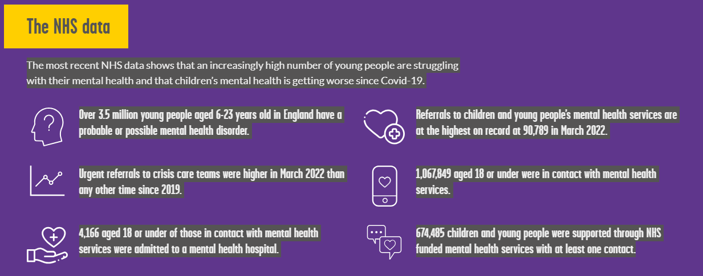**Academic citation:** Newlove-Delgado T, Marcheselli F, Williams T, Mandalia D, Davis J, McManus S, Savic M, Treloar W, Ford T. (2022) Mental Health of Children and Young People in England, 2022. NHS Digital, Leeds.

**Young Minds 2023**

**Useful resources/agencies/websites containing information on mental health:**

|  |  |  |
| --- | --- | --- |
| Organisation name | Website | Support offered |
| Young Minds | [www.youngminds.org.uk](http://www.youngminds.org.uk) | General guidance and information regarding mental health  Specific parent help line  Resources and training for schools  Young person’s crisis messenger service |
| Harmless | <https://harmless.org.uk/> | Offer online support for young people and families experiencing self-harm concerns, training for schools and consultancy for organisations. |
| Mentally Healthy Schools | [www.mentallyhealthyschools.org.uk](http://www.mentallyhealthyschools.org.uk) | Website offering resources and guidance on how to promote positive mental health in schools |
| Heads together | <https://harmless.org.uk/> | Heads Together is a mental health initiative spearheaded by The Royal Foundation of The Prince and Princess of Wales, which combines a campaign to tackle stigma and change the conversation on mental health with fundraising for a series of innovative new mental health services. |
| Beat | [www.beateatingdisorders**.**org.uk](http://www.beateatingdisorders.org.uk) | Website offering support for young people and their families experiencing an eating disorder. |
| Childline | [www.childline.org.uk](http://www.childline.org.uk) | Charity run organisation support children’s wellbeing |
| Mind | [www.mind.org.uk](http://www.mind.org.uk) | Mind is a leading mental health charity. Their website offers information and resources on various mental health issues. They also have local branches that may offer in-person support. |
| Anna Freud Centre | [www.annafreud.org](http://www.annafreud.org) | Children’s mental health charity |
| Hub of Hope | [www.hubofhope.co.uk](http://www.hubofhope.co.uk) | The Hub of Hope is the UK’s leading mental health support database. It has directed hundreds of thousands of people to life-changing and even life-saving support and it is now the UK’s go-to mental health support signposting tool, with thousands of local, regional and national support groups and services listed. |

**Appendix B**: Guidance and Advice documents

* Keeping children safe in education 2023-statutory guidance for schools and colleges. Department of education updated on a yearly basis.
* Relationships and sex education (RSE) and Health Education – Statutory guidance for schools This will help pupils understand the positive effects that good relationships have on their mental wellbeing, identify when relationships are not right and understand how such situations can be managed.
* Promoting and supporting mental health and wellbeing in schools and colleges DfE 2022- Taking a coordinated and evidence-informed approach to mental health in schools and colleges leads to improved pupil and student wellbeing, which, in turn, can improve learning.
* How we’re helping look after the mental health of children and young people- The Education Hub DfE 2023
* Supporting mental health and wellbeing in secondary schools-Guidance and advice produced by experts from the Anna Freud National Centre for children and families
* Promoting children and young people’s emotional health and wellbeing (a whole school and college approach)- produced by Public Health England
* Make it count. Mental Health is not extracurricular- Guidance for schools produced by the Mental Health Foundation
* Promoting emotional wellbeing in pupils on the autism spectrum- a guide for schools. –created in collaboration between NORSACA, NHS and Nottingham County council
* Measuring and monitoring children and young people’s mental wellbeing- A toolkit for schools and colleges- Created by Public Health England

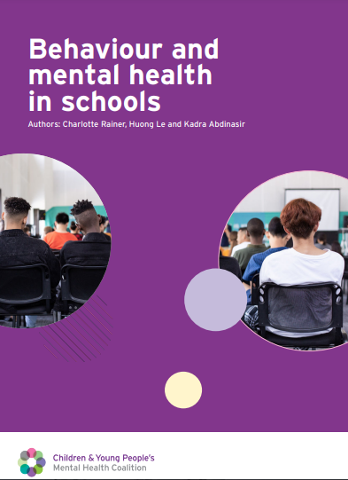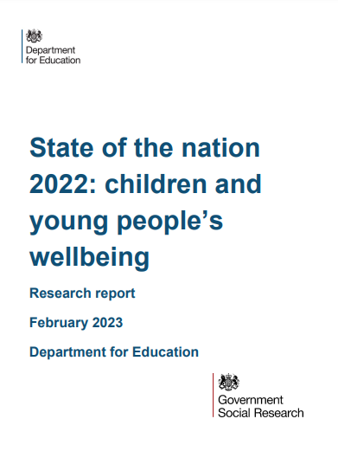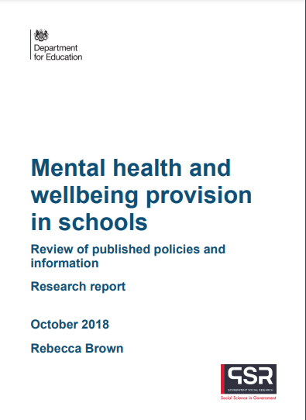Mental Health and behaviours in School (2018) Department of Education

**Appendix C**: Sources of support at school and in the local community

**School Based Support**

|  |  |  |  |
| --- | --- | --- | --- |
| Name of support | What does it offer? | Who is it for | How is it accessed |
| ELSA | Group and one to one mentoring. | Students who are experiencing general low mental health but have not met the threshold for specialist services | ELSA Leader referral  Planned sessions with a designated ELSA trained member of staff |
| Safeguarding Team | Support and guidance on referrals to external agencies | Students requiring specialist external agency support for their mental health | Speak directly with a safeguarding team member in school. |

**Local support**

|  |  |  |  |
| --- | --- | --- | --- |
| Name of support | What does it offer | Who is it for | How is it accessed |
| CAMHS (Children and adolescent mental health service | NHS services that assess and treat young people with emotional, behavioral or mental health difficulties | Students requiring specialist external agency support for their mental health | GP referral  School referral  Healthy families team referral |
| GP | Guidance, assessment, and access to mental health support including medication | Students and parents concerned about their mental health | Contact your local surgery |
| Healthy family’s team | One to one guidance based around mental health work with a young person. Drop-in sessions at schools. | Students who are experiencing general low mental health but have not met the threshold for specialist services | GP referral  School referral  Self-referral Rushcliffe area:  Tel: [0115 883 7368](tel:0115%20883%207368) appointments only Tel: [0115 883 7361](tel:0115%20883%207361) advice only  Self-referral Lincolnshire:  Under the age of 16 –  Tel: 0800 234 6342 (advice only)  Over the age of 16: complete a self-referral form via [lincs.spa@nhs.net](mailto:lincs.spa@nhs.net) |
| Base 51 | One to one counselling service and drop-in sessions | Students requiring counselling | Self-referral via their website or email [counselling@base51.org.uk](mailto:counselling@base51.org.uk) |
| The Catholic Childrens Society | On site CPD for school staff | Students experiencing bereavement | <https://www.cathchild.org.uk/rainbows-bereavment-support-programme/> |
| CGL | One to one drug and alcohol misuse support | Students experience drug and alcohol misuse | Self-referral by emailing:  [nottsyp.admin@cgl.org.uk](mailto:nottsyp.admin@cgl.org.uk) |
| Cruse bereavement care | One to one and group bereavement therapy | Students struggling to cope with the loss of a loved one | Self-referral by calling:  0115 9244404  Website: <https://www.cruse.org.uk/> |
| Women’s Aid | One to one and group therapy and advice | Support for women and young girls who have experienced or are experiencing domestic violence. | Self-referral by calling.  01472 575757  Website: <https://www.womensaid.org> |
| EDAN Lincs | Support | Is a registered charity providing support & assistance to anyone suffering or fleeing from Domestic Abuse in Lincolnshire. | Tel: 01522 510041  General Enquiry: [info@ldass.org.uk](mailto:info@ldass.org.uk)  Website: <https://edanlincs.org.uk/> |
| Kooth | online counselling and emotional well-being platform., accessible through mobile, tablet and desktop. | Students wanting online support for their mental health. | Visit their website:  [www.kooth.com](http://www.kooth.com) |
| MHST | Mental Health Support Team | Students  Family  Staff | School EMHP (Education Mental Health Practitioner) name: |

**Appendix D:** Mental Health First Aid England(MHFA)

A qualified Youth Mental Health First Aider is someone who has undertaken a two-day training course approved by MHFA England and holds a valid certificate of competence. MHFA is used in over 16 countries worldwide and was introduced into England by the National Institute for Mental Health England (NIMHE) in 2007. MHFA does not prepare people to become therapists. It does, however, enable people to recognise the symptoms of mental ill health, how to provide initial help (first aid) and how to guide a person towards appropriate professional help.

Mental Health First Aid England promote the following approach when supporting a young person experiencing poor mental health:

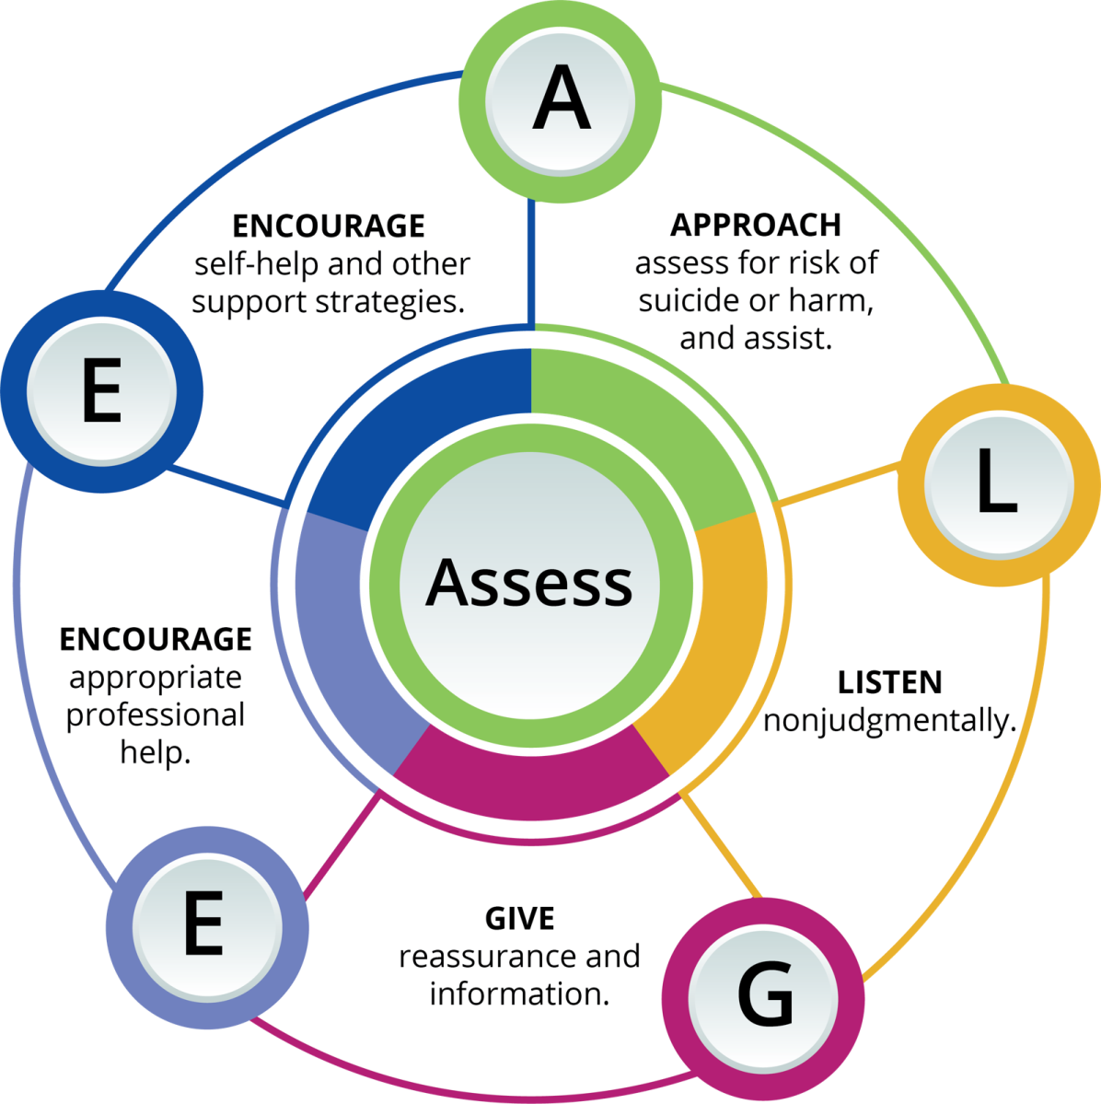**ALGEE:**

**A**pproach, assess, assist.

**L**isten non judgementally.

**G**ive support and information.

**E**ncourage appropriate professional help.

**E**ncourage other support.

**Non-judgmental listening**

The way you respond to a young person when they disclose a potential mental health concern will greatly affect their willingness to access support in the future, so it is important that you are visibly non-judgmental in any interaction. Guidance given by MHFA includes the following:

* Seek to understand before you seek to be understood.
* Be non-judgemental.
* Give your undivided attention to the speaker.
* Use silence effectively (don’t always rush to fill silences).
* Listen to the young person (don’t assume things).
* Accept that their worries are real for them.
* Don’t be critical, try not to get frustrated.
* Don’t try to solve their problems (we are not the experts).
* The most common problem in communication is not listening.

(Source: Youth Mental Health First Aid England)

**See below for the Listening wheel.**[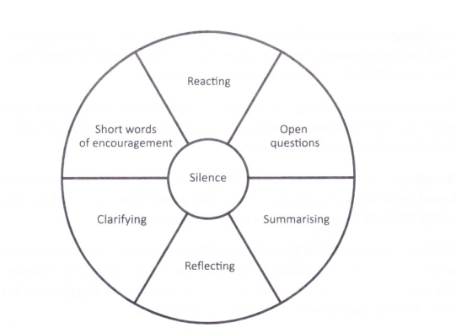](https://www.google.co.uk/url?sa=i&url=https://alittlemoreunderstanding.wordpress.com/2016/04/30/learning-to-listen/&psig=AOvVaw33fjBTef-utisGhTrG_tGU&ust=1580564871159000&source=images&cd=vfe&ved=0CAIQjRxqFwoTCMjHro_9recCFQAAAAAdAAAAABAJ)

More information and guidance are available from the school’s Mental Health First Aiders.

**Appendix E:** CAMHS referrals

CAMHS stands for Child and Adolescent Mental Health Services. They provide support and treatment for children, young people and their families who are experiencing mental health difficulties. They support children and young people aged up to 18 years (25 years if they have been a child in care and it is agreed that we are the best service to meet their needs) who are experiencing psychological distress and need support with their mental health.

The CAMHS team includes:

• mental health nurses

• social workers

• assistant practitioners

• psychologists

• consultant psychiatrists

• peer support workers

• administrators.

**Accessing CAMHS**

**Lincolnshire:**

Lincolnshire have a range of services that can support young people’s emotional or mental health. To ensure that the right service is offered the Access Team review all referrals and staff the Lincolnshire Here4You Line. In Lincolnshire, you can 'self-refer' to children and young people’s (CYP) services. This means that if your child is struggling with their emotional or mental health, you or your child can self-refer directly to services, without going to school or GP.

**Parents:**

**Lincolnshire Here4You Line**[**Telephone 0800 234 6342**](tel:08002346342)   
*The Here4You line is open 24 hours a day, 7 days a week for advice. However only able to take self-referrals between 9am to 4.30pm.*

**School referrals:** SENCo/Mental Health Lead/SLT, should first speak to the CAMHS Professional Advice Line (PAL) on **01522 309120**, available 9:00am-4:45pm, Monday to Friday. Once a referral has been confirmed as suitable it should be submitted using a CAMHS referral form.

**Nottinghamshire:**

**Parents:**

If you are the parent or carer for a young person aged 0 to 18 years old with a Nottinghamshire GP, you can refer on their behalf to CAMHS. This means that you can directly approach our team to ask for help. The telephone number is **0808 196 3779** option 1 and it is open from 8am to 5pm, Monday to Friday. You will speak to a specially trained professional who will ask you some questions and talk to you about how they can help. If you prefer, you can ask for help by completing an online referral form.

* [Complete online referral form](https://www.nottinghamshirehealthcare.nhs.uk/CAMHS-self-referral)

If you prefer you can speak to your GP or school health nurse who can get in touch by calling or writing. Any other professional who works with your child/ young person like a social worker, counsellor or youth worker can also contact us to find out how we can help you.

For a full range of Mental health Support services in Nottingham please download the following documents that the youth led MH2K team have put together:

* [MH2K - Information about local Mental Health Services in Nottingham City.pdf[pdf] 2MB](https://www.nottinghamshirehealthcare.nhs.uk/download.cfm?doc=docm93jijm4n7567.pdf&ver=13278)
* [MH2K - Information about local Mental Health Services in Nottinghamshire County.pdf[pdf] 5MB](https://www.nottinghamshirehealthcare.nhs.uk/download.cfm?doc=docm93jijm4n7568.pdf&ver=13279)

Professionals’ referrals

We accept referrals from any professional, including GPs and teachers.

County referrals (for children registered with a County GP)

All CAMHS referrals for Nottinghamshire County are made via our Single Point of Access:

Single Point of Access Team (SPA)  
Pebble Bridge  
Hopewood  
Foster Drive  
Nottingham  
NG5 3FL

Email: [SPAReferrals@nottshc.nhs.uk](mailto:SPAReferrals@nottshc.nhs.uk)

City referrals (for children registered with a City GP)

All CAMHS referrals for Nottingham City referrals are made via our Single Point of Access:

CAMHS Citywide Tier 2  
Nottingham City Council  
Glenbrook Management Centre  
Wigman Road  
Bilborough  
Nottingham  
NG8 4PD

[More information on referring to Nottingham City can be found here](https://www.asklion.co.uk/kb5/nottingham/directory/site.page?id=kJsvOknp0Yo).

**Things to consider prior to CAMHS referral:**

If the referral is urgent, it should be initiated by phone so that CAMHS can advise of best next steps. Before making the referral, have a clear outcome in mind. What do you want CAMHS to do? You might be looking for advice, strategies, support or a diagnosis, for instance.

You must also be able to provide evidence to CAMHS about what intervention and support has been offered to the pupil by the school and the impact of this. CAMHS will always ask ‘What have you tried?’ so be prepared to supply relevant evidence, reports and records.

**General considerations**

* Have you met with the parent(s) or carer(s) and the referred child or children?
* Has the referral to CAMHS been discussed with a parent or carer and the referred pupil?
* Has the pupil given consent for the referral?
* Has a parent or carer given consent for the referral?
* What is the parent or carer, pupil’s attitudes to the referral?

**Basic information**

* Is there a child protection plan in place?
* Is the child looked after?
* Name and date of birth of referred child/children.
* Address and telephone number
* Who has parental responsibility?
* Surnames if different to child’s
* GP details
* What is the ethnicity of the pupil / family?
* Will an interpreter be needed?
* Are there other agencies involved?

**Reason for referral**

* What are the specific difficulties that you want CAMHS to address?
* How long has this been a problem and why is the family seeking help now?
* Is the problem situation-specific or more generalised?
* Your understanding of the problem or issues involved.

**Further helpful information**

* Who else is living at home and details of separated parents if appropriate.
* Name of school
* Who else has been or is professionally involved and in what capacity?
* Has there been any previous contact with our department?
* Has there been any previous contact with social services?
* Details of any known protective factors
* Any relevant history i.e. family, life events and/or developmental factors
* Are there any recent changes in the pupil’s or family’s life?
* Are there any known risks, to self, to others or to professionals?
* Is there a history of developmental delay e.g. speech and language delay
* Are there any symptoms of ADHD/ASD and if so have you talked to the educational psychologist?

**Appendix F:** Mental health conditions, warning signs and risk factors.

**Anxiety and Depression**

**Anxiety disorders**

Anxiety is a natural, normal feeling we all experience from time to time. It can vary in severity from mild uneasiness through to a terrifying panic attack. It can vary in how long it lasts, from a few moments to many years.

All children and young people get anxious at times; this is a normal part of their development as they grow up and develop their ‘survival skills’ so they can face challenges in the wider world. In addition, we all have different levels of stress we can cope with - some people are just naturally more anxious than others and are quicker to get stressed or worried.

Concerns are raised when anxiety is getting in the way of a child’s day to day life, slowing down their development, or having a significant effect on their schooling or relationships.

**Anxiety disorders include:**

* Generalised anxiety disorder (GAD).
* Panic disorder and agoraphobia.
* Acute stress disorder (ASD).
* Separation anxiety.
* Post-traumatic stress disorder.
* Obsessive-compulsive disorder (OCD).
* Phobic disorders (including social phobia).

**Symptoms of an anxiety disorder**

These can include:

**Physical effects**

* Cardiovascular – palpitations, chest pain, rapid, heartbeat, flushing.
* Respiratory – hyperventilation, shortness of breath.
* Neurological – dizziness, headache, sweating, tingling and numbness.
* Gastrointestinal – choking, dry mouth, nausea, vomiting, diarrhoea.
* Musculoskeletal – muscle aches and pains, restlessness, tremor and shaking.

**Psychological effects**

* Unrealistic and/or excessive fear and worry (about past or future events).
* Mind racing or going blank.
* Decreased concentration and memory.
* Difficulty making decisions.
* Irritability, impatience, anger.
* Confusion.
* Restlessness or feeling on edge, nervousness.
* Tiredness, sleep disturbances, vivid dreams.
* Unwanted unpleasant repetitive thoughts.

**Behavioural effects**

* Avoidance of situations.
* Repetitive compulsive behaviour e.g. excessive checking.
* Distress in social situations.
* Urges to escape situations that cause discomfort (phobic behaviour).

**First Aid for anxiety disorders**

Follow the ALGEE principles (see appendix D for more details).

**How to help a pupil having a panic attack**

* If you are at all unsure whether the pupil is having a panic attack, a heart attack or an asthma attack, and/or the person is in distress, call an ambulance straight away.
* If you are sure that the pupil is having a panic attack, move them to a quiet safe place if possible.
* Help to calm the pupil by encouraging slow, relaxed breathing in unison with your own.
* Encourage them to breathe in and hold for 3 seconds and then breathe out for 3 seconds.
* Be a good listener, without judging.
* Explain to the pupil that they are experiencing a panic attack and not something life threatening such as a heart attack.
* Explain that the attack will soon stop and that they will recover fully.
* Assure the pupil that someone will stay with them and keep them safe until the attack stops.

Many young people with anxiety problems do not fit neatly into a particular type of anxiety disorder. It is common for people to have some features of several anxiety disorders. A high level of anxiety over a long period will often lead to depression and long periods of depression can provide symptoms of anxiety. Many young people have a mixture of symptoms of anxiety and depression as a result.

**Depression**

A clinical depression is one that lasts for at least 2 weeks, affects behaviour, and has physical, emotional and cognitive effects. It interferes with the ability to study, work and have satisfying relationships. Depression is a common but serious illness and can be recurrent.

Depression in young people often occurs with other mental disorders, and recognition and diagnosis of the disorder may be more difficult in children because the way symptoms are expressed varies with the developmental age of the individual. In addition to this, stigma associated with mental illness may obscure diagnosis.

**Risk Factors**

* Experiencing other mental or emotional problems.
* Divorce of parents.
* Perceived poor achievement at school.
* Bullying.
* Developing a long-term physical illness.
* Death of someone close.
* Break up of a relationship.

Some people will develop depression in a distressing situation, whereas others in the same situation will not.

**Symptoms**

**Effects on emotion**: sadness, anxiety, guilt, anger, mood swings, lack of emotional responsiveness, helplessness, hopelessness.

**Effects on thinking**: frequent self-criticism, self-blame, worry, pessimism, impaired memory and concentration, indecisiveness and confusion, tendency to believe others see you in a negative light, thoughts of death or suicide.

**Effects on behaviour**: crying spells, withdrawal from others, neglect of responsibilities, loss of interest in personal appearance, loss of motivation. Engaging in risk taking behaviours such as self-harm, misuse of alcohol and other substances, risk-taking sexual behaviour.

**Physical effects**: chronic fatigue, lack of energy, sleeping too much or too little, overeating or loss of appetite, constipation, weight loss or gain, irregular menstrual cycle, unexplained aches, and pains.

**First Aid for anxiety and depression**

Follow the ALGEE principles shown in *Appendix D.*

The most important role school staff can play is to familiarise themselves with the risk factors and warning signs outlined above and to make the safeguarding team aware of any child causing concern.

**Eating Disorders**

Anyone can get an eating disorder regardless of their age, gender, or cultural background. People with eating disorders are preoccupied with food and/or their weight and body shape and are usually highly dissatisfied with their appearance.

The majority of eating disorders involve low self-esteem, shame, secrecy and denial.

Anorexia nervosa and bulimia nervosa are two of the major eating disorders.

People with anorexia live at a low body weight, beyond the point of slimness and in an endless pursuit of thinness by restricting what they eat and sometimes compulsively over-exercising.

In contrast, people with bulimia have intense cravings for food, secretively overeat and then purge to prevent weight gain (by vomiting or use of laxatives, for example).

**Risk Factors**

The following risk factors, particularly in combination, may make a young person more vulnerable to developing an eating disorder:

**Individual Factors**

* Difficulty expressing feelings and emotions.
* A tendency to comply with other’s demands.
* Very high expectations of achievement.

**Family Factors**

* A home environment where food, eating, weight or appearance have a disproportionate.
* Significance.
* An over-protective or over-controlling home environment.
* Poor parental relationships and arguments.
* Neglect or physical, sexual or emotional abuse.
* Overly high family expectations of achievement.

**Social Factors**

* Being bullied, teased, or ridiculed due to weight or appearance.
* Pressure to maintain a high level of fitness/low body weight for e.g. sport or dancing.

**Warning Signs**

School staff may become aware of warning signs which indicate a pupil is experiencing difficulties that may lead to an eating disorder. These warning signs should always be taken seriously and staff observing any of these warning signs should seek further advice from one of the designated safeguarding team members.

.

**Physical Signs**

* Weight loss.
* Dizziness, tiredness, fainting.
* Feeling Cold.
* Hair becomes dull or lifeless.
* Swollen cheeks.
* Callused knuckles.
* Tension headaches.
* Sore throats / mouth ulcers.
* Tooth decay.

**Behavioural Signs**

* Restricted eating.
* Skipping meals.
* Scheduling activities during lunch.
* Strange behaviour around food.
* Wearing baggy clothes.
* Wearing several layers of clothing.
* Excessive chewing of gum/drinking of water.
* Increased conscientiousness.
* Increasing isolation / loss of friends.
* Believes they are fat when they are not.
* Secretive behaviour.
* Visits the toilet immediately after meals.
* Excessive exercise.

**Psychological Signs**

* Preoccupation with food.
* Sensitivity about eating.
* Denial of hunger despite lack of food.
* Feeling distressed or guilty after eating.
* Self-dislike.
* Fear of gaining weight.
* Moodiness.
* Excessive perfectionism.

**Self-Harm**

Self-harm is any behaviour where the intent is to deliberately cause harm to one’s own body for example:

* Cutting, scratching, scraping, or picking skin.
* Swallowing inedible objects.
* Taking an overdose of prescription or non-prescription drugs.
* Swallowing hazardous materials or substances.
* Burning or scalding.
* Hair-pulling.
* Banging or hitting the head or other parts of the body.
* Scouring or scrubbing the body excessively.

**Risk Factors**

The following risk factors, particularly in combination, may make a young person particularly vulnerable to self-harm:

**Individual Factors**:

* Depression/anxiety.
* Poor communication skills.
* Low self-esteem.
* Poor problem-solving skills.
* Hopelessness.
* Impulsivity.
* Drug or alcohol abuse.

**Family Factors**

* Unreasonable expectations.
* Neglect or physical, sexual, or emotional abuse.
* Poor parental relationships and arguments.
* Depression, self-harm, or suicide in the family.

**Social Factors**

* Difficulty in making relationships/loneliness.
* Being bullied or rejected by peers.

**Warning Signs**

School staff may become aware of warning signs which indicate a pupil is experiencing difficulties that may lead to thoughts of self-harm or suicide. These warning signs should always be taken seriously and staff observing any of these warning signs should seek further advice from the safeguarding team.

**Possible warning signs include:**

* Changes in eating/sleeping habits (e.g. pupil may appear overly tired if not sleeping well).
* Increased isolation from friends or family, becoming socially withdrawn.
* Changes in activity and mood e.g. more aggressive or introverted than usual.
* Lowering of academic achievement.
* Talking or joking about self-harm or suicide.
* Abusing drugs or alcohol.
* Expressing feelings of failure, uselessness, or loss of hope.
* Changes in clothing e.g. always wearing long sleeves, even in very warm weather.
* Unwillingness to participate in certain sports activities e.g. swimming.