**Our Father**

**Our Father, Who art in heaven**

**Hallowed by Thy name;**

**Thy kingdom come,**

**Thy will be done,**

**on earth as it is in heaven.**

**Give us this daily our daily bread,**

**and forgive us our trespasses,**

**as we forgive those who trespass against us;**

**and lead us not into temptation**

**but deliver us from evil.**

**Amen**

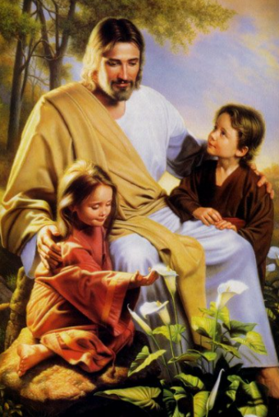

**Hail Mary**

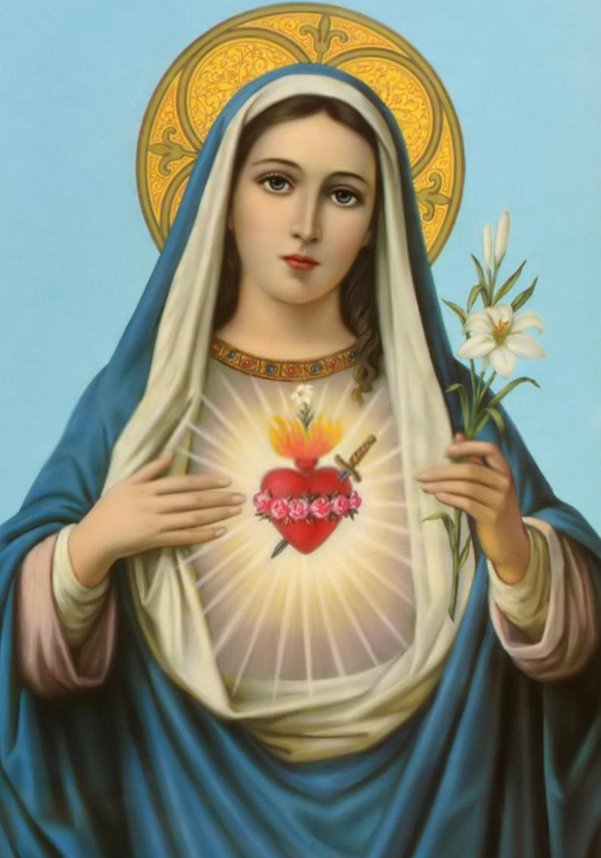

**Hail Mary, full of grace**

**the Lord is with thee.**

**Blessed art thou amongst women**

**and blessed is the fruit of thy woman, Jesus.**

**Holy Mary, mother of God**

**Pray for us sinners now**

**And at the hour of our death.**

**Amen**