Midday Prayer

Bless us O God as we sit together.
Bless the food we eat today.
Bless the hands that made the food.
Bless us O God,
Amen

Morning School Prayer

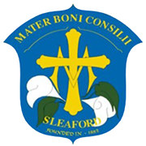

God our Father, to you we pray
to guide is in our work and play.
To show we love, to show we care
to those at school and everywhere.
Let us do right in every way,
as we love, live and learn in Christ
each day.
Amen

