Advent begins!
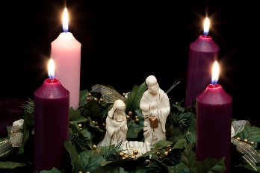

27.11.20

Dear Parents/Carers,

This Sunday, the 29th of November, marks the first Sunday of Advent and a time in the church’s year when we wait and prepare for the coming of Jesus, born on Christmas Day. During this special period, we are reminded to take time to reflect and encounter Jesus in our lives.

Each year in school, we usually send out a travelling crib, which is passed along the class to every child. This year, due to COVID, we are creating the packs in a slightly different way. Every child will receive a travelling crib pack but it will only travel from school to home and can then be kept just for you. This allows every child to experience a time of encountering Jesus during any time in Advent and to look at the nativity scene more than once.

The pack provided contains a nativity scene to cut out and create, a candle to light and some suggestions for how you can use it. There is also a reflection slip attached at the bottom of this letter, which we would love you to return, sharing with everyone your family’s reflections of using the special travelling crib.

We hope you enjoy receiving the pack and if you have any further questions, please feel free to email me on pippa.higdon@our-lady.lincs.sch.uk

Many thanks,

Mrs Higdon

REFLECTION SLIP
Name: _________________________________

Year Group: _____________________________

How did you feel using the travelling crib and sharing in the special Christmas journey?

______________________________________________________________________________________________

Any further comments you would like to add

_____________________________________________________________________________________________

