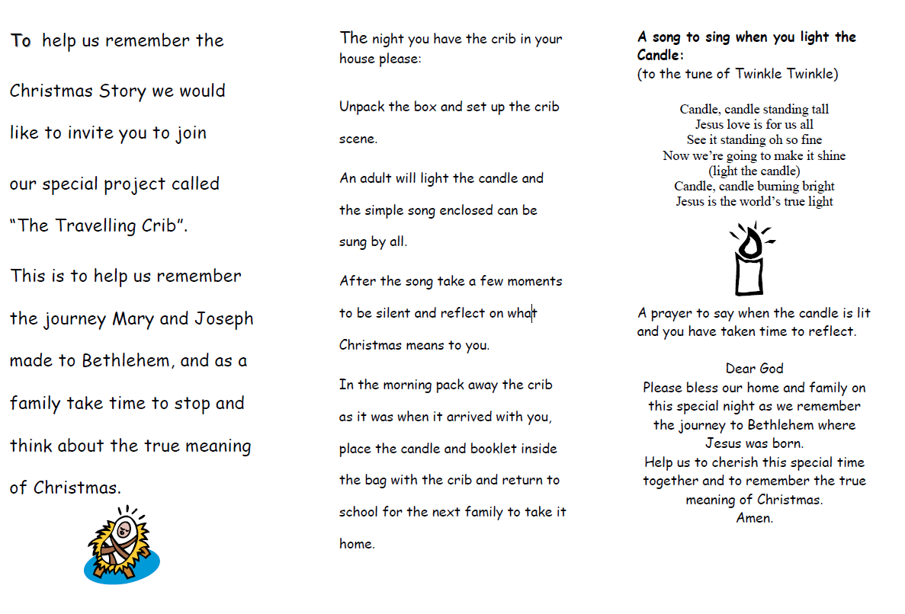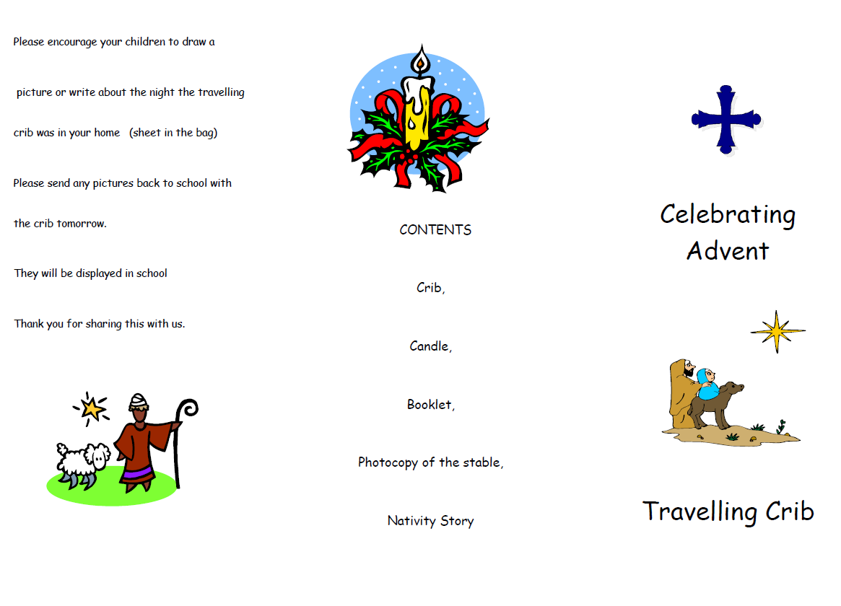



Please take time to read the Nativity story and discuss the true meaning of Christmas with your child.

In school during Advent, we think about how we can prepare ourselves to be ready for Jesus’s coming. Here are some great suggestions they’ve made for what they can do:

. Donate food to a food bank

. Pray at some point in the day

. Show an act of kindness to someone

Candle

Nativity scene characters to cut out

Reflection sheet

Nativity story

Leaflet